FOR IMMEDIATE RELEASE
FEBRUARY 17, 2021
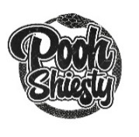
POOH SHIESTY’S SHIESTY SEASON OFFICIALLY DEBUTS AT #4 ON THE BILLBOARD 200 AND #1 ON TOP RAP ALBUMS
“BACK IN BLOOD” CELEBRATES 6TH WEEK ON THE HOT 100 (#17);
“NEIGHBORS” & “BOX OF CHURCHES” FT 21 SAVAGE MAKE THEIR DEBUT

DOWNLOAD/STREAM SHIESTY SEASON NOW: https://poohshiesty.lnk.to/ShiestySeason

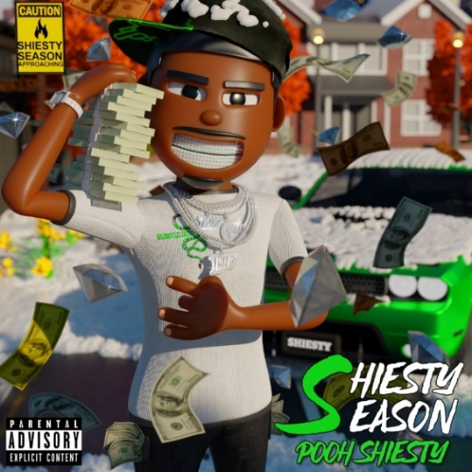
DOWNLOAD HI-RES GRAPHIC HERE

“…we’re all witnessing something special right before our eyes.”
– REVOLT

“Pooh Shiesty is already a star.”
- STEREOGUM

“For Memphis native Pooh Shiesty, the release of his debut Shiesty Season feels more like a highly anticipated follow-up rather than his first trip around the block.”
– HIPHOPDX

“…one of the hardest new rappers out…his potential is through the roof…”
- COMPLEX
SHIESTY SEASON, the highly anticipated debut mixtape from Memphis’ own POOH SHIESTY, officially sits as the #4 project in the country and serves as his first career entry on the Billboard 200 while “Neighbors” (#51) and “Box of Churches” ft 21 Savage (#81) both made their debut on this week’s Hot 100. The mixtape also debuted atop Billboard’s Top Rap Albums (#1), Rolling Stone’s Top 200 (#3), Spotify’s Top US Albums (#1) while remaining at #1 on both Apple Music’s All Genres & Hip-Hop/Rap charts. Upon release, all 17 of the mixtape’s tracks appeared in the Top 50 on Apple Music’s Top Songs All Genres. The triumphant first week arrives as “Back In Blood” celebrates its 6th week on the Hot 100 (currently #17) and it’s 6th week on Rolling Stone’s Top 100 (peaked at #1) after peaking at #1 on Apple Music’s All Genre & Hip-Hop/Rap charts (currently #2 on both). Pooh also sits atop Rolling Stone’s Artist 500 (#6) and Breakthrough 25 (#2) along with Billboard’s Artist 100 (#8).
Billboard recently tapped Pooh as the first artist to launch their newest franchise, Hip-Hop/R&B Rookie of The Month, after being named as one of their “15 Hip-Hop & R&B Artists to Watch in 2021.” Audiomack has spotlighted him as their latest UpNow artist as “Back In Blood” continues to be the #1 streamed song on the platform (catch his recent live piano medley performance of “Back In Blood” and “Guard Up” as a part of their Fine Tuned Series). He was also tapped as one of Complex’s “Rappers to Watch in 2021” and Rap Caviar’s “10 Artists to Watch in 2021.” Pitchfork praised SHIESTY SEASON going on to say it “punches well above its weight class as his solo debut and cements his position as top dog of the New 1017,” while HipHopDX acknowledged the widespread excitement surrounding the debut project claiming it “feels more like a highly anticipated follow-up rather than his first trip around the block.”
Pooh continued to celebrate his release week and unleashed the “See Red” visual which has already seen over 2.7M streams on YouTube. “’See Red’ is one of my favorite songs on SHIESTY SEASON,” says Pooh, “It’s one of those tracks that make you want to get in your car and just drive fast.” Other recently released visuals continue to grow in views including “Back In Blood” (46.5M), “Guard Up” (6.3M) and “Neighbors” (7.2M). He was also seen on the JUDAS AND THE BLACK MESSIAH original motion picture soundtrack with “No Profanity.”
Known for snaking through airy beats with a venomous bite and slick melodies, the Memphis born-and-bred rapper first incited buzz with 2019’s “Shiesty Summer” (10.2M views), later earning the attention of GRAMMY® Award-nominated, multi-platinum icon Gucci Mane, who promptly signed Pooh to his groundbreaking The New 1017 label. A series of increasingly popular hits followed, including “Monday to Sunday (Feat. Lil Baby & Big 30)“ (41.5M views), “7.62 God“ (22M views), “Main Slime Remix (Feat. Moneybagg Yo)“ (20.8M views), and “ABCGE (Feat. Big 30)“ (10M views), to name just a few. In addition, Pooh kicked off Audiomack’s “17 Bars with The New 1017” series with a cover of Gucci Mane’s classic “Lemonade,” currently boasting over 3M views.
# # #

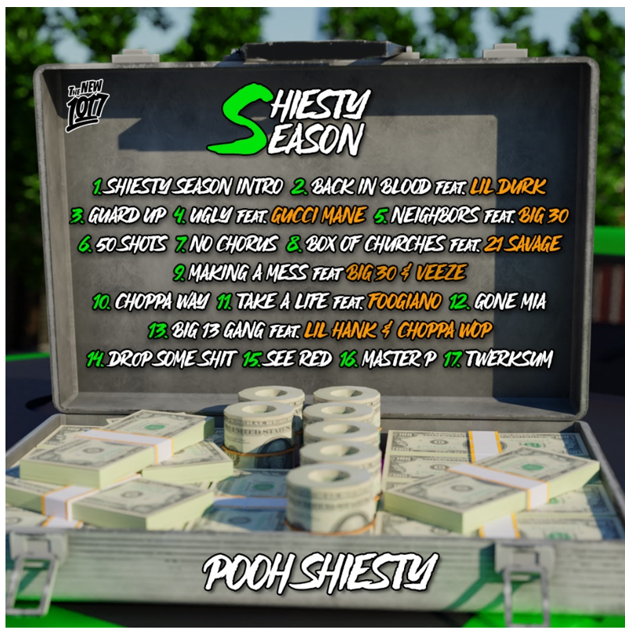
SHIESTY SEASON
Pooh Shiesty
The New 1017/Atlantic Records

Shiesty Season Intro
Back In Blood feat. Lil Durk
Guard Up
Ugly feat. Gucci Mane
Neighbors feat. BIG30
50 Shots
No Chorus
Box of Churches feat. 21 Savage
Making A Mess feat. BIG30 & Veeze
Choppa Way
Take A Life feat. Foogiano
Gone MIA
Big 13 Gang feat. Lil Hank & Choppa Wop
Drop Some Shit
See Red
Master P (feat. Tay Keith)
Twerksum

DOWNLOAD HI-RES PRESS IMAGES HERE
VIEW FULL BIO HERE

CONNECT:
WEBSITE | INSTAGRAM | TWITTER | FACEBOOK | SOUNDCLOUD | AUDIOMACK

POOH SHIESTY CONTACT:
SELAM.BELAY@ATLANTICRECORDS.COM

THE NEW 1017 LABEL CONTACT:
ASHLEY.KALMANOWITZ@ATLANTICRECORDS.COM

