FOR IMMEDIATE RELEASE
APRIL 1, 2022

CHRISTIAN LALAMA IS BACK WITH “NOBODY AIN’T YOU”

ATLANTIC RECORDS POP/R&B ARTIST SHARES VULNERABLE NEW SINGLE

LISTEN HERE | WATCH HERE

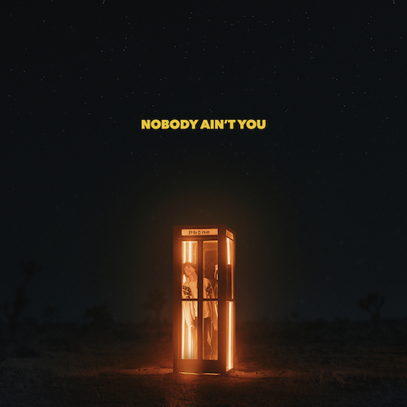
DOWNLOAD HI-RES ARTWORK

“Lalama is proving his worth among the ranks of pop icons like Justin Bieber and Shawn Mendes. A perfect blend of smooth R&B beats and addictive pop melodies.” – YOUNG HOLLYWOOD

Atlantic Records pop/R&B artist Christian Lalama has shared his most emotionally charged single to date. After teasing the new song with a viral performance on TikTok that has earned over 2M views, “Nobody Ain’t You” is available now at all DSPs and streaming services with the official music video premiering now at YouTube HERE.

“I’m very excited for the release of ‘Nobody Ain’t You,’” says Christian. “The lyrics show a much more vulnerable side to my music and I can’t wait for you guys to hear it!”

“Nobody Ain’t You” follows the release of Christian’s first new single in nearly two years, “Girlfriend,” available now at all DSPs and streaming services. The feel-good track – which interpolates Fabolous, P. Diddy & Jagged Edge’s “Trade It All (Part 2),” originally found on the blockbuster 2002 soundtrack to Barbershop – is joined by an official music video, streaming HERE.

Newly signed to Los Angeles-based music management company, The Shalizi Group (Marshmello, Alesso), the Ontario-based artist has worked tirelessly over the past year crafting his mature new sound. “Girlfriend” and “Nobody Ain’t You” mark a major leap forward for Christian, affirming his signature gift for blending his own mix of pop and R&B.

Christian developed his chops behind the piano and on the microphone as a kid in the small town of St. Catharines, Ontario. He went from showstopping impromptu performances at local restaurants to launching a mega-successful YouTube channel, earning a rabid fan base through covers of everyone from Post Malone and Justin Bieber to Eminem and Maroon 5, in addition to performing at packed gigs on both sides of the border. In 2018, he made his official Atlantic Records debut with his first original single, “Tic Toc,” accompanied by an official music video now boasting almost 2.5M views via YouTube. A string of increasingly acclaimed singles followed, including “Gotta Be You,” “Knocked Me Off My Feet,” “FrFr” and “Miss Me,” now approaching 1.5M views at YouTube following its exclusive premiere via Billboard.

Now, at only 18, the talented singer and multi-instrumentalist has earned more than 1.5M followers on TikTok and more than 75M individual views on his hugely popular YouTube channel, all as critical praise rolled in from high-profile media outlets including Billboard, E! News, Idolator, E! News, and more.

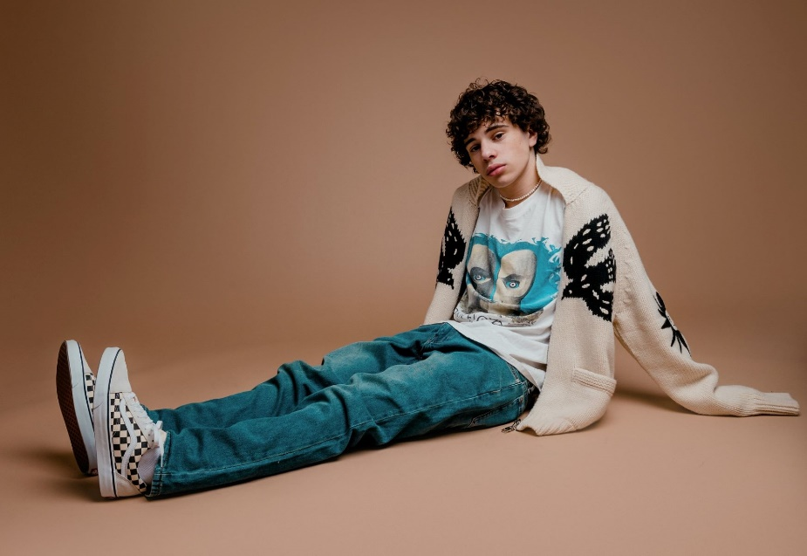
DOWNLOAD HI-RES PRESS PHOTOS (CREDIT: BRANDON PHILLIPS)

CONNECT:
WEBSITE | INSTAGRAM | YOUTUBE | TWITTER | FACEBOOK | TIKTOK | PRESS ASSETS

CONTACT:
Andrew George | andrew.george@atlanticrecords.com

