FOR IMMEDIATE RELEASE

MAY 15, 2020

ATLANTIC RECORDS UNLEASHES SCOOB! THE ALBUM

NEW SINGLE “ON ME” FROM THOMAS RHETT AND KANE BROWN FT. AVA MAX OUT NOW
LISTEN HERE AND WATCH THE OFFICIAL VIDEO HERE

WATCH THE ANIMATED VIDEO FOR “SUMMER FEELINGS”
FROM LENNON STELLA FT. CHARLIE PUTH HERE

BRAND NEW SONGS FROM RICO NASTY, JACK HARLOW, GALANTIS, FAOUZIA, R3HAB,
A R I Z O N A, PINK SWEAT$ AND MORE, PLUS BEST COAST’S REINVENTION OF THE ICONIC
“SCOOBY-DOO THEME SONG” AVAILABLE NOW

LISTEN TO SCOOB! THE ALBUM HERE

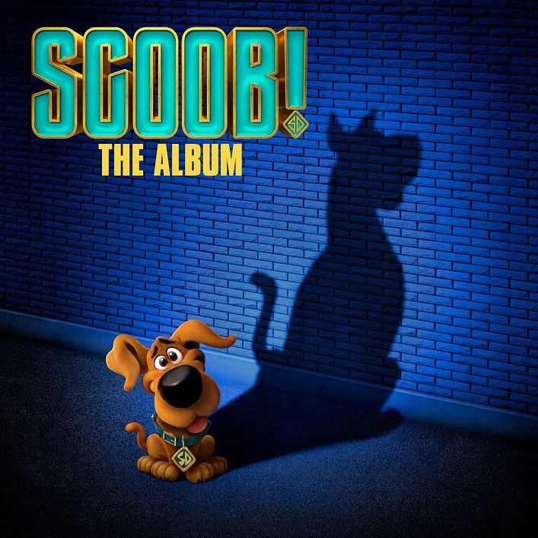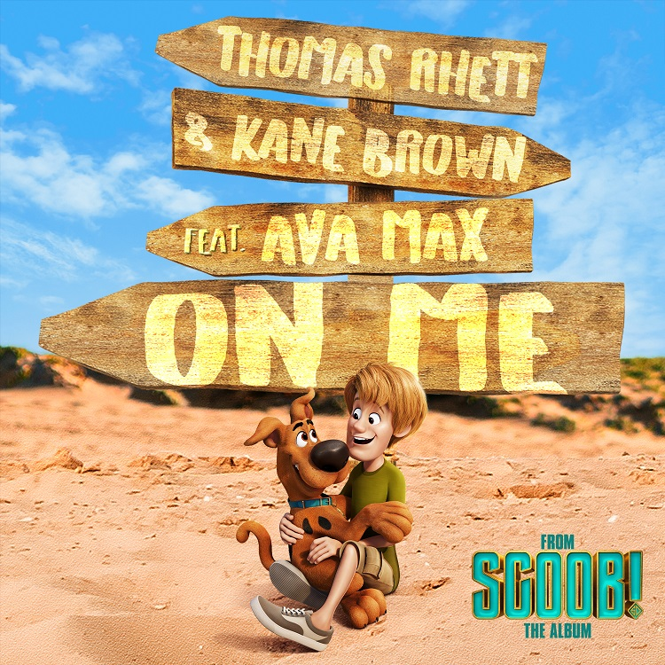
*DOWNLOAD HI-RES ART HERE*

Atlantic Records has officially unveiled SCOOB! THE ALBUM, the official musical companion to Warner Bros. Pictures and Warner Animation Group’s animated Scooby-Doo action adventure motion picture for the whole family. The soundtrack is now available globally at all retailers and streaming services and is highlighted by today’s release of the epic pop-country collaboration, “On Me” by country superstars Thomas Rhett & Kane Brown Ft. global pop sensation Ava Max – listen HERE. Watch the official video, which premiered earlier today on PEOPLE and features a mix of live-action footage shot in quarantine with animation from the film, streaming now on YouTube.

SCOOB! THE ALBUM launched earlier this week with feel-good lead single, “Summer Feelings” by singer-songwriter Lennon Stella Ft. multiple-GRAMMY nominated singer/songwriter/producer Charlie Puth. Produced by Invincible (“I Like It” – Cardi B), “Summer Feelings” garnered instant critical praise from Stereogum, Idolator and more. Listen HERE and watch the new animated video HERE.

Along with “Summer Feelings” and “On Me,” SCOOB! THE ALBUM features brand new songs and exclusive collaborations from an exciting array of major artists and rising stars, including Jack Harlow, Sage The Gemini Ft. BYGTWO3, Galantis Ft. Faouzia, Pink Sweat$, Rico Nasty, Rare Americans, R3HAB Ft. A R I Z O N A, Plested, and Token as well as an incredible reimagining of the iconic Scooby-Doo theme song from Best Coast (see tracklisting below). The soundtrack also arrives with the launch of an official video for Token’s new song, “Homies.” Watch the Massachusetts based rapper’s self-created visual now streaming at his official YouTube channel HERE.

SCOOB! THE ALBUM was executive produced by Xplicit. Additional key players involved in the creation of the album include Music Supervisor, Gabe Hilfer, A&R by Olly Sheppard and Executives in Charge of Music for Warner Bros. Pictures, Darren Higman and Niki Sherrod.

SCOOB! is available now for both Premium Video on Demand and premium digital ownership and features an all-star ensemble cast led by Will Forte, Mark Wahlberg, Jason Isaacs, Gina Rodriguez, Zac Efron, Amanda Seyfried, Kiersey Clemons, Ken Jeong, Tracy Morgan, Simon Cowell, and Frank Welker, as the voices of the Scooby-Doo gang and others from the Hanna-Barbera universe. Get ready for the fun-filled red carpet Twitter party at #ScoobMovieNight today at 7:00pm EST/4:00pm PST.

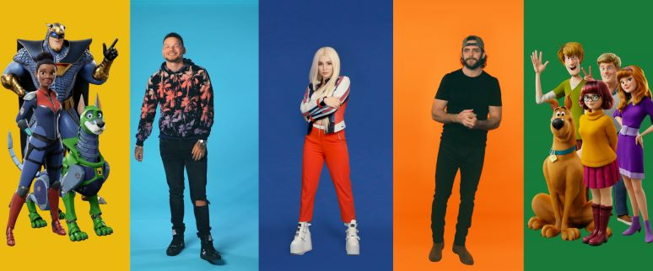
*DOWNLOAD HI-RES ART HERE*

ABOUT SCOOB!
SCOOB! is the never-before told stories of Scooby-Doo’s origins and the greatest mystery in the career of Mystery Inc. The fully animated, full-length action adventure reveals how lifelong friends Scooby and Shaggy first met and how they joined with young detectives Fred, Velma and Daphne to form the famous Mystery Inc. Now, with hundreds of cases solved and adventures shared, Scooby and the gang face their biggest, most challenging mystery ever: a plot to unleash the ghost dog Cerberus upon the world. As they race to stop this global “dogpocalypse,” the gang discovers that Scooby has a secret legacy and an epic destiny greater than anyone imagined.

SCOOB! is directed by Tony Cervone, Annie Award nominee for the feature, Space Jam, and two-time Emmy Award nominee for his work on Duck Dodgers. The film is produced by Pam Coats and Allison Abbate. Serving as executive producers are Adam Sztykiel, Charles Roven, Richard Suckle, Jesse Ehrman, Dan Povenmire, and Chris Columbus. The screenplay is by Adam Sztykiel and Jack C. Donaldson & Derek Elliott and Matt Lieberman, story by Matt Lieberman and Eyal Podell & Jonathon E. Stewart, based on characters created by Hanna-Barbera Productions.

A presentation of Warner Bros. Pictures and Warner Animation Group, SCOOB! is rated PG for some action, language and rude/suggestive humor.

“Scooby-Doo” and all related indicia are trademarks and copyright of Hanna-Barbera Productions © 2020 Warner Bros. Ent. All Rights Reserved.

www.scoob.movie
For downloadable press information, go to
https://mediapass.warnerbros.com

SCOOB! THE ALBUM
TRACKLIST

- Lennon Stella Feat. Charlie Puth – Summer Feelings
- Thomas Rhett and Kane Brown Feat. Ava Max – On Me
- Jack Harlow – Yikes
- Sage The Gemini Feat. BygTwo3 – Tick Tick Boom
- Galantis Feat. Faouzia – I Fly
- Pink Sweat$ - I Like It
- Rico Nasty – My Little Alien
- Rare Americans – Back Up Plan
- R3HAB Feat. A R I Z O N A – Feel Alive
- Plested – 25 Hours
- Token – Homies
- Best Coast - Scooby Doo Theme Song

PRESS ASSETS:
PRESS.ATLANTICRECORDS.COM/SCOOB-THE-ALBUM

PRESS CONTACT:
ANDREW GEORGE
ANDREW.GEORGE@ATLANTICRECORDS.COM

