SARA KAYS SHARES OFFICIAL VIDEO FOR “REMEMBER THAT NIGHT?”

INSTANT FAN FAVORITE SINGLE SURPASSES 13 MILLION GLOBAL STREAMS

MULTI-TALENTED SINGER-SONGWRITER’S CAMERA SHY EP OUT NOW

WATCH THE VIDEO FOR “REMEMBER THAT NIGHT?” HERE
LISTEN TO “REMEMBER THAT NIGHT?” HERE

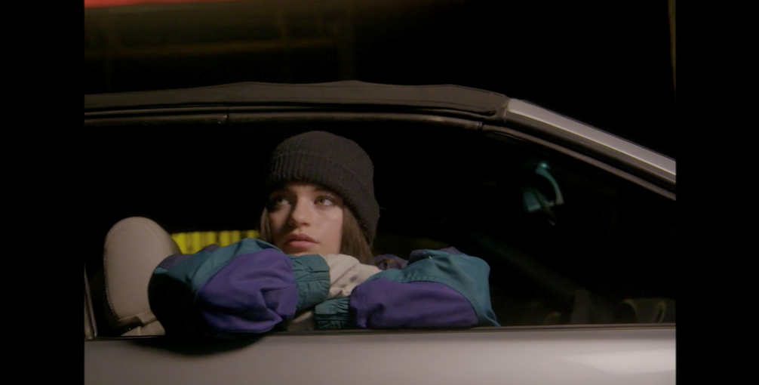
DOWNLOAD HIGH-RES VIDEO STILL

“In her first visual not shot on an iPhone, Kays also brings the song’s reflective lyrics to life…thinking back on an ex while the ruminative acoustic guitar and thumping beat of the song accompany her.” – FLOOD

Nashville-based solo songwriter, talented guitarist, and ukulele player Sara Kays is celebrating the success of her current single, “Remember That Night?,” with today’s arrival of her first-ever official music video, streaming now at YouTube.

“Remember That Night?” is fast proving a viral sensation, with over 13M global audio streams. The track’s incredible trajectory began when Kays performed a brief acoustic rendition of the then-unreleased song on her hugely popular TikTok. The short snippet immediately blew up, garnering nearly 3M views and over 720K likes in less than one week. Following the positive fan reaction, Kays worked quickly to officially finish and release the song.

Garnering 1.2M U.S. streams in its first week of release, “Remember The Night?” has continued its popular ascent, boosted by another blockbuster TikTok approaching nearly 18M views. Billboard declared it one of “10 Cool New Pop Songs,” praising “the full-bodied nature of (Kays’) songwriting, which tells the story of post-breakup wistfulness while the vocals are layered during the most piercing stray thoughts. Gorgeous and delicate -- but with a hook that can go viral, too.”

Receiving her first guitar as a gift at 12 years old, Kays often busked for two-to-three hours at local restaurants multiple times per week in high school. She then met producer Steven Martinez and took a trip to Nashville to record with him. Dropping “Rich Boy” in 2018, the rising artist has since amassed 1.3M TikTok followers, building an audience that feels more like a supportive community.

“Remember That Night?” follows this fall’s release of Kays’ EP, Camera Shy. The seven-track EP arrived after the breakthrough success of Sara’s emotionally vulnerable streaming favorites, “No Matter The Season,” “Smaller Than This,” and “Chosen Last.” Highlighted by the confessional single, “I’m Okay Though,” the EP also features new songs including “High School” and “Same House.” Camera Shy showcases Kays’ uniquely comforting, cathartic, and catchy brand of alternative pop which she writes and records all on her own. The EP, which has garnered over 12M worldwide streams to date, sees the 21-year-old artist turning her internal struggles with isolation, body image, and a fractured family into bravely candid acoustic songcraft that captures her personal fears while simultaneously offering listeners relief through relatable storytelling.

Kays has earned a wide range of media attention with Alternative Press naming her one of “50 New Artists You Need To Hear In November” while Idolator declared her a “breakout star,” adding, “Kays has built a loyal following with alt-leaning, emotionally-raw pop songs…which explore themes like body image, otherness and the final, fleeting days of adolescence…on the 21-year-old’s excellent Camera Shy EP.” “In her debut EP, Camera Shy, Sara boasts a 7-track collection of original songs that help to capture the authenticity of her messages to fans,” raved POPULAR.

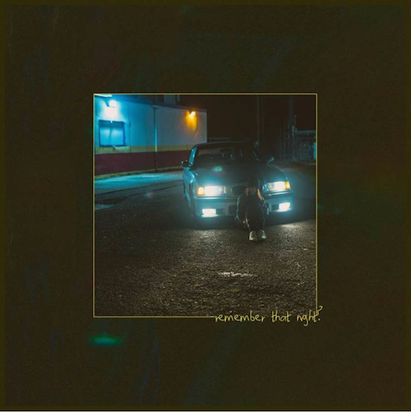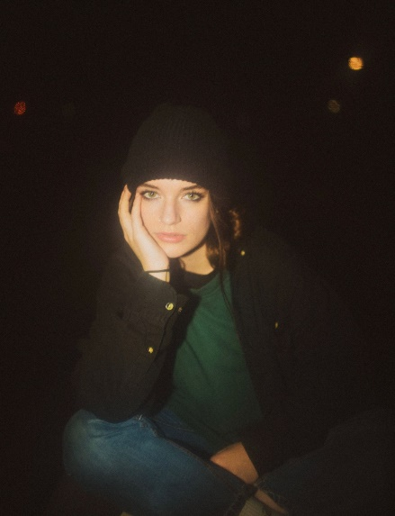
DOWNLOAD HIGH-RES ARTWORK

CONNECT WITH SARA KAYS:
TIKTOK | TWITTER | INSTAGRAM | YOUTUBE | PRESS ASSETS

PRESS CONTACT:
ANDREW.GEORGE@ATLANTICRECORDS.COM

