FOR IMMEDIATE RELEASE
AUGUST 6, 2021

SARA KAYS UNVEILS STRUCK BY LIGHTNING EP

TITLE TRACK FEAT. CAVETOWN ARRIVES ALONGSIDE TENDER MUSIC VIDEO

INTERNATIONAL HEADLINE STRUCK BY LIGHTNING TOUR KICKS OFF OCTOBER 9TH
TICKETS ON SALE NOW HERE

LISTEN TO THE STRUCK BY LIGHTNING EP HERE
WATCH THE VIDEO FOR “STRUCK BY LIGHTNING” HERE

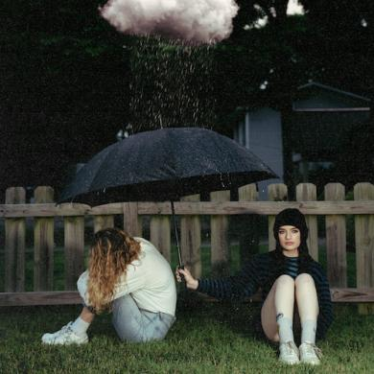
DOWNLOAD HIGH-RES ARTWORK

“Sara Kays’ music has something to offer for everyone.” – PEOPLE

“Sara Kays knows what it takes to craft heartfelt lyrics spun with velvet, tight-knit arrangements that simply elevate the already high-flying material.” – AMERICAN SONGWRITER

“One Of Pop Music’s Breakout Stars” – HUFFPOST

Acclaimed Nashville-based singer-songwriter Sara Kays has unveiled her Struck By Lightning EP available now via Atlantic Records at all DSPs and streaming services HERE. Including her viral breakup anthem, “Remember That Night?”, the EP is highlighted by the new single and title track featuring UK-based indie pop artist Cavetown. Capturing the nuances of Sara’s confessionally quirky lyrics, glassy melodies, and chantable observations, “Struck By Lightning (Ft. Cavetown) is accompanied by an official music video co-starring both artists and streaming now via YouTube HERE.

“A friend of mine struggled a lot with depression and didn’t necessarily always talk to me about it,” said Sara. “It can be frustrating when you know someone’s going through something, but they won’t say anything. So, the idea is, ‘I’ll sit out there with you in silence.’ Around the same time, my ‘For You’ page had a ton of trending videos of people laying down in driveways in the rain. I brought all of that together, and it was really cool to duet with Cavetown. I’m basically saying, ‘I’d get struck by lightning for you.’”

Having cultivated an intensely engaged and supportive audience nearing 2M followers on TikTok Sara is disarmingly raw about everything from body image to mental health. The Indiana-born artist continues to make a heart-to-heart connection on her new 7-track collection. Profiled for Billboard’s “Emerging Artists Spotlight” and named among People’s “Talented Emerging Artists Making Their Mark on the Musical Landscape,” Kays assembled the Struck By Lightning EP over the past year, teasing its arrival with “Backseat Rider,” “Traffic Lights,” “Future Kids,” and “Picture Of You.” In addition to her collaboration with Cavetown, the EP also features Sara’s bitterly honest new song, “Freeze.” Observations, thoughts, and truths straight from the Notes app on her phone inform diary-style stories spotlighted by gentle acoustic guitar, soft ukulele, and a keyboard murmur.

The 22-year-old will celebrate the EP release with her first ever international headline tour. The Struck By Lightning Tour begins October 9th at San Francisco, CA’s Brick & Mortar Music Hall and then travels North America and Europe through late November. Kays will bookend her headline tour with a US run alongside Mt. Joy (August 24-29) and a UK tour supporting Cavetown (December 2-15). For complete details and ticket availability, please visit www.sarakays.com/tour.

Last year, Kays’ Camera Shy EP racked up over 100M streams on the strength of fan favorites such as “Chosen Last,” “Smaller Than This,” and “Home For The Summer.” On its heels, she posted a clip of the then unreleased “Remember That Night?” on TikTok which exploded to the tune of 3 million views. Now, the official audio has eclipsed 200M global streams. Meanwhile, she crashed the Rolling Stone “Breakthrough 25” chart, earned her first Top 10 on any Billboard chart, and made her national television debut with a performance on The Late Show with Stephen Colbert (streaming HERE).

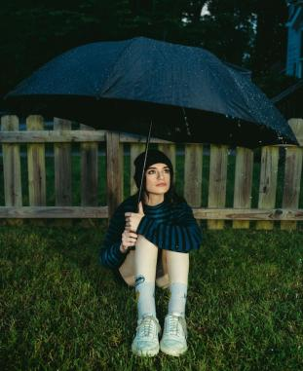
DOWNLOAD HI-RES IMAGES

SARA KAYS
STRUCK BY LIGHTNING EP
(Atlantic Records)

TRACKLIST:
1. Struck By Lightning (Ft. Cavetown)
2. Remember That Night?
3. Traffic Lights
4. Backseat Rider
5. Freeze
6. Future Kids
7. Picture Of You

SARA KAYS ON TOUR 2021

MT. JOY TOUR SUPPORT DATES
8/24 – Denver, CO – The Mission Ballroom
8/25 – Salt Lake City, Utah – The Depot
8/27 – Boise, ID – The Knitting Factory
8/28 – Seattle, WA – The Moore Theatre
8/29 – Portland, OR – Roseland Theater

STRUCK BY LIGHTNING HEADLINE TOUR
10/9 – San Francisco, CA – Brick & Mortar Music Hall – PURCHASE HERE
10/12 – Los Angeles, CA – The Echo – PURCHASE HERE
10/14 – New York, NY – Mercury Lounge – PURCHASE HERE
10/17 – Atlanta, GA – Vinyl – PURCHASE HERE
10/19 – Toronto, ON – Rivoli – PURCHASE HERE
10/20 – Chicago, IL – Schubas – PURCHASE HERE
10/22 – Nashville, TN – The Basement – PURCHASE HERE
11/16 – Stockholm, Sweden – Obaren
11/17 - Oslo, Norway – Parkteateret
11/18 – Copenhagen, Denmark – Ideal Bar
11/20 – Hamburg, Germany –Turmzimmer
11/22 – Cologne, Germany – Helios
11/23 – Amsterdam, Netherlands – Paradiso Upstairs
11/25 – Berlin, Germany – Privatclub
11/27 – Antwerp, Belgium – Kavka
11/29 – Paris, France – Pop Up Du Label

CAVETOWN TOUR SUPPORT DATES
11/30 – Leeds, UK – Stylus
12/2 – Glasgow, UK – O2 Academy
12/4 – Birmingham, UK – Institute
12/5 – Manchester, UK – Academy
12/7– Nottingham, UK – Rock City
12/9 – Brighton, UK – Chalk
12/10 – Cambridge, UK – Junction
12/11 – London, UK – Roundhouse
12/13 – Bristol, UK – SWX

CONNECT WITH SARA KAYS:
TIKTOK | TWITTER | INSTAGRAM | facebook | YOUTUBE | PRESS ASSETS

PRESS CONTACT:
ANDREW.GEORGE@ATLANTICRECORDS.COM

