FOR IMMEDIATE RELEASE
FEBRUARY 18, 2022

SARA KAYS SHARES “WHEN YOU LOOK AT ME”

ACCLAIMED SINGER-SONGWRITER CELEBRATES BIRTHDAY WITH NEW SINGLE

SET TO JOIN ALEC BENJAMIN ON TOUR THIS SPRING

LISTEN TO “WHEN YOU LOOK AT ME”
WATCH OFFICIAL LYRIC VIDEO

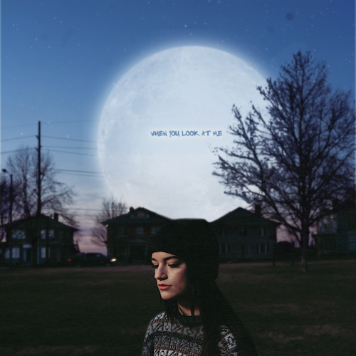
DOWNLOAD HIGH-RES ART + PRESS PHOTOS (CREDIT: CHASE DENTION)

RIAA gold-certified singer-songwriter Sara Kays is celebrating her birthday with today’s premiere of her eagerly awaited new single. “When You Look At Me” is available now via Atlantic Records at all DSPs and streaming services with an official lyric video streaming at YouTube.

The acclaimed Nashville-based musician recently shared an early demo of “When You Look At Me” on her hugely popular TikTok and almost immediately earned more than 1.7M views and close to 500K likes. In trademark fashion, Sara was inspired by the response and quickly hit the studio to record an official version of the song.

“‘When You Look At Me,’ is about feeling like the person you’re with doesn’t look at you the same anymore, or act like they used to around you,” Sara shares. “I wrote this song about a month ago when I was feeling that way in my relationship, and decided to record it shortly after that while it was still real to me.”

To further mark the occasion, Kays has unveiled plans to support one of her favorite artists, Alec Benjamin, on tour this spring with dates kicking off April 9th at Spokane, WA’s Knitting Factory and traveling through mid-May (full itinerary below). For details and ticket information, please visit www.sarakays.com/tour.

2021 proved a landmark year for Kays, with multiple highlights including her first-ever headline tour, international performances supporting Cavetown in the UK, and her late night TV debut performance of the RIAA gold-certified breakthrough hit, “Remember That Night?” on The Late Show with Stephen Colbert (streaming HERE).

Having cultivated an intensely engaged and supportive audience on TikTok nearing 2M followers, Sara is disarmingly raw about everything from body image to mental health as proven on her 2021 Struck By Lightning EP. Observations, thoughts, and truths straight from the Notes app on her phone inform diary-style stories spotlighted by gentle acoustic guitar, soft ukulele, and a keyboard murmur. Profiled for Billboard’s “Emerging Artists Spotlight” and named among People’s “Talented Emerging Artists Making Their Mark on the Musical Landscape,” the Indiana-born artist teased the EP’s arrival with “Backseat Rider,” “Traffic Lights,” “Future Kids,” and “Picture Of You.” In addition to her collaboration with Cavetown on the title track, which arrived alongside a music video co-starring both artists (watch HERE), the EP features the bitterly honest “Freeze” and is highlighted by her viral breakup anthem, “Remember That Night?” for which the video has surpassed over 11.5M views via YouTube HERE.

WHAT CRITICS ARE SAYING ABOUT SARA:

“Sara Kays’ music has something to offer for everyone.” – PEOPLE

“Sara Kays knows what it takes to craft heartfelt lyrics spun with velvet, tight-knit arrangements that simply elevate the already high-flying material.” – AMERICAN SONGWRITER

“Normalizing life’s struggles that often seem easier to avoid, Sara has carved out a unique space…quickly creating a community through her message.” – FLAUNT

“Sara Kays has cultivated a devoted following by wearing her heart on her sleeve. The rapidly rising artist's growing fanbase is a testament to her understated gift for empathetic songwriting.” – ONES TO WATCH

“One Of Pop Music’s Breakout Stars” – HUFFPOST

SARA KAYS ON TOUR 2022
4/9 – Spokane, WA – Knitting Factory
4/10 – Boise, ID – Knitting Factory
4/13 – Eugene, OR – McDonald Theatre
4/19 – Las Vegas, NV – House Of Blues Las Vegas
4/26 – Albuquerque, NM – El Rey Theater
4/28 – Oklahoma City, OK – Diamond Ballroom
4/29 – Kansas City, MO – The Truman
4/30 – St. Louis, MO – The Pageant
5/1 – Omaha, NE – The Admiral
5/3 – Madison, WI – The Sylvee
5/4 – Indianapolis, IN – Egyptian Room @ Old National Centre
5/5 – Cincinnati, OH – Bogart’s
5/6 – Grand Rapids, MI – GLC Live at 20 Monroe
5/9 – Columbus, OH – KEMBA LIVE!
5/10 – Pittsburgh, PA – Roxian Theatre
5/11 – Buffalo, NY – Town Ballroom
5/13 – South Burlington, VT – Higher Ground Ballroom
5/14 – Providence, RI – The Strand
5/15 – Portland, ME – State Theatre

CONNECT WITH SARA KAYS:
TIKTOK | TWITTER | INSTAGRAM | facebook | YOUTUBE | PRESS ASSETS

PRESS CONTACT:
ANDREW.GEORGE@ATLANTICRECORDS.COM

