FOR IMMEDIATE RELEASE
THURSDAY, NOVEMBER 11TH

LISTEN TO FLOWERKID’S DEBUT EP ‘EVERYONE HAS A BREAKING POINT’

LISTEN HERE | DOWNLOAD ASSETS
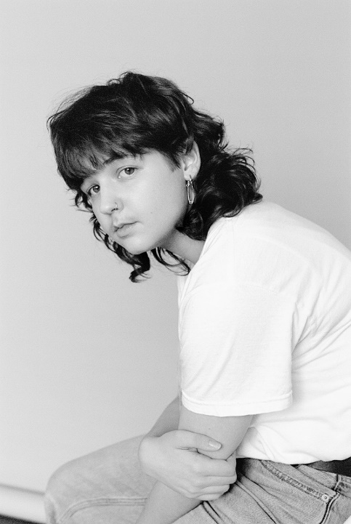
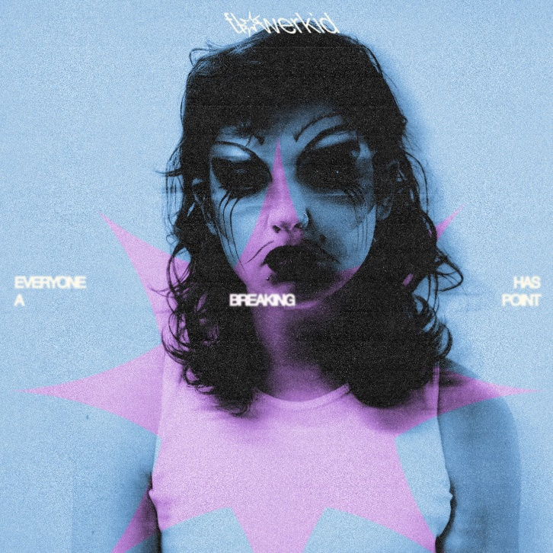

(Download Hi-Res Photos + Art HERE – Credit: Joe Brennan)

flowerkid — the moniker of 20-year-old, Sydney-based, singer-songwriter-producer Flynn Sant — has shared his transcendent debut EP everyone has a breaking point, available everywhere now. Listen HERE.
The revelatory release is the natural culmination of flowerkid’s years of introspection and art-making. Featuring singles like ‘miss andry’, the gripping collaboration ‘It’s Happening Again’ with LA-based Australian-native KUCKA, the gut-wrenching ‘vodka orange juice’ and new songs ‘I Met The Devil At 4 Years Old’, ‘Take Two’ and ‘Why Bother’, Flynn’s uncompromising vulnerability and bare-souled approach is unmatched.

LISTEN TO “I MET THE DEVIL AT 4 YERS OLD” HERE

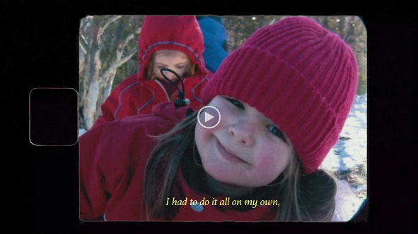
Confessional and clear-minded, relatable and raw, Flynn is anything but timid as he leads the listener through the pain and beauty of his coming of age. Conceived from personal experience and his most intimate observations, his songs manage to hum with universal relevance. It’s the kind of music that by sharing, encourages you to share — to consider your own life and concealed pain. It also offers to do that alongside you, guiding you through with tender confidence. Like an outstretched arm or a knowing glance, everyone has a breaking point is pop at its most empathetic.
With glowing reviews and streaming numbers that stretch well into the multi-millions, Flynn has been met with international praise at each release. From his cathartic debut ‘late night therapy’ and the reflective follow up ‘boy with the winfields and the wild heart’, through to songs lifted from the EP, Flynn has been championed by the likes of triple j, BBC Radio 1, Billboard, The Guardian and NME, to name but a few.

everyone has a breaking point EP TRACKLIST
1. It’s Happening Again
2. Miss Andry
3. vodka orange juice
4. Take Two
5. Why Bother
6. I Met The Devil At 4 Years Old

ABOUT FLOWERKID
flowerkid has always drawn on his most intimate observations to craft music well beyond his years. Whether the voice memo melodies he’d record as a teenager or the tracks that fill his soaring debut EP everyone has a breaking point, this has long been the sound of necessity.

Growing up in Western Sydney, Flynn first fell into music after his aunt gifted him an old Yamaha keyboard. It revealed a natural obsession as he quickly began teaching himself to write and produce fledgling tracks while hidden away in his teen bedroom.

Released when he was just 16, his debut ‘Late Night Therapy’ was just that — an opportunity to process his own emotions. "I really didn't know that I was capable of expressing my thoughts in that way. It was all very new to me and I thought, 'This is perfect. It feels so good to be able to do this'."

Gradually coming to understand that he was trans, in the midst of Catholic school and a breakup with his first love, Flynn leaned into songwriting above all out of his need to vent. The overwhelming response to the song proved that Flynn wasn’t alone in that respect. Brutally honest and engaging, his trademark generosity as an artist saw him start to amass a following that has only grown in dedication over the ensuing years.

flowerkid maintained that bare-souled approach with sophomore single ‘boy with the winfields and the wild heart’, and in the releases following. Now in the latter half of 2021, flowerkid returns with his revelatory debut EP. “I want us to lose ourselves hand in hand,” Flynn explains, “on this ethereal and spiritual musical journey I created for us. Please listen and watch as my internal and external struggles flourish into bloom. I can’t wait for you to hear this excerpt of my heart and soul.”

CONNECT:
PRESS ASSETS | INSTAGRAM | SPOTIFY | YOUTUBE | SOUNDCLOUD | FACEBOOK

CONTACT:
ANDREW.GEORGE@ATLANTICRECORDS.COM

