FOR IMMEDIATE RELEASE
FRIDAY, SEPTEMBER 18TH

FLOWERKID RETURNS WITH 'MISS ANDRY'
LISTEN HERE | WATCH THE OFFICIAL VIDEO HERE

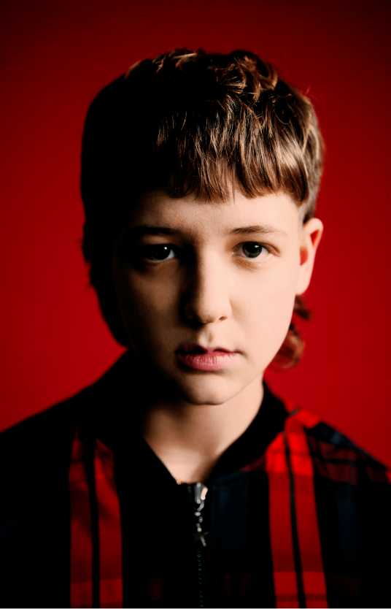
(Download Hi-Res Photos + Art HERE – Credit: Levon Baird)

flowerkid, the musical project of 19-year-old Flynn Sant, has shared his compelling new single 'miss andry' after its premiere on triple j last night. Written and produced by flowerkid, the song grapples with difficult emotions born of painful childhood experiences. Over propellant drums and distorted synths, flowerkid grabs a hold of weighty ideas and forces his listeners to face them too.

Watch the powerful video, directed by Madeleine Purdy and shot in Flynn’s hometown of Sydney HERE:

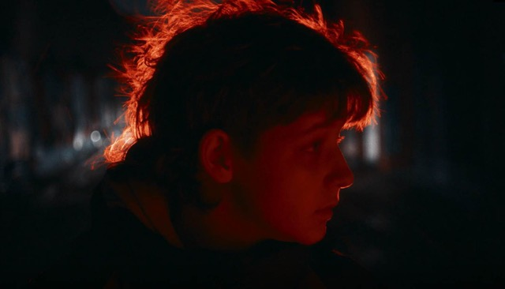

"This song roots from a hatred and distrust for men that developed from such a young age," explains Flynn. Events he experienced himself compounded with stories of injustice – told to him by friends and from people around the world – to produce a unique kind of misandry that was only complicated further when Flynn came out as trans two years ago. "It isn't your typical man hatred; I had to tackle the feeling of: I hate these boys and these men that have been in my life so much. Why do I envy them though?"

In his lyrics, Flynn compares himself to the size and smells of men around him and chastises himself for doing so. "I will always feel this inadequacy with any cisgender man … but when I made this song, I needed to regroup and basically take responsibility. I'd say, you know, 'It isn't healthy to be thinking these things. I feel this way because of the events that happened in my life and childhood trauma I've experienced. But it's not an excuse to hate all men'."

He hopes 'miss andry' creates a similar opportunity for people to connect, even if creating it has been confronting. "When I made the song, I was terrified because it was so truthful. It was so raw. It was like ripping myself open for everyone to see. There's this whole new level of anger to it that I don't necessarily like to show. But I think being honest about it will help me resolve those feelings." It's been a journey to be this honest – with himself, and now with his audience – but Flynn says he can't imagine making music any other way. flowerkid floats between genres, but the sentiment that connects everything is brutal honesty in his writing, and a sound that's full of emotion and full of life.

'miss andry' is flowerkid’s second single and the follow up to his breakthrough debut ‘Boy With The Windfields and the Wild Heart’, which received huge support on triple j and over a million streams on DSPs, revealing flowerkid to be one of Australia’s most exciting young songwriters.

The single and video release follows Monday’s announcement of flowerkid's global team.

CONNECT:
PRESS ASSETS | INSTAGRAM | SPOTIFY | YOUTUBE | SOUNDCLOUD | FACEBOOK

CONTACT:
ANDREW.GEORGE@ATLANTICRECORDS.COM

