FOR IMMEDIATE RELEASE
THURSDAY, OCTOBER 7TH

FLOWERKID FINDS CATHARSIS IN NEW SONG
‘vodka orange juice’

DEBUT EP ‘EVERYONE HAS A BREAKING POINT’ OUT NOVERMBER 11TH

LISTEN HERE | WATCH THE OFFICIAL VIDEO HERE

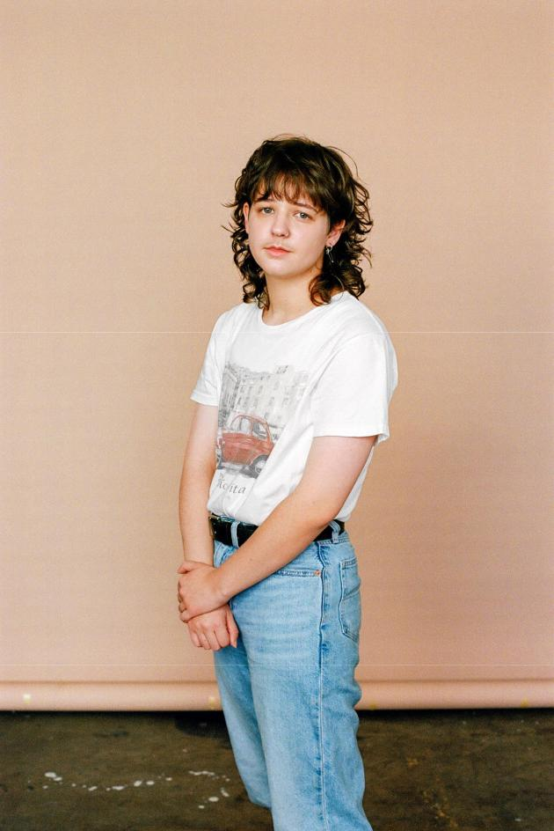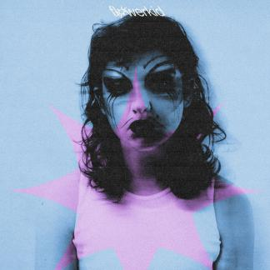
(Download Hi-Res Photos + Art HERE – Credit: Joe Brennan)

'She said “The girls want a real boy and you’re not that"'

So goes a line in flowerkid’s (aka 20-year-old Sydney artist Flynn Sant) affecting new song ‘vodka orange juice’, wherein his delicate vocal and restrained sonics bely the sucker-punch of the lyrics. With his now-trademark brutal honesty, flowerkid paints an impression of his personal experience of coming out as trans as a teenager that stays with you long after the first listen. Listen HERE.

flowerkid says: "The track is about all the times people have said things like this to me - at parties, at bars and clubs. Over time, it becomes strenuous to fight these people. They are threatened by what they can’t understand (or haven’t tried to) and it takes a massive toll on me personally.

It was hugely cathartic writing this song. I was on the coast in a caravan by the water, reflecting on my past. I did it in one take and started crying by the time I got to the last chorus. I hope when other people are listening to this, they feel the same way.

If you are listening and feel like you are not accepted for who you are - please know that you are loved. My heart goes out to all of you. flowerkid xx”

The recording is accompanied by a transfixing new video directed by Bailey Watts, which plays with the concepts of gender, drag and metamorphosis. Listen/Watch HERE.

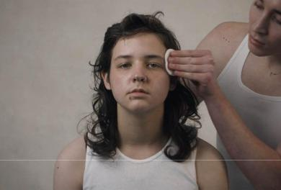

'vodka orange juice’ follows the equally revelatory ‘It’s Happening Again feat. KUČKA’ released this past July and comes with the announcement of flowerkid’s debut EP, Everyone Has A Breaking Point, out November 11th.

ABOUT FLOWERKID

As a child, flowerkid (the moniker of Flynn Sant) was drawn to music, and began teaching himself to play, write and produce after being gifted his aunt’s old Yamaha keyboard. Playing around on that, on the ukulele, and singing into the voice memos app on his iPod eventually lead to locking himself away in his room to pour his pent-up feelings into tracks like 'Late Night Therapy', a song whose title reflects what it offered for Flynn when he made it at age 16.

In 2019, Flynn left the Catholic school that provided a daily struggle. He began writing as a way to process the overwhelming feeling of having so much love to give but not knowing what to do with it. This confessional, bared-soul approach would typify what flowerkid became, and with each release Flynn bravely opens himself up to an audience that’s grown significantly over the past two years.

'boy with the winfields and the wild heart' tapped into the spiritual connection Flynn has always felt with an uncle who took his own life before Flynn was born. The response to the song – which received glowing reviews on triple j Unearthed and millions of streams – has revealed to Flynn the potential and power in sharing his story, with listeners all over the world reaching out to him to share their own experiences of loss, depression and suicide.

'miss andry’ created a similar opportunity for people to connect, even though creating it was confronting. Written and produced by flowerkid, the song grappled with difficult emotions borne of painful childhood experiences. Over propellant drums and distorted synths, he grabbed a hold of weighty ideas and forced his listeners to face them too.

Then came ‘It’s Happening Again’, a gripping collaboration with LA-based, Australian-native KUČKA. Released in July this year, the song marked the beginning of a new period of expression and healing for the young songwriter with Flynn sharing: “It’s Happening Again featuring the beautiful KUČKA, and what will follow soon afterwards, has been everything I have thought about for a very long time. And this body of work is a feeling that has been bottled up inside me for all of my existence on this earth. I want us to lose ourselves hand in hand, on this ethereal, spiritual, and timeless musical journey I created for us. Please listen and watch, as my internal and external struggles flourish into bloom. I can’t wait for you to hear this excerpt of my heart and soul."

CONNECT:
PRESS ASSETS | INSTAGRAM | SPOTIFY | YOUTUBE | SOUNDCLOUD | FACEBOOK

CONTACT:
ANDREW.GEORGE@ATLANTICRECORDS.COM

