PA SALIEU IS “GLIDIN’” ON NEW SINGLE FEAT. SLOWTHAI
STREAM “GLIDIN’ (FEAT. SLOWTHAI)” HERE | WATCH “GLIDIN’ (FEAT. SLOWTHAI)” HERE
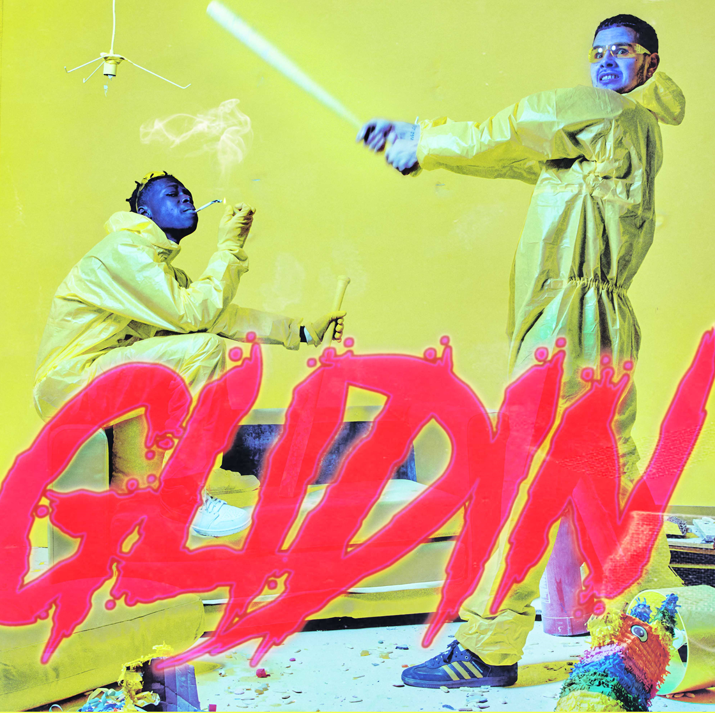

Quicky-rising British rapper Pa Salieu has enlisted the help of fellow UK rapper slowthai for his newest track, both of whom are known for their politically-charged lyrics and standout flows. “Glidin’” is streaming now via DSPs and streaming services HERE alongside its lively music video streaming now via YouTube HERE.
The 23-year-old Pa recently released his debut project, Send Them To Coventry. Send Them To Coventry is the realization Pa Salieu's distinct take on UK rap that he's showcased across his early releases. It's a release that built around his singular voice, but also that of rising UK artists like Mahalia and M1llionz, Trinidad artist Boy Boy and UK singer Eight9Fly, alongside those of emerging rappers from his hometown on "Active" (Ni Santora, Lz Dinero, Stizee and Shakavellie). The project includes his previously-released singles "B***K," "Frontline," "Betty," and "My Family"
Few artists are able to create the groundswell of excitement and support the way that Pa has in such a short amount of time. Mobilizing specialist support with the massive "Frontline" at the start of the year, which was not only the second song the gifted young artist ever recorded but also one of the most played tracks at BBC 1Xtra this year, Pa continued to both innovate and refine his singular style with the release of double singles "Bang Out" and "Betty" in May, the latter of which sampled new romantic hero David Sylvian. Since then, Pa has collaborated with a range of artists from SL to jazz virtuoso Yussef Dayes, not to mention his Burberry x The Face project with Black Midi’s Morgan Simpson, and won over a laundry list of champions that include Burberry’s Riccardo Tisci, OVO co-founder Oliver El-Khatib, Annie Mac, Tiffany Calver, Benji B, FKA twigs and Virgil Abloh amongst others, cementing him as an artist whose unique style both defies labels. Pa kicked off this year with a performance of his breakout hit “Frontline” on The Tonight Show Starring Jimmy Fallon. Watch the captivating performance HERE.

Connect with Pa Salieu
Instagram | Twitter | Facebook

(Download hi-res assets HERE)

"[Pa Salieu] carved out a lane of his own"
Complex

"Pa Salieu Will Make You Feel Heard"
DJ Booth

"Coventry’s hopeful rap star"
The FADER

"Pa Salieu presents black suffering in its diasporic complexity"
Pitchfork

