RICHMOND VIRGINIA’S OWN TRAPTIZE KY MARKS HIS RETURN WITH “NO HOOK”

WATCH THE OFFICIAL VIDEO HERE

BACK I GO AVAILABLE NOW
AT ALL DSPS AND STREAMING SERVICES

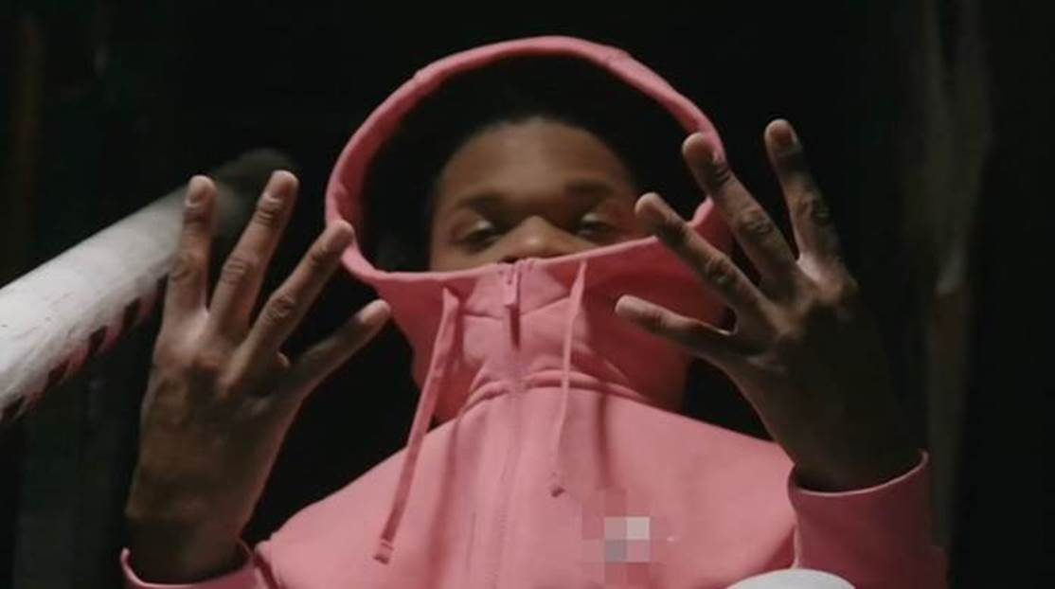

Rising rapper Traptize Ky is a force, making his long-awaited return in 2021 with a brand new single and video release, “No Hook.” The fast-paced record highlights Ky’s lyrical abilities, with a catchy flow that fans will love—check out the accompanying visual HERE.

“No Hook” arrives after “White Tee,” his memorable single released last September; check out the official video HERE. “White Tee” was celebrated by the launch of a special contest for fans, where the rapper gave away custom merch from his collaboration with designer Earl Mack. Last year, Traptize Ky also unveiled his touching single “Streets vs. Amerika,” second of the rapper’s releases since his mixtape, Back I Go. The 14-track project, which has amassed over 1.3 million streams since its release, is at turns shockingly sophisticated and full of heart. In addition, the anthem “Streets vs. Amerika” is an example of the ways in which Traptize Ky has utilized his platform and talents to make a statement surrounding all of the injustices faced by black people and people of color worldwide.

Back I Go was celebrated with an official video for “Poverty Gospel,” a chilling melody that speaks to his experiences growing up in Virginia's "Small City.” Earlier, Traptize Ky introduced an eye-catching visual for another one of the standout tracks on Back I Go, “They Ain’t”; watch HERE. The rapper made his mark as an artist to watch in early 2019, with the release of “All Whites,” an infectious Virginia staple that took the streets and the internet by storm. Now, in 2021 with his upcoming new releases fans can be assured that he is just getting started.

CONNECT WITH TRAPTIZE KY
INSTAGRAM
YOUTUBE
TWITTER
FACEBOOK

FOR ALL INQUIRIES, CONTACT:
ARIANA WHITE
ARIANA.WHITE@ATLANTICRECORDS.COM

# # #

