**RICO CARTEL JOINS TOOSII FOR NEW SINGLE AND VIDEO "2 PILLS"**

**WATCH THE OFFICIAL VIDEO** [**HERE**](https://nam04.safelinks.protection.outlook.com/?url=https%3A%2F%2Fricocartel.lnk.to%2F2PillsVideo&data=04%7C01%7CVeronica.Lainey%40atlanticrecords.com%7C1de1fceb8a964083ab2608d8e50399d7%7C8367939002ec4ba1ad3d69da3fdd637e%7C0%7C0%7C637511150924175351%7CUnknown%7CTWFpbGZsb3d8eyJWIjoiMC4wLjAwMDAiLCJQIjoiV2luMzIiLCJBTiI6Ik1haWwiLCJXVCI6Mn0%3D%7C1000&sdata=qRCc2l%2F2h7pXlz4oN4egGCMig%2FytNXFHdif9SC0YO%2B8%3D&reserved=0)

**"2 PILLS (FEAT. TOOSII)" AVAILABLE NOW VIA ALL DIGITAL RETAILERS AND STREAMING PLATFORMS**[**HERE**](https://nam04.safelinks.protection.outlook.com/?url=https%3A%2F%2Fricocartel.lnk.to%2F2Pills&data=04%7C01%7CVeronica.Lainey%40atlanticrecords.com%7C1de1fceb8a964083ab2608d8e50399d7%7C8367939002ec4ba1ad3d69da3fdd637e%7C0%7C0%7C637511150924185307%7CUnknown%7CTWFpbGZsb3d8eyJWIjoiMC4wLjAwMDAiLCJQIjoiV2luMzIiLCJBTiI6Ik1haWwiLCJXVCI6Mn0%3D%7C1000&sdata=iJYkIzbKzKepyTk4mDjXezD%2F2TPJq%2FmgEfcCZ7bVxdI%3D&reserved=0)



Today, Rico Cartel announced the release of a striking new collaboration with singer/songwriter Toosii, "2 Pills." The record is now available via all digital retailers and streaming platforms [HERE](https://nam04.safelinks.protection.outlook.com/?url=https%3A%2F%2Fricocartel.lnk.to%2F2Pills&data=04%7C01%7CVeronica.Lainey%40atlanticrecords.com%7C1de1fceb8a964083ab2608d8e50399d7%7C8367939002ec4ba1ad3d69da3fdd637e%7C0%7C0%7C637511150924185307%7CUnknown%7CTWFpbGZsb3d8eyJWIjoiMC4wLjAwMDAiLCJQIjoiV2luMzIiLCJBTiI6Ik1haWwiLCJXVCI6Mn0%3D%7C1000&sdata=iJYkIzbKzKepyTk4mDjXezD%2F2TPJq%2FmgEfcCZ7bVxdI%3D&reserved=0). In addition, Rico Cartel unveiled an official companion video available now via YouTube [HERE](https://nam04.safelinks.protection.outlook.com/?url=https%3A%2F%2Fricocartel.lnk.to%2F2PillsVideo&data=04%7C01%7CVeronica.Lainey%40atlanticrecords.com%7C1de1fceb8a964083ab2608d8e50399d7%7C8367939002ec4ba1ad3d69da3fdd637e%7C0%7C0%7C637511150924195262%7CUnknown%7CTWFpbGZsb3d8eyJWIjoiMC4wLjAwMDAiLCJQIjoiV2luMzIiLCJBTiI6Ik1haWwiLCJXVCI6Mn0%3D%7C1000&sdata=tNK8EZ%2FpxGpp%2BHGV23IlhgwU1E7su6FTfnjCNo%2FYLvk%3D&reserved=0). Hailing from West Orlando, Florida, Rico Cartel has a signature sound and raw talent that is perfectly represented when paired with Toosii's harmonious vocals.

Last month, the 21-year old rapper arrived with his third official single, “Fat Bankroll.” The release was accompanied by an official music video for the track, watch it now via Rico Cartel’s official YouTube channel [HERE](https://nam04.safelinks.protection.outlook.com/?url=https%3A%2F%2Fricocartel.lnk.to%2FFatBankrollVideo&data=04%7C01%7CVeronica.Lainey%40atlanticrecords.com%7C1de1fceb8a964083ab2608d8e50399d7%7C8367939002ec4ba1ad3d69da3fdd637e%7C0%7C0%7C637511150924205224%7CUnknown%7CTWFpbGZsb3d8eyJWIjoiMC4wLjAwMDAiLCJQIjoiV2luMzIiLCJBTiI6Ik1haWwiLCJXVCI6Mn0%3D%7C1000&sdata=IWacXGSAt2E2UDm6SCvxSm%2B%2BwykreUEERxuN%2BPrK5x4%3D&reserved=0).

Rico's latest collaboration "2 Pills (Feat. Toosii)" along with “Fat Bankroll” were preceded by the memorable “[I Like](https://nam04.safelinks.protection.outlook.com/?url=https%3A%2F%2Fwww.youtube.com%2Fwatch%3Fv%3DXzw7g900iCA%26feature%3Dyoutu.be%26src%3DLinkfire%26lId%3D7c7e5596-480b-4311-b311-b5c48b0b5863%26cId%3Dd3d58fd7-4c47-11e6-9fd0-066c3e7a8751&data=04%7C01%7CVeronica.Lainey%40atlanticrecords.com%7C1de1fceb8a964083ab2608d8e50399d7%7C8367939002ec4ba1ad3d69da3fdd637e%7C0%7C0%7C637511150924205224%7CUnknown%7CTWFpbGZsb3d8eyJWIjoiMC4wLjAwMDAiLCJQIjoiV2luMzIiLCJBTiI6Ik1haWwiLCJXVCI6Mn0%3D%7C1000&sdata=VvLhNq4QFehQ7Ew%2BVTX8%2F%2BDOX2sO5CuQWZ8kTu1Jfbg%3D&reserved=0),’ which has become a hit amongst fans & followed his single, “[Far From Average](https://nam04.safelinks.protection.outlook.com/?url=https%3A%2F%2Fwww.youtube.com%2Fwatch%3Fsrc%3DLinkfire%26lId%3Da9656299-406e-4c85-8a8a-897658b53271%26cId%3Dd3d58fd7-4c47-11e6-9fd0-066c3e7a8751%26v%3D0tpcoACWVB8%26feature%3Dyoutu.be&data=04%7C01%7CVeronica.Lainey%40atlanticrecords.com%7C1de1fceb8a964083ab2608d8e50399d7%7C8367939002ec4ba1ad3d69da3fdd637e%7C0%7C0%7C637511150924215175%7CUnknown%7CTWFpbGZsb3d8eyJWIjoiMC4wLjAwMDAiLCJQIjoiV2luMzIiLCJBTiI6Ik1haWwiLCJXVCI6Mn0%3D%7C1000&sdata=rP1TOJZefVxVtz6lacUMFLLSgeNiSASmOGlQ7cNMdss%3D&reserved=0)” that was released in 2020. Rico Cartel is fresh into his career with impressive talent and an unwavering fan base, along with a series of standout releases that separate him from others within his class. His most popular releases, “[Erykah Badu (remix),”](https://nam04.safelinks.protection.outlook.com/?url=https%3A%2F%2Fwww.youtube.com%2Fwatch%3Fv%3D94IFStaQ5Rg&data=04%7C01%7CVeronica.Lainey%40atlanticrecords.com%7C1de1fceb8a964083ab2608d8e50399d7%7C8367939002ec4ba1ad3d69da3fdd637e%7C0%7C0%7C637511150924215175%7CUnknown%7CTWFpbGZsb3d8eyJWIjoiMC4wLjAwMDAiLCJQIjoiV2luMzIiLCJBTiI6Ik1haWwiLCJXVCI6Mn0%3D%7C1000&sdata=vJVF1oeMT87Xedr4ciUtS7OWwlnuaOliKwfK%2BlzII3s%3D&reserved=0) “[Hate It or Love It](https://nam04.safelinks.protection.outlook.com/?url=https%3A%2F%2Fwww.youtube.com%2Fwatch%3Fv%3D1y5tzh1SH8k&data=04%7C01%7CVeronica.Lainey%40atlanticrecords.com%7C1de1fceb8a964083ab2608d8e50399d7%7C8367939002ec4ba1ad3d69da3fdd637e%7C0%7C0%7C637511150924225131%7CUnknown%7CTWFpbGZsb3d8eyJWIjoiMC4wLjAwMDAiLCJQIjoiV2luMzIiLCJBTiI6Ik1haWwiLCJXVCI6Mn0%3D%7C1000&sdata=MfWNm8hX3aJQNz5Zg1OvaeLQ0AJoBVrclUZYpmQ4YVg%3D&reserved=0)” and “[Operation Wop](https://nam04.safelinks.protection.outlook.com/?url=https%3A%2F%2Fwww.youtube.com%2Fwatch%3Fv%3Dp09QT8YH0VM&data=04%7C01%7CVeronica.Lainey%40atlanticrecords.com%7C1de1fceb8a964083ab2608d8e50399d7%7C8367939002ec4ba1ad3d69da3fdd637e%7C0%7C0%7C637511150924225131%7CUnknown%7CTWFpbGZsb3d8eyJWIjoiMC4wLjAwMDAiLCJQIjoiV2luMzIiLCJBTiI6Ik1haWwiLCJXVCI6Mn0%3D%7C1000&sdata=HFdh8n1K3SQgborlc4FBDbgQ0b3nIfXahRZDd%2F8Cs8Q%3D&reserved=0)” accumulated over 2.5 million views combined in just under 12 months. Most recently, the rising rapper joined Audiomack for an IG live interview last month for their "Open Forum" series.

Rico has attracted much critical acclaim, being featured in publications like SPIN (Blue Chips) and Pitchfork (The Ones), with his “[Erykah Badu (remix)](https://nam04.safelinks.protection.outlook.com/?url=https%3A%2F%2Fwww.youtube.com%2Fwatch%3Fv%3D94IFStaQ5Rg&data=04%7C01%7CVeronica.Lainey%40atlanticrecords.com%7C1de1fceb8a964083ab2608d8e50399d7%7C8367939002ec4ba1ad3d69da3fdd637e%7C0%7C0%7C637511150924235090%7CUnknown%7CTWFpbGZsb3d8eyJWIjoiMC4wLjAwMDAiLCJQIjoiV2luMzIiLCJBTiI6Ik1haWwiLCJXVCI6Mn0%3D%7C1000&sdata=ctY8HR7il3zae4Lpn05OuH5xAm8KPI1GwRJOZRpntxA%3D&reserved=0)” release hailed as the “must-hear rap song of the day.“ Rico Cartel is a dynamic, young artist with an appreciation for all genres, a prominent fan of famed musicians like Erykah Badu and Taylor Swift. In a short amount of time, his sounds have begun to transcend beyond his hometown and attracted the likes of music’s biggest stars, hinting at a promising future for the talented young musician. Fans can expect to see more from Rico Cartel this year, with his debut mixtape is slated to arrive this Spring.

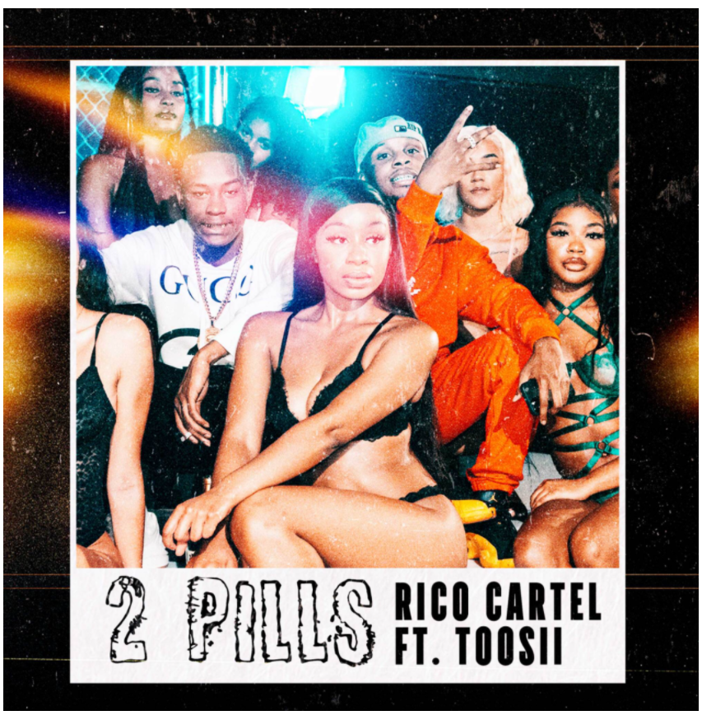

**CONNECT WITH RICO CARTEL**

[INSTAGRAM](https://nam04.safelinks.protection.outlook.com/?url=https%3A%2F%2Fwww.instagram.com%2Fricocartel438%2F%3Fhl%3Den&data=04%7C01%7CVeronica.Lainey%40atlanticrecords.com%7C1de1fceb8a964083ab2608d8e50399d7%7C8367939002ec4ba1ad3d69da3fdd637e%7C0%7C0%7C637511150924235090%7CUnknown%7CTWFpbGZsb3d8eyJWIjoiMC4wLjAwMDAiLCJQIjoiV2luMzIiLCJBTiI6Ik1haWwiLCJXVCI6Mn0%3D%7C1000&sdata=uVuPfMcqtkuAiyJoI7rt1ZdLKwAyfMLpHe3JkrcJueQ%3D&reserved=0) | [MERCH](https://nam04.safelinks.protection.outlook.com/?url=https%3A%2F%2Fthehyv.shop%2Fcollections%2Fricocartel&data=04%7C01%7CVeronica.Lainey%40atlanticrecords.com%7C1de1fceb8a964083ab2608d8e50399d7%7C8367939002ec4ba1ad3d69da3fdd637e%7C0%7C0%7C637511150924245049%7CUnknown%7CTWFpbGZsb3d8eyJWIjoiMC4wLjAwMDAiLCJQIjoiV2luMzIiLCJBTiI6Ik1haWwiLCJXVCI6Mn0%3D%7C1000&sdata=E0ETaxpi4NsgO7E2dMBQ4fMsNriUukuv7f5fyH1KtgI%3D&reserved=0) | [YOUTUBE](https://nam04.safelinks.protection.outlook.com/?url=https%3A%2F%2Fwww.youtube.com%2Fchannel%2FUChSvH8tK9GcSJn49EuQAe5Q&data=04%7C01%7CVeronica.Lainey%40atlanticrecords.com%7C1de1fceb8a964083ab2608d8e50399d7%7C8367939002ec4ba1ad3d69da3fdd637e%7C0%7C0%7C637511150924245049%7CUnknown%7CTWFpbGZsb3d8eyJWIjoiMC4wLjAwMDAiLCJQIjoiV2luMzIiLCJBTiI6Ik1haWwiLCJXVCI6Mn0%3D%7C1000&sdata=BMiVzKs4UdkwiSxbN99qG2odh3EPmu2c6CcW6q7ezO4%3D&reserved=0)

**FOR INQUIRIES, CONTACT**

**ALYSSA REDDISH**

[ALYSSA.REDDISH@ATLANTICRECORDS.COM](mailto:ALYSSA.REDDISH@ATLANTICRECORDS.COM)

**TRACK**

[OFFICIAL100KMGMT@GMAIL.COM](mailto:official100kmgmt@gmail.com)