RICO CARTEL RELEASES BRAND NEW VIDEO, “ROLLIN”

WATCH “ROLLIN” OFFICIAL VIDEO HERE

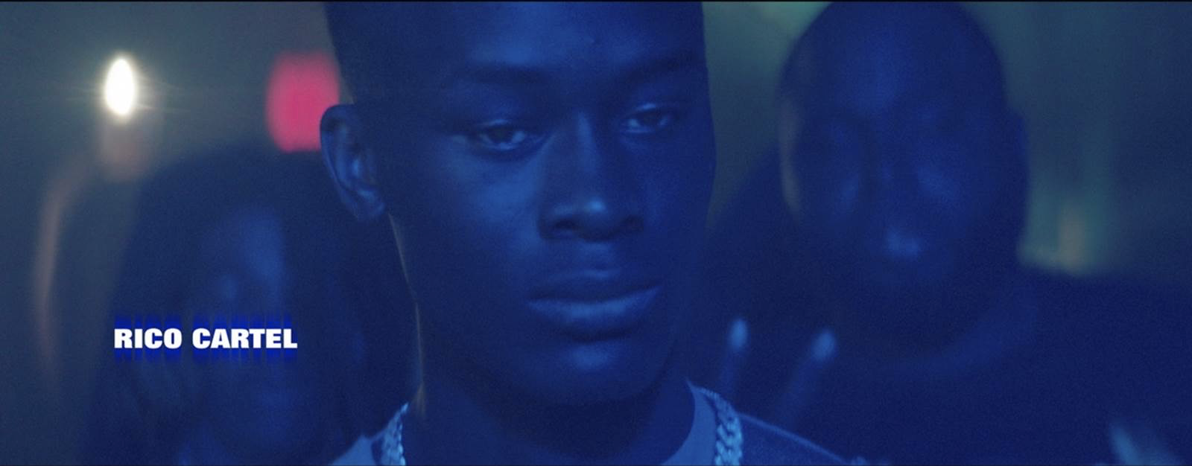

Atlantic Records/100K MGMT artist Rico Cartel presents his latest single, “Rollin”, a standout track from his LEGENDARY NIGHTZ mixtape. The audio is accompanied by an official music video for the track, available now on his official YouTube channel.

LEGENDARY NIGHTZ includes recent singles, “Lakers (Ft. Big 30),” “Charge It,” “My Old Bitches,” “2 Pills (Ft. Toosii),” “Fat Bankroll,” “I Like” and “Far From Average,” all of which were joined by official music videos streaming now.

Hailed by Pitchfork for his “menacing, yet youthful tone,” Rico Cartel made waves with a series of mixtapes demonstrating his multifaceted rap toolbox, his verses touching on unconditional love and cautionary tales of how to maneuver in his home city of West Orlando, FL. Last June saw Rico earning national acclaim for his “Erykah Badu (remix),” while the vintage New Orleans rap tempo and bouncy Florida rhythms of “I Like” prompted SPIN to simply rave, “It sounds like Rico’s rapping as he swaggers into a saloon in a silent film, his glizzy tucked but ready to draw on anybody who ‘ain’t from ‘round,’” adding, “With ‘I Like,’ (Rico’s) coming into his own.”

CONNECT WITH RICO CARTEL
INSTAGRAM | MERCH | YOUTUBE | PRESS SITE

PRESS CONTACT
SELAM BELAY | SELAM.BELAY@ATLANTICRECORDS.COM

