RICO CARTEL RELEASES NEW SINGLE & VIDEO, “MY OLD BITCHES”
WATCH/SHARE OFFICIAL VIDEO HERE
DOWNLOAD/STREAM HERE

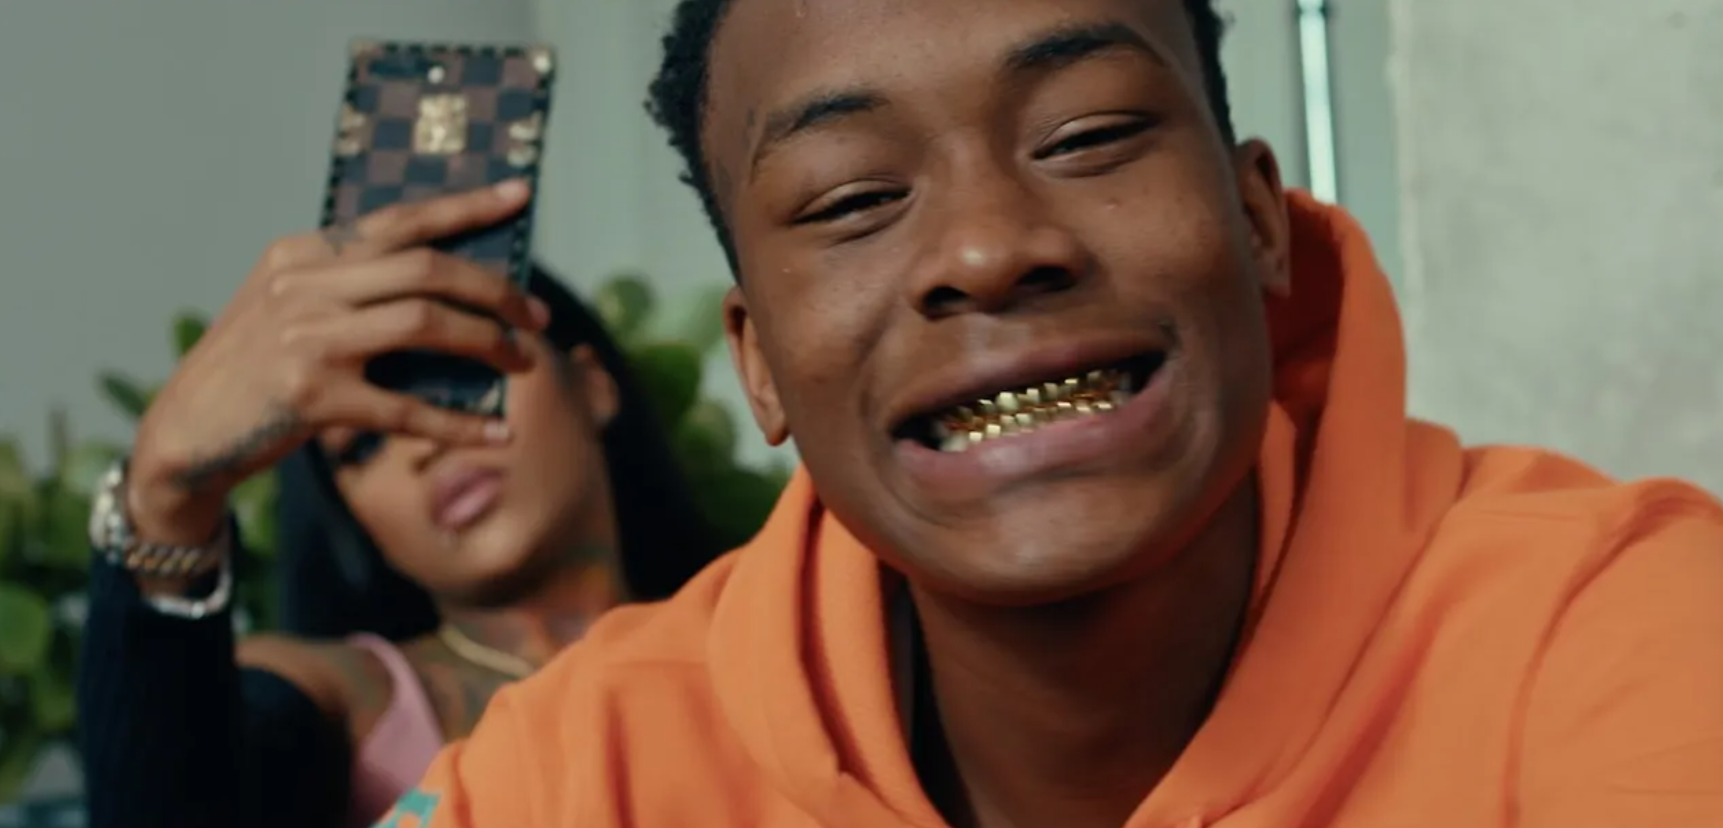
Rising rapper, Rico Cartel, has returned with the release of a new single “My Old Bitches” which also arrives with a companion visual available now. The new release arrives after the recently released “2 Pills” (feat Toosii), “Fat Bankroll,” “I Like” and “Far From Average.” Other popular releases include “Erykah Badu (remix),” “Hate It or Love It” and “Operation Wop” which accumulated over 2.5 million views combined in just under 12 months.
Most recently Rico joined Audiomack for an IG live interview for their "Open Forum" series after attracting critical acclaim from publications like SPIN (Blue Chips) and Pitchfork (The Ones), with his “Erykah Badu (remix)” release hailed as the “must-hear rap song of the day.“ Fans can expect to see more from Rico Cartel this year, with his debut mixtape slated to arrive this Spring.

CONNECT WITH RICO CARTEL
INSTAGRAM | MERCH | YOUTUBE

PRESS CONTACT
Selam Belay | selam.belay@atlanticrecords.com

