RISING BROOKLYN RAPPER COACHDAGHOST RELEASES THE OFFICIAL VIDEO FOR “BODY 4 BODY”

STREAM/DOWNLOAD GHOST STORIES HERE

WATCH VIDEO HERE

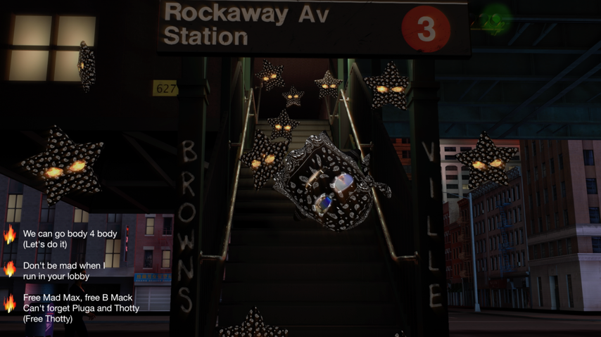

CoachDaGhost releases the official video for the latest single off his mixtape Ghost Stories available now via Atlantic Records at all DSPs and streaming services HERE. The animated video features the voice of Coach embodied as a ghost floating through the city while spitting menacing rhymes. Watch the official music video for “Body 4 Body” now HERE.

Hailed as a major force in the groundbreaking Brooklyn drill scene, CoachDaGhost has already unleashed a series of breakthrough tracks including “S.H.Y.N.E. Freestyle,” available for streaming and download HERE. Produced by CoachDaGhost with famed UK drill producer Ghosty and featuring a sample from Shyne’s Swizz Beatz-produced rap classic, “Shyne,” the freestyle proved to be an immediate hit upon its December debut, now boasting over 5.3M global streams while its official music video has drawn over 2M individual views via YouTube HERE. “Meditate”, the first track on the Ghost Stories mixtape has racked up over 2.9M global streams and is quickly approaching 1M YouTube views HERE.

Last year also saw Coach teaming with fellow Brooklyn drill pioneer 22Gz for the blockbuster collaboration, “Movie," swiftly earning over 10.5M global streams; with the official video boasting over 3.4M views via YouTube HERE.

Born in Guatemala and raised in Brooklyn, Culture “CoachDaGhost” Bermudez has a keen understanding of what it is to be multicultural. He learned English as a second language during his youth, simultaneously embracing the sounds of NYC rap icons like Notorious B.I.G. and Jay-Z. Nicknamed “Coach” by his peers (short for Culture) and adopting the cryptic “Ghost” label later in life, CoachDaGhost began creating his own unique music, songs that would later evolve into track like “Eternal Life”, that hammer home the lyricism and introspective subject matter that set Coach apart from the average drill rapper. “Hit List” dropped in early 2020, drawing co-signs by some of rap’s biggest stars along with over 7M worldwide video views HERE. “Gooey Sauce” followed in the summer, accompanied by an official music video currently with over 3.9M views via WorldStarHipHop HERE.

FOR MORE INFORMATION, PLEASE VISIT:
COACHDAGHOSTMUSIC.COM
TWITTER
YOUTUBE
INSTAGRAM
FACEBOOK

FOR ALL PRESS INQUIRIES, PLEASE CONTACT:
ARIANA.WHITE@ATLANTICRECORDS.COM

