FOR IMMEDIATE RELEASE
JANUARY 7, 2021

RISING POP SONGSTRESS BENNETT reveals the new SINGLE when it’s too good

WHEN IT’S TOO GOOD AVAILABLE NOW AT ALL DSPS AND STREAMING SERVICES

WATCH VIDEO HERE

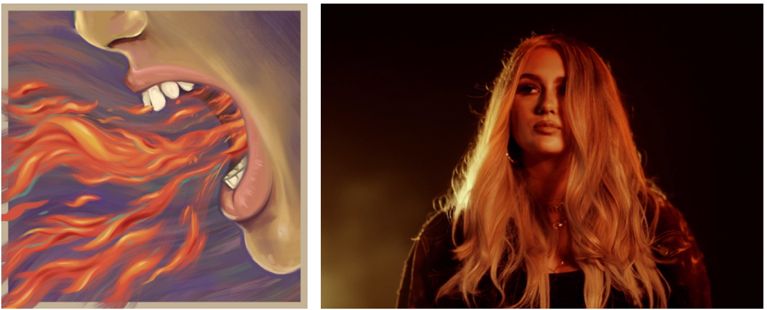

“Few artists are able to perk our ears up after releasing a single, let alone are able to continue delivering again and again.” – ONES TO WATCH

Rising pop/soul songstress BENNETT has unveiled the music video for her latest track “When It’s Too Good”. The track sees BENNETT sabotaging a relationship that appears too good to be true and is accompanied by an official music video, directed by Art Camp, available now on BENNETT’s YouTube channel HERE.

BENNETT closed out 2021 with the release of THE BUZZED MIXES an EP that collected multiple versions of “Buzzed,” the first single from her upcoming EP, including the spirited new “Buzzed (Icona Pop Remix),” reimagined for dancefloors everywhere by GRAMMY® Award-winning pop icons Icona Pop. The mix pack further features an electrifying live take HERE), a stripped-down acoustic rendition, and an addition remix by Brisbane, Australia-based DJ Zaerd, each of which showcase the many facets of BENNETT’s distinctive artistry. “Buzzed” is also joined by a colorful music video, streaming now at YouTube.

BENNETT is like the friend who always understands exactly what you’re going through and knows what to say to make you feel better. Tears, toxic relationships, heartbreak, addiction, anxiety, and anxiousness absorb into her music and bleed back out as R&B-backed bops with bite. Under the influence of Lana Del Rey, Stevie Wonder, Frank Ocean, SZA, and her “favorite artist” The Weeknd, the Connecticut-based singer and songwriter made waves with her debut single, “Never Yours,” eventually earning close to 3M worldwide streams. BENNETT’s Atlantic Records debut EP, THINGS I NEVER SAID, dropped in 2020, with its lead single, “Give Me A Reason,” scoring over 6M global streams, 1M YouTube views, and high profile praise from Ones To Watch, Cool Accidents, and Elevator Mag, which simply declared, “It certainly doesn’t appear that stardom is far off for the enigmatic vocalist as her unique appeal is captivating.”

CONNECT WITH BENNETT
WEBSITE | INSTAGRAM | FACEBOOK | TWITTER

PRESS CONTACT
SELAM BELAY // SELAM.BELAY@ATLANTICRECORDS.COM

# # #

