FOR IMMEDIATE RELEASE

OCTOBER 29, 2021

**REILEY DROPS *brb, having an identity crisis* EP**

**3-TRACK COLLECTION FROM EMERGING POP STAR & TIKTOK ICON**

**WITH MASSIVE 11 MILLION PLUS FOLLOWING AVAILABLE NOW,**

**ALONGSIDE MELODY MAKER-DIRECTED “YOU” MUSIC VIDEO**

[DOWNLOAD HIGH-RES IMAGES](https://press.atlanticrecords.com/reiley/)

**WATCH “YOU” MUSIC VIDEO:** <https://reiley.lnk.to/YouVideo>

**STREAM *brb, having an identity crisis* EP**: [https://Reiley.lnk.to/brbhavinganidentitycrisis](https://nam04.safelinks.protection.outlook.com/?url=https%3A%2F%2Freiley.lnk.to%2Fbrbhavinganidentitycrisis&data=04%7C01%7CBrian.Sommer%40atlanticrecords.com%7C680c42bf142d4989ac7608d982d4d0d7%7C8367939002ec4ba1ad3d69da3fdd637e%7C0%7C0%7C637684672809267384%7CUnknown%7CTWFpbGZsb3d8eyJWIjoiMC4wLjAwMDAiLCJQIjoiV2luMzIiLCJBTiI6Ik1haWwiLCJXVCI6Mn0%3D%7C1000&sdata=Uw5T1laDIXMwaGc9UeM0FdNnBRtf%2BJamjwjcPHtqac0%3D&reserved=0)

Rising pop sensation **Reiley** has dropped his highly anticipated debut EP, ***brb, having an identity crisis*** *–* available now via **Atlantic** **Records**. The 3-track collection features standout track “**YOU**,” arriving alongside an epic Melody Maker-directed music video tackling an extraterrestrial love triangle set to the artist’s signature vocal acrobatics and fluttering high-register.

***brb, having an identity crisis*** sees **Reiley** teaming up withan all-star roster of co-writers and producers, including **Noonie** **Bao** (**Charli** **XCX**, **Carly** **Rae** **Jepsen**), **Patrik** **Berger** (**Robyn**, **Lana** **Del** **Rey**), **Mike** **Sabath** (**Lizzo**, **Camila** **Cabello**), **Lostboy** (**Zedd**, **Bebe** **Rexha**), **The Nocturns** (**James** **Bay**, **Jonas** **Blue**), **Dreamlab** (**Justin** **Bieber**, **Katy** **Perry**) & more. The EP was preceded last month by emotional single “**Superman**,” which saw the singer tearfully confront the ripple effect of addiction on his family, and also features fiery new track “**Strange** **Love**.”

Born to remote origins in the Faroe Islands (about 200 miles north of the UK with a population of just over 50,000 people), **Reiley** quietly made a global impact with an exuberant presence as loud as his traffic-stopping voice and as colorful as his runway-ready aesthetic. During 2020, he embraced TikTok ([@reiley](https://www.tiktok.com/@reiley?lang=en)) as a way to connect with listeners far and wide. Against a colorful backdrop, he belted hits into a silver mic practically floating in front of him, ultimately generating nearly 1 billion views, inciting 128 million likes, and attracting nearly 11 million followers.

***brb, having an identity crisis*** follows **Reiley**’s infectious debut single “[**Let It Ring**](https://www.youtube.com/watch?v=E_viAcnwDYo)” – which was deemed *“already historic”* by **PAPER** upon release earlier this year, in addition to receiving praise from the likes of **Billboard**, **Cosmopolitan**, **Flaunt** & more. The track features the first-ever licensed sample of the instantly recognizable official iPhone ringtone and has picked up an incredible 12 million plus streams in addition to over 2 million YouTube views since its release.

The singer, songwriter, director, producer, and personality properly tells his story in his own words on ***brb, having an identity crisis***, and much more to come. “*As an artist, it’s my job to bare my soul and reveal my true self,”* he explains. *“I hope, if you’ve had similar experiences to mine, you can find comfort in knowing you’re not alone. At the end of the day, that’s really why I’m here.”*

***brb, having an identity crisis*** EP:

1. “YOU”

2. “Superman

3. Strange Love”

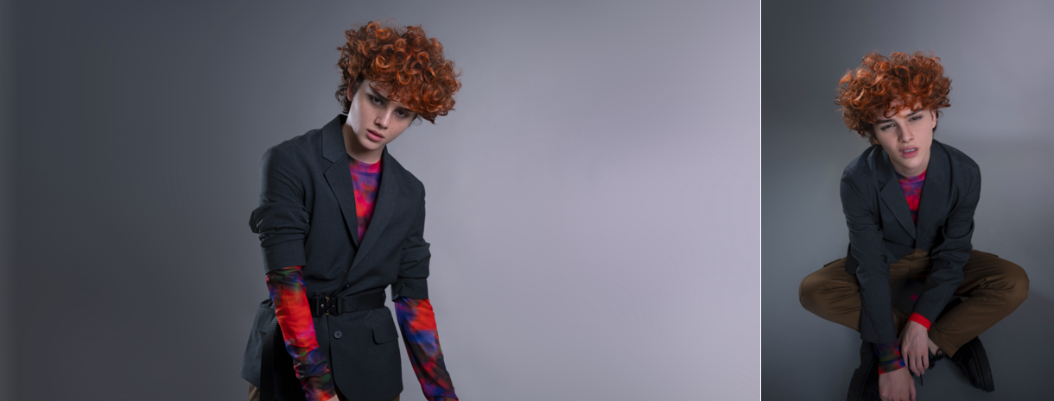

[DOWNLOAD HIGH-RES IMAGES](https://press.atlanticrecords.com/reiley/)

**CONNECT:**

[Official](https://www.reileyofficial.com/) | [TikTok](https://www.tiktok.com/@reiley?lang=en) | [Instagram](https://www.instagram.com/reiley/?hl=en) | [Twitter](https://twitter.com/reileymusic) | [Facebook](https://www.facebook.com/Reileyofficial) | [YouTube](https://www.youtube.com/c/ReileyPeters/) | [Press Assets](https://press.atlanticrecords.com/reiley/)