FOR IMMEDIATE RELEASE
JUNE 11, 2021

REILEY STRIPS DOWN HIS DEBUT SINGLE “LET IT RING”

ACOUSTIC RELEASE FROM EMERGING POP STAR & TIKTOK ICON
WITH MASSIVE 11 MILLION PLUS FOLLOWING AVAILABLE NOW

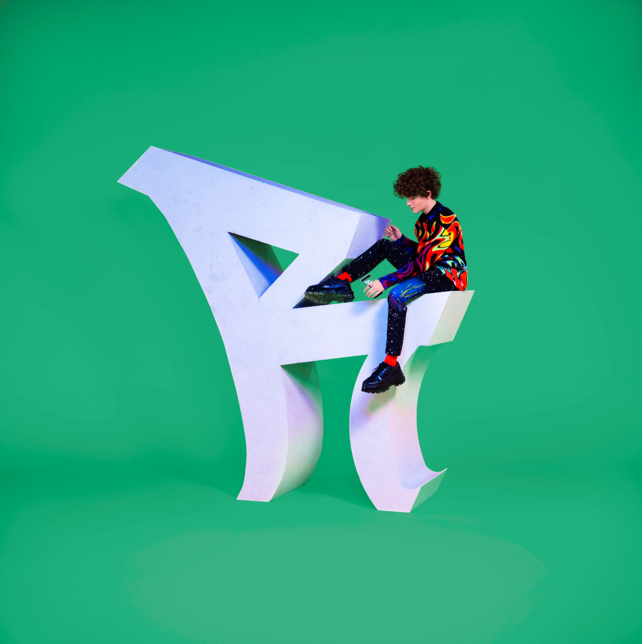
DOWNLOAD HIGH-RES IMAGES

STREAM “LET IT RING (ACOUSTIC)”: https://reiley.lnk.to/LetItRingAcoustic
WATCH/STREAM “LET IT RING”: reiley.lnk.to/LetItRingPR

Rising pop sensation, Reiley, has unveiled a stripped back version of his debut single, “Let It Ring,” available now. The new rendition of the infectious single swaps out the song’s slinky synthetic bass line for an equally energetic acoustic guitar. The original version of the song penned/produced by Lostboy (Zedd, Bebe Rexha), Lauren Aquilina (Rina Sawayama, Olivia O’Brien) & JHart (Jennifer Lopez, Camila Cabello) features the first-ever licensed sample of the instantly recognizable official iPhone ringtone and has picked up an incredible seven million plus streams in addition to over one million YouTube views since its release.

Born to remote origins in the Faroe Islands (about 200 miles north of the UK with a population of just over 50,000 people), Reiley always had to dream big. Art served as a window into the wider world as he channeled his early creativity into piano, photography and filmmaking – a blend of creative skills that lent perfectly to social media. In 2019, he uploaded his first TikTok (@reiley) which exploded to the tune of 10 million views right out of the gate – quickly translating into a huge following of over 11 million and over 125 million likes and counting. Standing in front of a bold color backdrop with nothing more than a dangling silver microphone, an instantly recognizable figure was already cut. Embracing a cinematic fashion sense, theatrical delivery, and undeniable charisma, Reiley asserted himself as a rare force in popular culture.

“I want to be an artist who pushes boundaries and defines what it is to be a male pop artist in 2021,” Reiley exclaims. "It’s not only about the music either, I’m creating a 360-degree experience. My art is communicated through all mediums: the fashion, the dancing, the visuals, the set design, and the storyline.”

Rather than disguise or hide his ambition, Reiley discloses it as loudly and as publicly as possible. Outsized personality, skyscraping vocals, and towering presence drive “Let It Ring,” fueled by a fearless confidence that manifests harmoniously in both brazen and timid forms – an inimitable dichotomy that comprises the essence of Reiley the artist.

Reiley is introspective, yet larger than life. Reiley has a soft side and a tougher one. As he explains, “we’re all walking contradictions, not one-dimensional creatures – and I’m celebrating that."

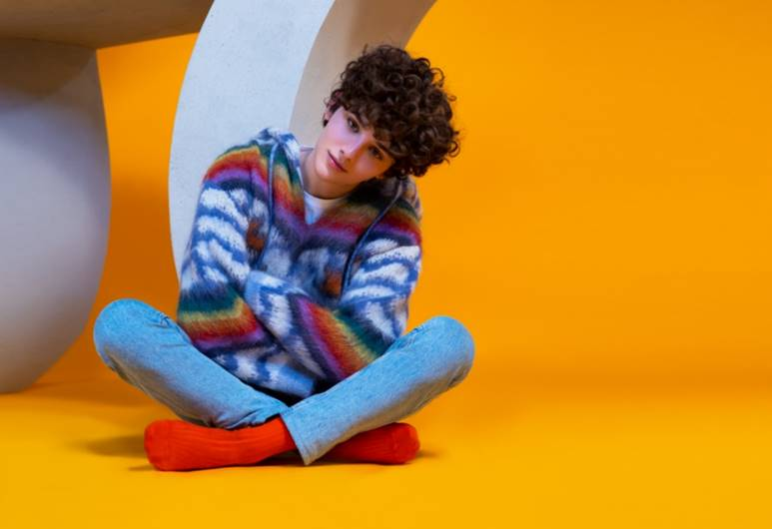
DOWNLOAD HIGH-RES IMAGES

CONNECT:
Official | TikTok | Instagram | Twitter | Facebook | YouTube | Press Assets

CONTACT:
Ted Sullivan (Atlantic Records) | ted.sullivan@atlanticrecords.com

