FOR IMMEDIATE RELEASE
May 7, 2021

REILEY UNLEASHES “LET IT RING (DIGITAL FARM ANIMALS & FRANKLIN REMIX)”

REVAMPED SINGLE FROM METEORICALLY ASCENDING POP SENSATION WITH
MASSIVE 11 MILLION PLUS TIKTOK FOLLOWING AVAILABLE NOW

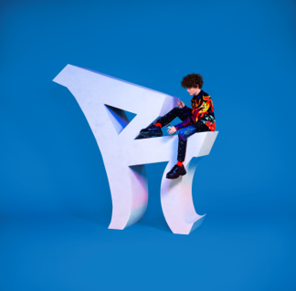
DOWNLOAD HIGH-RES IMAGES

STREAM “LET IT RING (DIGITAL FARM ANIMALS & FRANKLIN REMIX)”: https://Reiley.lnk.to/LIRdfafranklinRMX
WATCH/STREAM “LET IT RING”: reiley.lnk.to/LetItRingPR

After serving as upcoming pop sensation Reiley’s Atlantic Records debut single, “Let It Ring” is receiving yet another high-octane remix – this time courtesy of British recording artist/producer Digital Farm Animals & Franklin. Now including the remixers’ signature flares, the reworked version of the infectious jam penned/produced by Lostboy (Zedd, Bebe Rexha), Lauren Aquilina (Rina Sawayama, Olivia O’Brien) & JHart (Jennifer Lopez, Camila Cabello) which features the first-ever licensed sample of the instantly recognizable official iPhone ringtone fused with a slinky bass line and earworm hook, is available now.

Born to remote origins in the Faroe Islands (about 200 miles north of the UK with a population of just over 50,000 people), Reiley always had to dream big. Art served as a window into the wider world as he channeled his early creativity into piano, photography and filmmaking – a blend of creative skills that lent perfectly to social media. In 2019, he uploaded his first TikTok (@reiley) which exploded to the tune of 10 million views right out of the gate – quickly translating into a huge following of over 11 million and over 100 million likes and counting. Standing in front of a bold color backdrop with nothing more than a dangling silver microphone, an instantly recognizable figure was already cut. Embracing a cinematic fashion sense, theatrical delivery, and undeniable charisma, Reiley asserted himself as a rare force in popular culture.

“I want to be an artist who pushes boundaries and defines what it is to be a male pop artist in 2021,” Reiley exclaims. "It’s not only about the music either, I’m creating a 360-degree experience. My art is communicated through all mediums: the fashion, the dancing, the visuals, the set design, and the storyline.”

Rather than disguise or hide his ambition, Reiley discloses it as loudly and as publicly as possible. Outsized personality, skyscraping vocals, and towering presence drive “Let It Ring,” fueled by a fearless confidence that manifests harmoniously in both brazen and timid forms – an inimitable dichotomy that comprises the essence of Reiley the artist.

Reiley is introspective, yet larger than life. Reiley has a soft side and a tougher one. As he explains, “we’re all walking contradictions, not one-dimensional creatures – and I’m celebrating that."

ABOUT DIGITAL FARM ANIMALS:
Digital Farm Animals is the British artist/producer best known for his trademark pig helmet and his high-profile collaborations with artists such as Dua Lipa, Alan Walker, Craig David, Louis Tomlinson, Anne-Marie and KSI (the latter two both collaborators on the 2021 single “Don’t Play”, which promptly shot to #2 on the UK Singles chart). Embedded with elements of garage, pop, house and hip-hop, Digital Farm Animals has drawn from the vast sonic palette he’s honed since his childhood in northwest London. Proof of the hyper-creativity that powers Digital Farm Animals, his live show is dominated by an outrageous sense of spectacle. With its over-the-top intensity and dizzying visuals, a Digital Farm Animals live set ultimately creates a musical experience that transcends all convention.

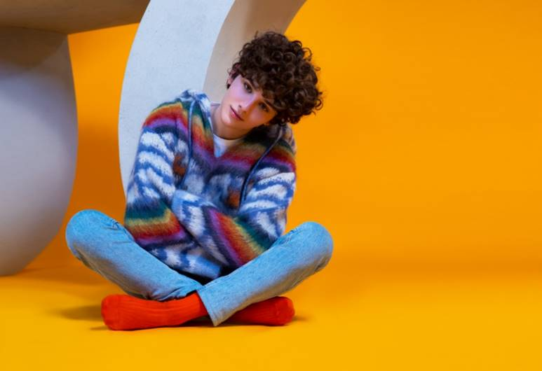
DOWNLOAD HIGH-RES IMAGES

CONNECT:
Official | TikTok | Instagram | Twitter | Facebook | YouTube | Press Assets

CONTACT:
Ted Sullivan (Atlantic Records) | ted.sullivan@atlanticrecords.com

