FOR IMMEDIATE RELEASE
APRIL 23, 2021

REILEY RELEASES “LET IT RING (DISCO KILLERZ REMIX)”

REWORKED SINGLE FROM EMERGING POP SENSATION WITH
MASSIVE 11 MILLION PLUS TIKTOK FOLLOWING AVAILABLE NOW

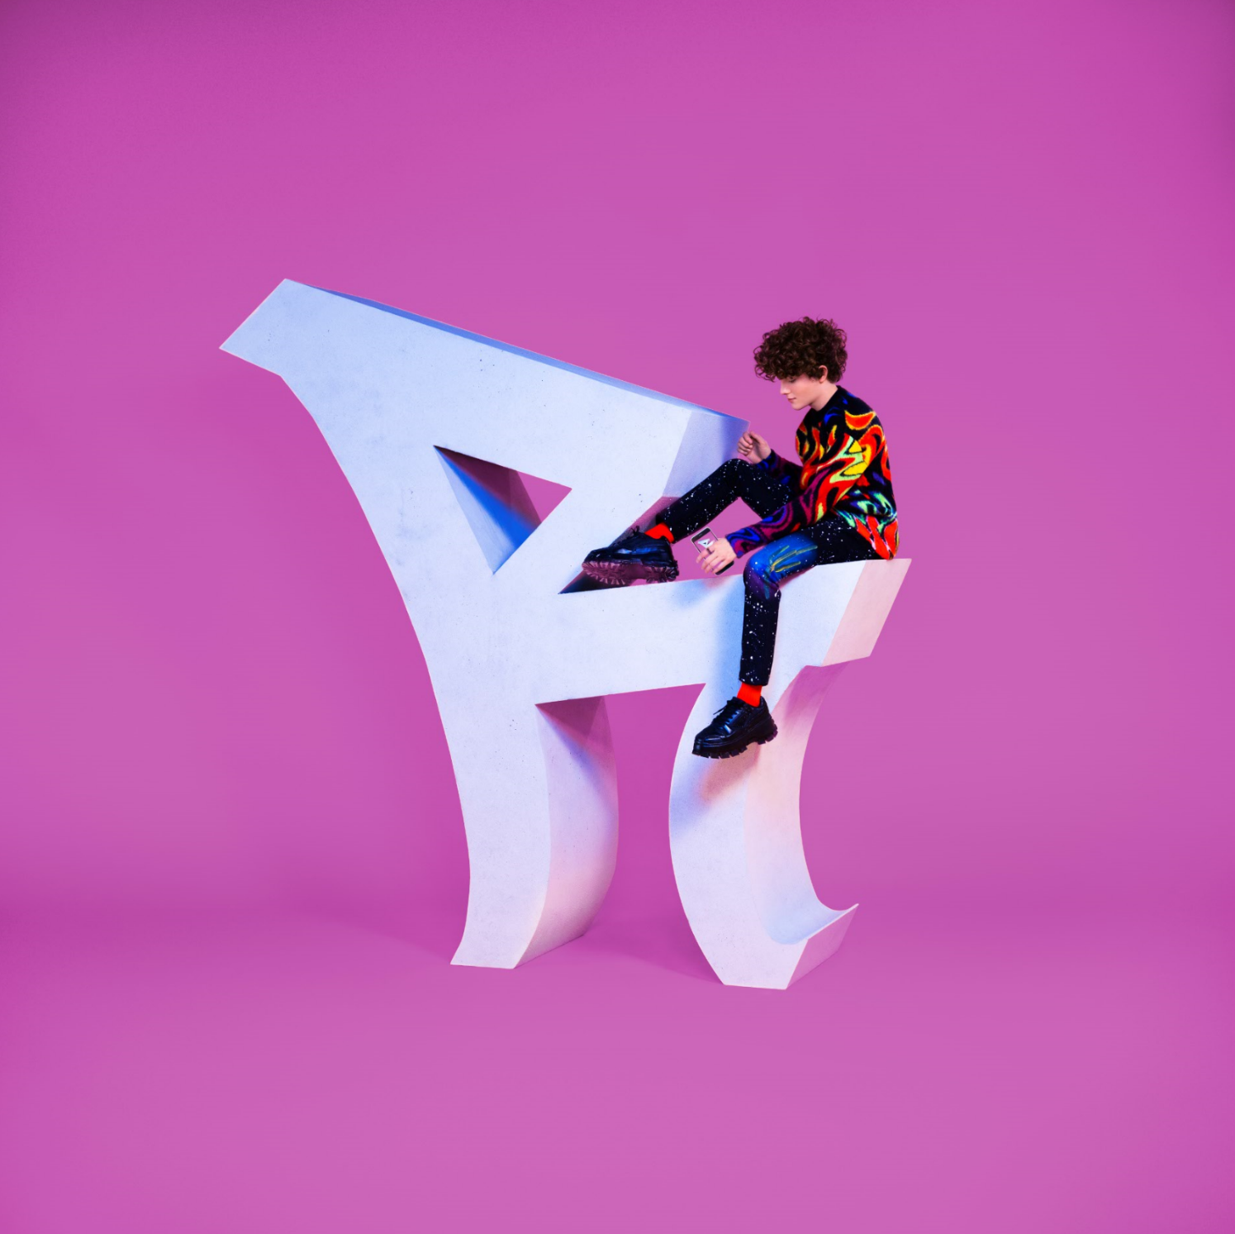
DOWNLOAD HIGH-RES IMAGES

STREAM “LET IT RING (DISCO KILLERZ REMIX)”: https://Reiley.lnk.to/LIRDiscoKillerzRMX
WATCH/STREAM “LET IT RING”: reiley.lnk.to/LetItRingPR

After serving as upcoming pop sensation Reiley’s Atlantic Records debut single, “Let It Ring” is receiving an energetic remix from New York-based producers/DJ duo, Disco Killerz. Built on the infectious single penned/produced by Lostboy (Zedd, Bebe Rexha), Lauren Aquilina (Rina Sawayama, Olivia O’Brien) & JHart (Jennifer Lopez, Camila Cabello) which features the first-ever licensed sample of the instantly recognizable official iPhone ringtone fused with a slinky bass line and earworm hook, the remix is available now.

Born to remote origins in the Faroe Islands (about 200 miles north of the UK with a population of just over 50,000 people), Reiley always had to dream big. Art served as a window into the wider world as he channeled his early creativity into piano, photography and filmmaking – a blend of creative skills that lent perfectly to social media. In 2019, he uploaded his first TikTok (@reiley) which exploded to the tune of 10 million views right out of the gate – quickly translating into a huge following of over 11 million and over 100 million likes and counting. Standing in front of a bold color backdrop with nothing more than a dangling silver microphone, an instantly recognizable figure was already cut. Embracing a cinematic fashion sense, theatrical delivery, and undeniable charisma, Reiley asserted himself as a rare force in popular culture.

“I want to be an artist who pushes boundaries and defines what it is to be a male pop artist in 2021,” Reiley exclaims. "It’s not only about the music either, I’m creating a 360-degree experience. My art is communicated through all mediums: the fashion, the dancing, the visuals, the set design, and the storyline.”

Rather than disguise or hide his ambition, Reiley discloses it as loudly and as publicly as possible. Outsized personality, skyscraping vocals, and towering presence drive “Let It Ring,” fueled by a fearless confidence that manifests harmoniously in both brazen and timid forms – an inimitable dichotomy that comprises the essence of Reiley the artist.

Reiley is introspective, yet larger than life. Reiley has a soft side and a tougher one. As he explains, “we’re all walking contradictions, not one-dimensional creatures – and I’m celebrating that."

ABOUT DISCO KILLERZ:
Hailing from NYC, Disco Killerz is a DJ/Producer duo, featuring Matthew Danger and Uri Illuz. Their music is regularly played on dance radio nationwide as well as featured on leading playlists across all of the major music platforms. Well known for their multiple releases on Armada and Enhanced Music, as well as remixes for Toni Braxton, Famba, David Solomon and more, their productions have been supported by Top DJ’s ranging from Tiesto to Don Diablo, Martin Garrix and Armin Van Buuren. They have appeared twice on the Billboard Dance/Mix Show airplay chart, as well as Mediabase Dance Radio Airplay and charting #1 on leading electronic music station, Sirius XM BPM. Their song, "Million Things," in collaboration with GATTÜSO charted top 10 Billboard Dance Radio, was featured on New Music Friday and top electronic playlists world wide. The song features vocalist Laura White, known for her work on the Galantis smash hit, “Love on Me”. They have been featured in publications ranging from Billboard Magazine to Dancing Astronaut and Bloomberg. Follow Disco Killerz on Instagram: @discokillerz

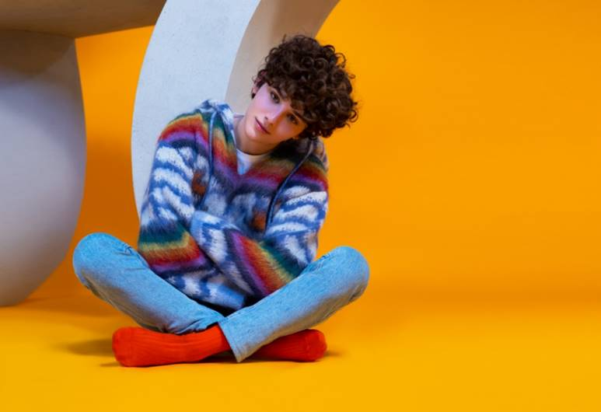
DOWNLOAD HIGH-RES IMAGES

CONNECT:
Official | TikTok | Instagram | Twitter | Facebook | YouTube | Press Assets

CONTACT:
Ted Sullivan (Atlantic Records) | ted.sullivan@atlanticrecords.com

