FOR IMMEDIATE RELEASE  
MARCH 26, 2021

**REILEY TAKES OFF WITH “LET IT RING”**

**DEBUT SINGLE FROM 11 MILLION-STRONG TIKTOK POP SENSATION**

**AVAILABLE NOW VIA ATLANTIC RECORDS**



[DOWNLOAD HIGH-RES IMAGES](https://press.atlanticrecords.com/reiley/)

**WATCH/STREAM “LET IT RING”:** [reiley.lnk.to/LetItRingPR](https://reiley.lnk.to/LetItRingPR)

**Atlantic Records** is proud to announce the signing of TikTok pop sensation **Reiley**, alongside the arrival of his debut single “**Let It Ring**” – available now with a bold visual companion self-directed by **Reiley** and **Nicholas Lam** (**Monsta X**, **Nick Jonas**). Penned/produced by **Lostboy** (**Zedd**, **Bebe Rexha**), **Lauren** **Aquilina** (**Rina** **Sawayama**, **Olivia O’Brien**) & **JHart** (**Jennifer Lopez**, **Camila Cabello**), “**Let It Ring**” features the first-ever licensed sample of the instantly recognizable official iPhone ringtone fused with a slinky bass line and infectiously chantable hook.

Born to remote origins in the Faroe Islands (about 200 miles north of the UK with a population of just over 50,000 people), **Reiley** always had to dream big. Art served as a window into the wider world as he channeled his early creativity into piano, photography and filmmaking – a blend of creative skills that lent perfectly to social media**.** In 2019, he uploaded his first TikTok ([@reiley](https://www.tiktok.com/@reiley?lang=en)) which exploded to the tune of 10 million views right out of the gate – quickly translating into a huge following of over 11 million and over 100 million likes and counting. Standing in front of a bold color backdrop with nothing more than a dangling silver microphone, an instantly recognizable figure was already cut. Embracing a cinematic fashion sense, theatrical delivery, and undeniable charisma, Reiley asserted himself as a rare force in popular culture.

*“I want to be an artist who pushes boundaries and defines what it is to be a male pop artist in 2021,”* **Reiley** exclaims. *"It’s not only about the music either, I’m creating a 360-degree experience. My art is communicated through all mediums: the fashion, the dancing, the visuals, the set design, and the storyline.”*

Rather than disguise or hide his ambition, **Reiley** discloses it as loudly and as publicly as possible. Outsized personality, skyscraping vocals, and towering presence drive “**Let It Ring**,” fueled by a fearless confidence that manifests harmoniously in both brazen and timid forms – an inimitable dichotomy that comprises the essence of **Reiley** the artist.

**Reiley** is introspective, yet larger than life. **Reiley** has a soft side and a tougher one. As he explains*, “we’re all walking contradictions, not one-dimensional creatures – and I’m celebrating that."*

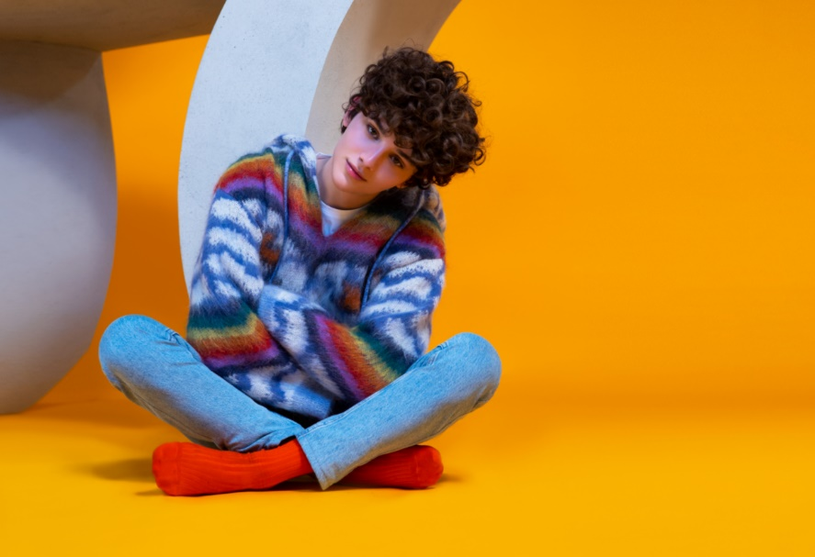

[DOWNLOAD HIGH-RES IMAGES](https://press.atlanticrecords.com/reiley/)

**CONNECT:**

[Official](https://www.reileyofficial.com/) | [TikTok](https://www.tiktok.com/@reiley?lang=en) | [Instagram](https://www.instagram.com/reiley/?hl=en) | [Twitter](https://twitter.com/reileymusic) | [Facebook](https://www.facebook.com/Reileyofficial) | [YouTube](https://www.youtube.com/c/ReileyPeters/) | [Press Assets](https://press.atlanticrecords.com/reiley/)

**CONTACT:**

Ted Sullivan (Atlantic Records) | [ted.sullivan@atlanticrecords.com](mailto:ted.sullivan@atlanticrecords.com)