FOR IMMEDIATE RELEASE
SEPTEMBER 29, 2021

REILEY SOARS WITH “SUPERMAN”

NEW SINGLE/VIDEO FROM EMERGING POP STAR & TIKTOK ICON
WITH MASSIVE 11 MILLION PLUS FOLLOWING AVAILABLE NOW

DEBUT brb, having an identity crisis EP ARRIVES
OCTOBER 27TH VIA ATLANTIC RECORDS

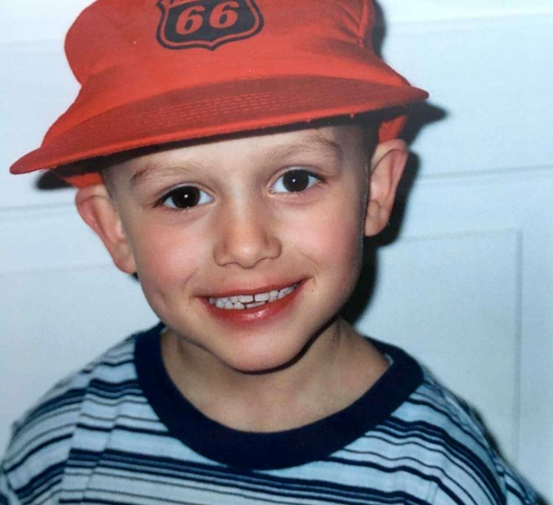
DOWNLOAD HIGH-RES IMAGES

WATCH/STREAM “SUPERMAN”: https://Reiley.lnk.to/Superman
PRE-SAVE brb, having an identity crisis EP: https://Reiley.lnk.to/brbhavinganidentitycrisis

Rising pop sensation Reiley has premiered his highly anticipated sophomore single “Superman,” arriving today alongside a compelling self-directed video companion. The track marks the latest offering from his forthcoming debut EP, brb, having an identity crisis, arriving October 27th via Atlantic Records.

Co-written by Reiley, “Superman” sees the him tearfully confront the ripple effect of addiction on his family. “It’s a song about disappointment,” he admits. “It explores my relationship with my father. He’s struggled with alcoholism. Before I got signed, his addiction got so bad it almost broke up our family. When I wrote ‘Superman,’ I had so many emotions bottled up: pain, resentment, fear, empathy, pity. Even a sense of loss. Above all I was so incredibly disappointed. I grew up idolizing my father and thought he was infallible. But he’s only human. I think the realization that your parents can do wrong is always scary.”

Born to remote origins in the Faroe Islands (about 200 miles north of the UK with a population of just over 50,000 people), Reiley quietly made a global impact with an exuberant presence as loud as his traffic-stopping voice and as colorful as his runway-ready aesthetic. During 2020, he embraced TikTok (@reiley) as a way to connect with listeners far and wide. Against a colorful backdrop, he belted hits into a silver mic practically floating in front of him, ultimately generating nearly 1 billion views, inciting 128 million likes, and attracting nearly 11 million followers.

“Superman” follows Reiley’s infectious debut single “Let It Ring” – which was deemed “already historic” by PAPER upon release earlier this year, in addition to receiving praise from the likes of Billboard, Cosmopolitan, Flaunt & more. The track, penned/produced by Lostboy (Zedd, Bebe Rexha), Lauren Aquilina (Rina Sawayama, Olivia O’Brien) & JHart (Jennifer Lopez, Camila Cabello), features the first-ever licensed sample of the instantly recognizable official iPhone ringtone and has picked up an incredible 10 million plus streams in addition to over 2 million YouTube views since its release.

The singer, songwriter, director, producer, and personality properly tells his story in his own words on his forthcoming brb, having an identity crisis EP, and much more to come in 2021. “As an artist, it’s my job to bare my soul and reveal my true self,” he explains. “I hope, if you’ve had similar experiences to mine, you can find comfort in knowing you’re not alone. At the end of the day, that’s really why I’m here.”

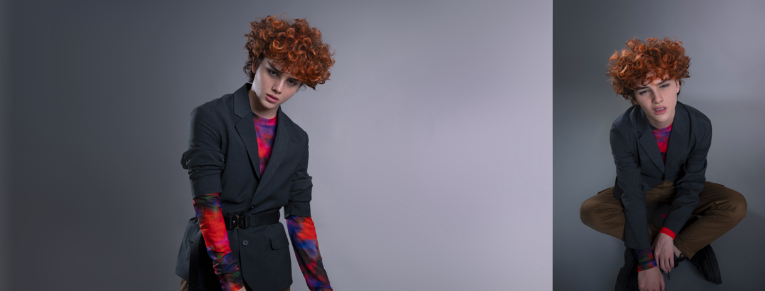
DOWNLOAD HIGH-RES IMAGES

CONNECT:
Official | TikTok | Instagram | Twitter | Facebook | YouTube | Press Assets

