METEORIC ALT POP ARTIST ROYAL & THE SERPENT RETURNS WITH 2 NEW SINGLES, “CHOKE” & “WARN YOU”

WATCH THE “CHOKE” OFFICIAL MUSIC VIDEO HERE: https://youtu.be/fxHgXm0XxkI
LISTEN HERE: https://royalandtheserpent.lnk.to/getagrip

AS PART OF ‘GET A GRIP’ PROJECT OUT TODAY THAT ALSO INCLUDES BREAKOUT TRACK “OVERWHELMED” + A STRIPPED VERSION
ROYAL TO JOIN YUNGBLUD ON HIS ‘THE WEIRD TIME OF LIFE’ DIGITAL TOUR
“OVERWHELMED” LEAPS TO #17 ON BILLBOARD’S ALT RADIO CHART & REACHES 44 MILLION GLOBAL STREAMS + OVER 3.5M CREATES ON TIKTOK
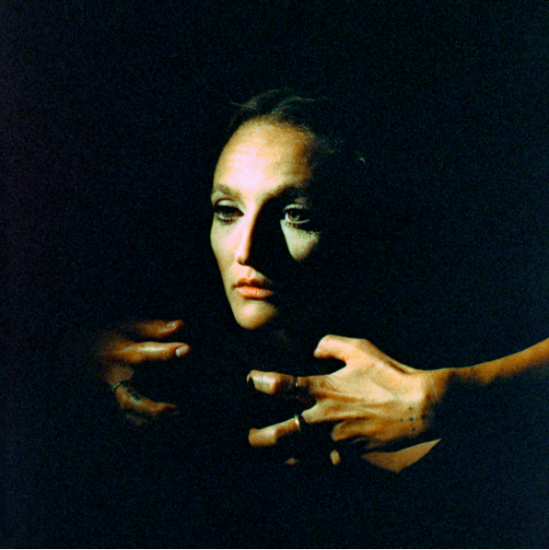
DL art here

Following the breakout success of her track “Overwhelmed,” mystifying alt pop artist Royal & The Serpent releases her next project ‘get a grip’ today that includes 2 new tracks “Choke” and “Warn You,” “Overwhelmed” and a stripped version of the single. Watch the “Choke” official music video featuring Royal HERE and listen to ‘get a grip’ HERE.

“Overwhelmed” continues its momentum, cracking Top 20 at Alt Radio and clocking more than 44M plays and 3.5M creates on TikTok since June. Watch the “Overwhelmed” music video HERE. Royal was also recently featured as a YouTube Trending Artist on the Rise and released an “Overwhelmed” Marky Style remix featuring dark pop artist Mothica. Listen to “Overwhelmed (Ft. Mothica) [Marky Style Remix]” HERE.
Royal will be joining YUNGBLUD on his ‘The Weird Time of Life’ global digital tour, kicking off November 16th, 2020 and spanning 16 dates across the globe. Each show will be a unique localized experience with full-scale production. Tickets are on sale now HERE. See full dates below. You can watch an FAQ video on the tour HERE.
‘get a grip’ Tracklisting:
- Overwhelmed
- Choke
- Warn You
- Overwhelmed (Stripped)

Los Angeles-based Royal & The Serpent made her debut in 2017, earning acclaim for a series of self-released singles such as “MMXX,” “Salvador Dali,” and “Bad Bad Blood”, which was featured in the Season 6 trailer for ABC’s How To Get Away With Murder. In each piece of music she shares with the world, Royal reveals the wild duality at the heart of her artistry and speaks to the incredible power of embracing your true nature, in all its outrageous complexity. A Gemini to the core, she’s passionate but pensive, sensitive but self-possessed, enigmatic but an open book when it comes to exposing what’s inside her mind. “I definitely feel like I’m two people living in one body, where I can just slip at the drop of dime and become a totally different person,” notes Santiago, who equally identifies as a “sweet sunshine angel” (i.e., the Royal persona) and a “freaky devil maniac” (the Serpent).

“With boundary pushing lyrics and palpable energy, she has an onstage spirit that has fans referring to her as ‘Lady Cobain,’” wrote Ones To Watch. “The duality she expresses makes her both relatable and captivating, as she unapologetically shares a full spectrum of experience, from royal soul to luring serpent. Royal delivers the perfect combination of funk and grace in a sweet sound rich with hypnotic melodies.”

YUNGBLUD’S ‘WEIRD TIME OF LIFE’ 2020 HEADLINE TOUR
With Royal & the Serpent as Direct Support
November 16: London
November 17: Glasgow
November 18: Manchester
November 19: Dublin
November 20: Paris
November 21: Berlin
November 22: Munich
November 23: Amsterdam
November 30: New York
December 1: Boston
December 2: Toronto
December 3: Chicago
December 4: Atlanta
December 5: Seattle
December 6: Los Angeles
December 7: Sydney
CONNECT WITH ROYAL & THE SERPENT:
OFFICIAL I INSTAGRAM I YOUTUBE I FACEBOOK I TWITTER
Press contact: Corey.brewer@atlanticrecords.com

