FOR IMMEDIATE RELEASE
FEBRUARY 16, 2021

ROZEI FINDS HIS WAY OUT OF THE “HEARTBREAK HOTEL”

VIRAL HITMAKER RELEASES GENRE-BENDING BANGER JUST IN TIME FOR VALENTINE’S DAY

LISTEN TO “HEARTBREAK HOTEL” HERE
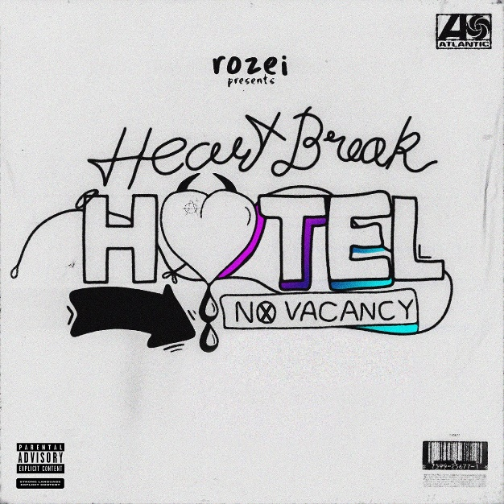
DOWNLOAD ARTWORK + PRESS PHOTOS HERE

Multi-talented rising hitmaker Rozei has released his eagerly anticipated single “Heartbreak Hotel” – available now HERE. Produced by GRAMMY nominated, multi-Platinum producer Roy Lenzo (Lil Nas X, Kid Cudi) and Frans Mernick (A$AP Rocky, Miguel), the catchy track chronicles Rozei leading his girl, who has been hurt in the past, out of the “Heartbreak Hotel,” showcasing his signature flow and irrespirable melodic hook.

“’Heartbreak Hotel’ is the pivot point of the progression in which my evolving sound has been taking while creating my project” Rozei shared. “Reconnecting with an ex at the hotel bar and realizing that time hasn’t been the most kind for either of you, is something that i feel like a lot of people can relate to metaphorically or literally.”

“Heartbreak Hotel” arrives on the heels of “Chase” which was released earlier this month. Early Rising praised the song saying it “makes listeners want to lean and rock with the music, getting lost for a moment of time” and Fresh Music Freaks raved “’Chase’ is a catchy electro-pop-hip-hop blend and will definitely be a new fan favorite!”

The Pennsylvania native first made waves with his viral track “Ooo La La” which currently boasts over 25 million streams and has topped the Spotify Viral Charts in multiple countries. The track arrived alongside a FaZe Clan directed official video, starring Rozei and famous gamer FaZe Nikan and currently boasts over 1.3 million views.

Following “Ooo La La,” Rozei released impressive singles “Droptop,” which was produced with Billboard Top 200 producer DJ Chose and co-written with multi-platinum, GRAMMY-winning songwriter London Jae (Cardi B, Beyoncé, Rihanna, Tinashe), and the upbeat summer track “Hollywood.” “Hollywood” was featured on LA Weekly’s “in rotation” series and praised as “a song that is gloriously appropriate both for the summer and for this region.” Known for his signature melodic crossover sound, Rozei draws from a range of genres with influences including Juice WRLD, Lil Skies and iann dior for a unique and unforgettable style and sound. With recent praise from Billboard, HipHopDX and more Rozei is not showing any signs of slowing down!

Stay tuned for more new music from Rozei coming soon!

FOLLOW ROZEI
OFFICIAL SITE | INSTAGRAM|TWITTER|SOUNDCLOUD|YOUTUBE

PRESS CONTACT:
Jessica Nall // Jessica.Nall@atlanticrecords.com

