FOR IMMEDIATE RELEASE

OCTOBER 2, 2020

**ROZEI TAPS LUH KEL FOR “OOO LA LA” REMIX**

**RISING STAR’S VIRAL HIT SINGLE GETS NEW VERSE FROM EMERGING R&B SENSATION LUH KEL**

**ORIGINAL TRACK HAS AMASSED OVER 20 MILLION STREAMS WORLDWIDE**

**LISTEN TO “OOO LA LA (FEAT. LUH KEL)”** [**HERE**](https://rozei.lnk.to/OooLaLaRemixPR)



[DOWNLOAD ARTWORK HERE](https://press.atlanticrecords.com/wp-admin/post.php?post=43659&action=edit)

21-year-old Atlantic Records recording artist **Rozei** has teamed up with RIAA Gold certified, St. Louis-bred R&B player **Luh Kel** for a brand-new remix of his viral hit single “Ooo La La” – listen now [HERE](https://rozei.lnk.to/OooLaLaRemixPR). The dynamic pair team up to put a seamless and fresh new spin on the irresistibly catchy track.

The [original track](https://rozei.lnk.to/OooLaLa) immediately caught the attention of the international gaming community and launched the song and rising rapper into an online phenomenon racking up over **20 million streams** and topping the **Spotify Viral Charts** in multiple countries. The **FaZe Clan** directed [official video](https://www.youtube.com/watch?v=ATWJG9nFY2o&feature=youtu.be&src=Linkfire&lId=7700fa11-9739-468a-acf0-01f3faa14f6d&cId=243a20ab-c558-413d-a755-b68ba13bc941), starring Rozei alongside famous gamer **FaZe Nikan**, currently has over **1 million views** and continues to climb. Similarly to Rozei, **Luh Kel** rose to popularity through explosive online support and widespread praise. The rising R&B star got his start on TikTok and currently has an overall social media reach of over **6 million followers**.

This new remix follows Rozei’s upbeat summer track “[Hollywood](https://rozei.lnk.to/Hollywood)” which [LA Weekly](https://www.laweekly.com/in-rotation-rozeis-hollywood/) featured on their “in rotation” series and praised as “a song that is gloriously appropriate both for the summer and for this region.” Known for his signature melodic crossover sound, Rozei draws from a range of genres with influences including Juice WRLD, Lil Skies and Iann Dior for a unique and unforgettable style and sound. With recent praise from Billboard, HipHopDX and more the rising rapper is not showing any signs of slowing down!

Stay tuned for more new music from Rozei coming soon!

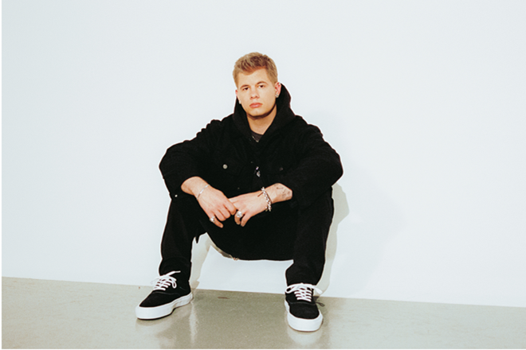

[DOWNLOAD PRESS PHOTO HERE](https://nam04.safelinks.protection.outlook.com/?url=https%3A%2F%2Fwarnermusicgroup.box.com%2Fs%2F33272tibq6mjnntkjgqu18e5d7cbg9k6&data=02%7C01%7CMegan.Rasmussen%40atlanticrecords.com%7Cdc6e8f706ad64bfd2fc908d818860273%7C8367939002ec4ba1ad3d69da3fdd637e%7C0%7C0%7C637286311148823211&sdata=bO12an%2FFP8zASEQATuPsbZEIpFr7Z2BjpZJAxdso1FA%3D&reserved=0)

**FOLLOW ROZEI**

[INSTAGRAM](https://nam04.safelinks.protection.outlook.com/?url=https%3A%2F%2Fwww.instagram.com%2Frozeimusic%2F%3Fhl%3Den&data=02%7C01%7CMegan.Rasmussen%40atlanticrecords.com%7Cdc6e8f706ad64bfd2fc908d818860273%7C8367939002ec4ba1ad3d69da3fdd637e%7C0%7C0%7C637286311148823211&sdata=DMbHkae1OLuPjhS3gR717VfbL92d%2Fl1w9Aw%2BRETD7es%3D&reserved=0)|[TWITTER](https://nam04.safelinks.protection.outlook.com/?url=https%3A%2F%2Ftwitter.com%2FRozeiMusic%3Fref_src%3Dtwsrc%255Egoogle%257Ctwcamp%255Eserp%257Ctwgr%255Eauthor&data=02%7C01%7CMegan.Rasmussen%40atlanticrecords.com%7Cdc6e8f706ad64bfd2fc908d818860273%7C8367939002ec4ba1ad3d69da3fdd637e%7C0%7C0%7C637286311148833206&sdata=fM%2BXEM0anBebp0zTTSbsCNUM5AnwVGF0r1xbnHDfEew%3D&reserved=0)|[SOUNDCLOUD](https://nam04.safelinks.protection.outlook.com/?url=https%3A%2F%2Fsoundcloud.com%2Frozei&data=02%7C01%7CMegan.Rasmussen%40atlanticrecords.com%7Cdc6e8f706ad64bfd2fc908d818860273%7C8367939002ec4ba1ad3d69da3fdd637e%7C0%7C0%7C637286311148833206&sdata=KkVl2oS%2BGFPEdudq%2FcHe4vPzxfTgJIiVJj916tJAj6Q%3D&reserved=0)|[YOUTUBE](https://nam04.safelinks.protection.outlook.com/?url=https%3A%2F%2Fwww.youtube.com%2Fchannel%2FUCEkgFVFZd8dsrYvIJZH1Cug&data=02%7C01%7CMegan.Rasmussen%40atlanticrecords.com%7Cdc6e8f706ad64bfd2fc908d818860273%7C8367939002ec4ba1ad3d69da3fdd637e%7C0%7C0%7C637286311148843201&sdata=3zsPHipU3rzzMrAoqTTDIZfKmACjh%2B2YYoumetm6KJs%3D&reserved=0)

**PRESS CONTACT:**

Jessica Nall // [Jessica.Nall@atlanticrecords.com](mailto:Jessica.Nall@atlanticrecords.com)