FOR IMMEDIATE RELEASE
DECMEBER 17, 2021

ROZEI RELEASES “WAY BACK WHEN”

GENRE-BENDING ARTIST UNVEILS HIGH ENERGY POP-PUNK SINGLE PRODUCED BY COLIN BRITTAIN

LISTEN TO “WAY BACK WHEN” HERE
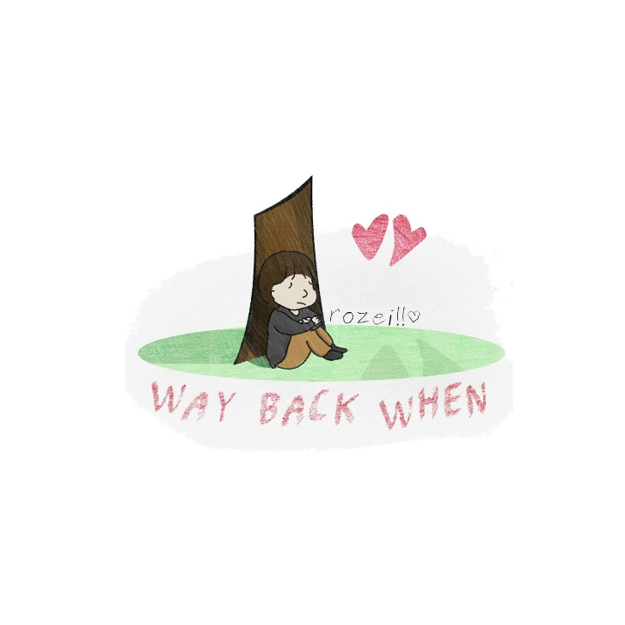
DOWNLOAD HI-RES PHOTOS + ARTWORK

“Rozei is a singer, rapper, producer, and artist all in one, and he’s here to make an impact in the music industry. Blending the genres of hip-hop, alternative, R&B, and pop into one melting pot, the Erie, Pennsylvania native croons lyrics inspired by real-life experiences, over an animated sonic backdrop that’s as vibrant as his personality.”
– FLAUNT

Genre-blurring singer-songwriter-producer Rozei has released his pop-punk-rock single “Way Back When.” Produced by Colin ‘DOC’ Brittain (Sueco, 5 Seconds of Summer, All Time Low, Papa Roach), “Way Back When” is available now HERE.

Fresh off the release of his single “Fever Dreams,” Rozei continues his impressive string of singles. Named by Alternative Press as one of “40 New Artists You Need To Hear,” Rozei’s recent critically acclaimed singles include “The World Is Over,” “Heartbreak Hotel” and “Chase.” The genre-blending tracks continue to receive widespread praise from Billboard, LA Weekly, FLAUNT, Early Rising, Glasse Factory, Banger Of The Day and more.

Rozei exploded onto the scene with last year’s viral smash, “Ooo La La,” which topped the Spotify Viral Charts in multiple countries and currently boasts over 40M worldwide streams and counting. “Ooo La La” was joined by an official music video – directed by FaZe Clan’s Youssef Ali and co-starring famed gamer FaZe Nikan – now with close to 1.6M views.

Known for melding powerful alternative energy with tantalizing pop zeal his own trademark brand of hip-hop bounce, Rozei draws from a range of genres to create a unique and unforgettable musical style all his own. The 22-year-old, Erie, PA-based artist is currently hard at work crafting more innovative, emotionally resonant music.

# # #

FOLLOW ROZEI
OFFICIAL SITE | INSTAGRAM| TWITTER | SOUNDCLOUD | YOUTUBE | TIKTOK

PRESS CONTACT:
Jessica Nall // Jessica.Nall@atlanticrecords.com

