FOR IMMEDIATE RELEASE
JANUARY 28, 2022

SAINT PHNX WELCOME ALL TO THEIR HAPPY PLACE

ACCLAIMED ALT-POP BROTHER DUO UNVEIL EAGERLY AWAITED EP

HIGHLIGHTS INCLUDE BREAKTHROUGH TITLE TRACK, “HAPPY PLACE,”
AND THE TOUCHING NEW SINGLE, “ANGEL”

“ANGEL” ARRIVES TODAY ALONGSIDE AN OFFICIAL VIDEO, STREAMING NOW

LISTENT TO HAPPY PLACE HERE
WATCH ANGEL HERE
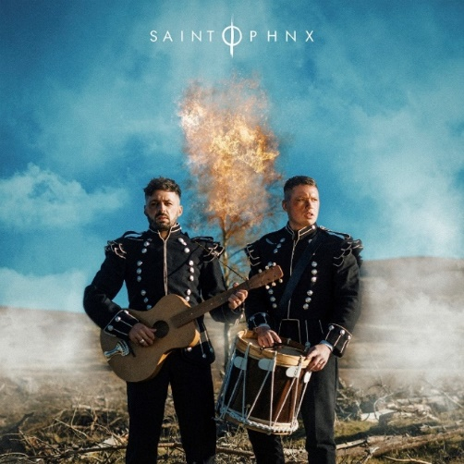
DOWNLOAD ARTWORK + PRESS PHOTOS HERE

“If you love feel-good music with substance, you love SAINT PHNX. Composed of brothers Stevie and Alan Jukes, the Glasgow, Scotland-based musicians have established themselves as a force to be reckoned with in the music industry, far beyond just the music. On top of their undeniably anthemic records, it’s their sense of humor and personalities that result in contagious good energy and laughter for their growing fanbase.”
– FLAUNT

Acclaimed alt-pop brother duo SAINT PHNX have unveiled their new EP, HAPPY PLACE, available now HERE. The EP includes the duo’s Atlantic Records label debut, “Happy Place,” as well as the standout track, “Angel.” “Angel” arrives today alongside an Alexander Kenny-directed video, starring the inspiring brothers. Watch “Angel” on SAINT PHNX’s YouTube channel HERE.

“Happy place EP is a collection of songs that we have written in tribute to our Dad,” SAINT PHNX shares. “It's a journey of emotions on how we felt and how he felt during the last 6 months of his life. We hope this collection of songs can help others through difficult times and give them some sort of comfort. We want to tell the world his story and make him and our mum proud. This is for him.

A touching ode to the Glasgow, Scotland-based duo’s late father, “Happy Place” arrived last summer and quickly struck a chord with listeners. The track is currently ascending at UK radio while boasting over 8M worldwide streams and top 20 placement on Shazam charts around the world. Along with its popular success, “Happy Place” has been met by widespread support from friends and fellow artists like Yungblud, Lewis Capaldi, Catie Turner, and Jamie Miller, as well as many publications including American Songwriter, which wrote, “With a palpably uplifting energy, ‘Happy Place’ has an incredibly unique vibe to it. With such a distinctive message of hope, grounded by the profound sadness of losing a parent, the song boasts an incredibly complex emotional palette, marrying the joys and sorrows of life into a single, beautiful expression.”

In addition, Happy Place includes a further version of the immensely moving track also featuring guest vocals from longtime friend – and fellow Atlantic recording artist – Jasmine Thompson, streaming now HERE; the track was joined by an official performance video, streaming now HERE.

SAINT PHNX – who recently supported Yungblud for two spectacular shows at their hometown’s famed Glasgow Barrowlands – will celebrate HAPPY PLACE with a range of live dates, including an eagerly awaited UK and European spring headline tour. For updates and additional information, please visit www.saintphnx.com/tour.

# # #

SAINT PHNX
HAPPY PLACE

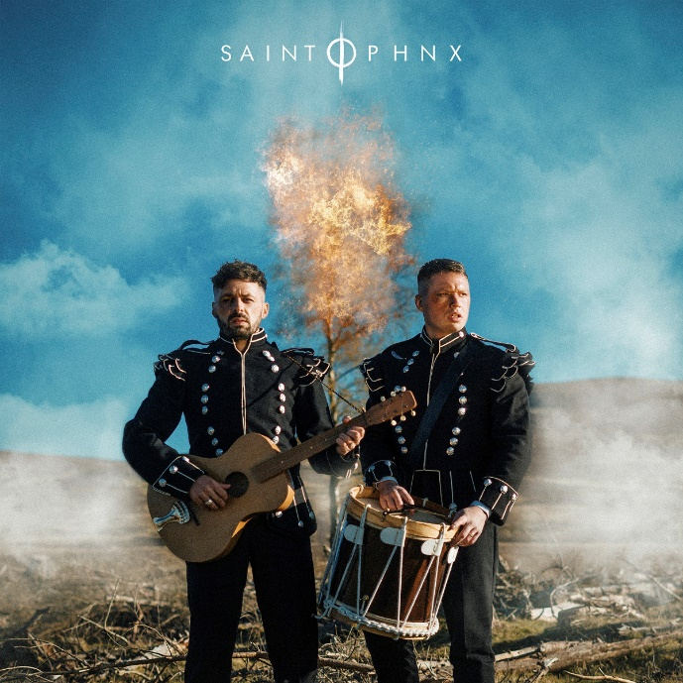

TRACKLIST
1. Happy Place
2. Angel
3. Invisible
4. Blue Feather
5. Peace
6. Happy Place (Ft. Jasmine Thompson)

# # #

ABOUT SAINT PHNX
A brotherly bond drives the music of SAINT PHNX. The Glasgow duo of Stevie and Alan Jukes feel everything twice as hard together. Those mutual feelings inform the pair’s skyscraping alternative pop uplifted by towering hooks, eloquent songcraft, and energetic instrumentation. Since 2016, they’ve hustled hard, performed countless gigs, and even touched down on U.S. soil to write in Las Vegas. The duo served up their single “KING” and eventually garnered over 19M Spotify streams and counting. In between touring with Yungblud and opening for everyone from Lewis Capaldi to Imagine Dragons, they unveiled their independent full-length debut, DDMN, in 2020. In the middle of their international rise, their dad was diagnosed with pulmonary fibrosis, which is a terminal lung condition. The boys had initially encouraged him to move to a warmer client, but he chose to stay in Glasgow, bought land in the Tinto Hills, and built a house. He turned the room above the garage into a studio where Stevie and Alan wrote, recorded, and remained close to him. During this time, they recorded “Happy Place” as dad cheered them on. They played it for him on his death bed, and now it tells their story together on the grandest scale possible. After gathering tens of millions of streams, touring with some of the biggest bands in the world, and receiving acclaim from Clash, Alternative Press, and more, the group welcome everyone into their family on a series of 2021 singles for Atlantic Records.

(DOWNLOAD HI-RES PHOTOS // PHOTO CREDIT: ALEXANDER JAMES)

CONNECT WITH SAINT PHNX
SAINTPHNX.COM | INSTAGRAM | TWITTER | FACEBOOK | YOUTUBE

# # #
For press inquiries, please contact:
Jessica Nall // Jessica.Nall@atlanticrecords.com

