FOR IMMEDIATE RELEASE
FEBRUARY 5, 2021
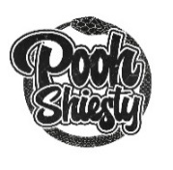
POOH SHIESTY OFFICIALLY INTRODUCES HIGHLY ANTICIPATED DEBUT MIXTAPE, SHIESTY SEASON
ARRIVES WITH A COMPANION VISUAL FOR “NEIGHBORS” FEAT. BIG30 AVAILABLE NOW

INCLUDES GUEST APPEARANCES FROM GUCCI MANE, FOOGIANO, 21 SAVAGE AND MORE

“BACK IN BLOOD” CELEBRATING ITS 4th WEEK ON BILLBOARD’S HOT 100;
CURRENTLY PEAKING AT #40

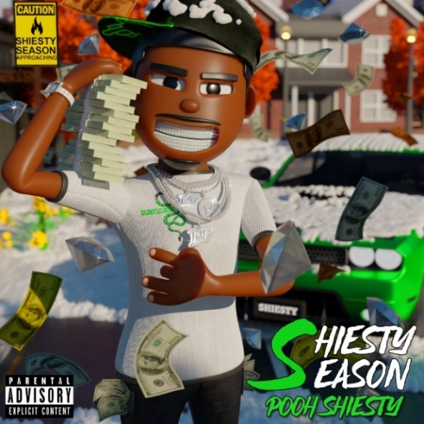
DOWNLOAD HI-RES GRAPHIC HERE

“Just about anything with Memphis rapper Pooh Shiesty’s name on it is practically guaranteed to go gangbusters. With a laconic delivery and chilly street narratives, he justifies the attention.”
- UPROXX

“…one of the hardest new rappers out…his potential is through the roof…”
- COMPLEX
Today, quickly rising Memphis rapper, POOH SHIESTY, officially introduces his highly anticipated debut mixtape SHIESTY SEASON via Gucci Mane’s The New 1017 and Atlantic Records along with an official companion visual for “Neighbors” featuring BIG30. The tape arrives after it sat atop of Apple Music’s pre-add charts for 2 weeks straight and before its release has already peaked at #2 and #3 on Apple Music’s Hip-hop/Rap & All Genre charts, respectively. SHIESTY SEASON includes guest appearances from Gucci Mane, Foogiano, 21 Savage, BIG30, Lil Durk, Veeze, Lil Hank and Choppa Wop. SHIESTY SEASON is available now at all DSPs and streaming services.

SHIESTY SEASON includes the recent earworm “Back In Blood” which now celebrates its third week on Billboard’s Hot 100 (currently peaking at #40). The track has also peaked at #4 and #2 on Apple Music’s All Genre and Rap charts, respectively, while peaking at #36 on Spotify’s US Viral 50 Chart. The tape will also include the recently released “Guard Up” and “Twerksum” which both have made their way onto Apple Music’s Top 200 Rap Chart.

Pooh has been named as one of Billboard’s “15 Hip-Hop & R&B Artists to Watch in 2021,” Complex’s “Rappers to Watch in 2021” and Rap Caviar’s “10 Artists to Watch in 2021.” He’s also staked his claim on a number of other influential charts in addition to Billboard’s Hot 100, including Rolling Stone’s “Breakthrough 25” (recently peaking at #2) and Billboard’s Emerging Artists chart (peaking at #6). He also spent over 20 weeks at the top of Pandora’s Trendsetter Chart.

Known for snaking through airy beats with a venomous bite and slick melodies, the Memphis born-and-bred rapper first incited buzz with 2019’s “Shiesty Summer” (9.8M views), later earning the attention of GRAMMY® Award-nominated, multi-platinum icon Gucci Mane, who promptly signed Pooh to his groundbreaking The New 1017 label. A series of increasingly popular hits followed, including “Monday to Sunday (Feat. Lil Baby & Big 30)“ (38M views), “7.62 God“ (21M views), “Main Slime Remix (Feat. Moneybagg Yo)“ (19.5M views), and “ABCGE (Feat. Big 30)“ (9.5M views), to name just a few. In addition, Pooh recently kicked off Audiomack’s “17 Bars with The New 1017” series with a cover of Gucci Mane’s classic “Lemonade,” currently boasting close to 3M views.

# # #

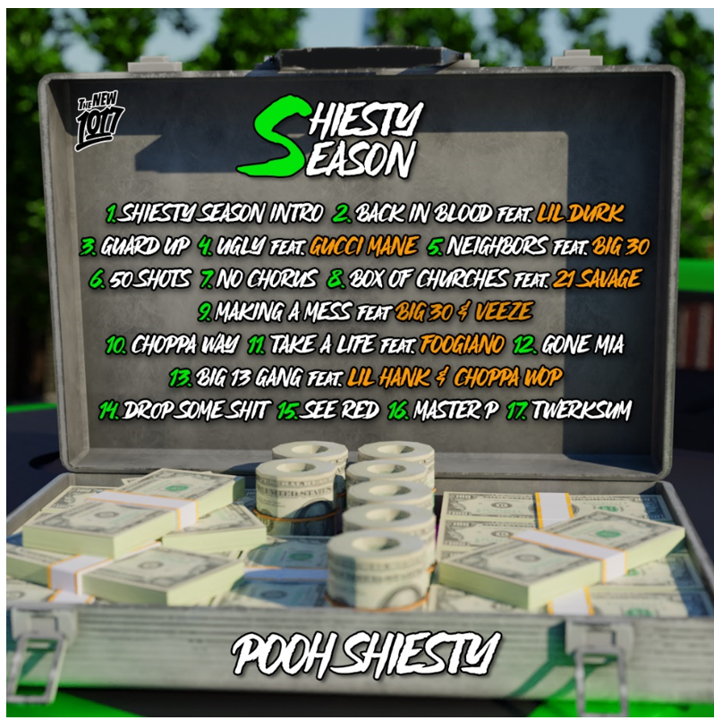

- Shiesty Season Intro
- Back In Blood feat. Lil Durk
- Guard Up
- Ugly feat. Gucci Mane
- Neighbors feat. BIG30
- 50 Shots
- No Chorus
- Box of Churches feat. 21 Savage
- Making A Mess feat. BIG30 & Veeze
- Choppa Way
- Take A Life feat. Foogiano
- Gone MIA
- Big 13 Gang feat. Lil Hank & Choppa Wop
- Drop Some Shit
- See Red
- Master P
- Twerksum

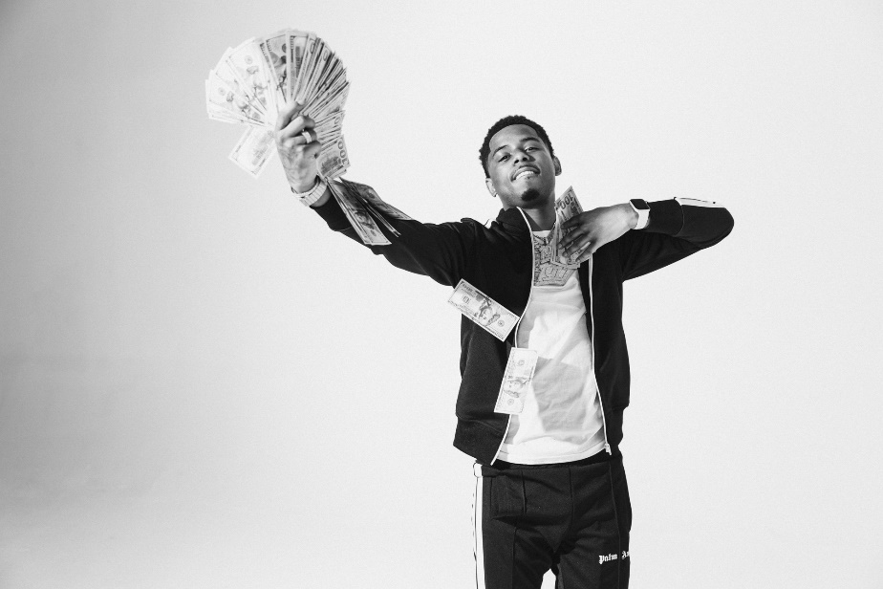
DOWNLOAD HI-RES PRESS IMAGES HERE
VIEW FULL BIO HERE

CONNECT:
WEBSITE | INSTAGRAM | TWITTER | FACEBOOK | SOUNDCLOUD | AUDIOMACK

POOH SHIESTY CONTACT:
SELAM.BELAY@ATLANTICRECORDS.COM

THE NEW 1017 LABEL CONTACT:
ASHLEY.KALMANOWITZ@ATLANTICRECORDS.COM

