GRAMMY NOMINATED, MULTI-PLATINUM PRODUCER AND ARTIST SONNY DIGITAL RELEASES BRAND NEW SOLO SINGLE, “DANCE” ON HIS 30TH BIRTHDAY

“DANCE” NOW AVAILABLE EVERYWHERE HERE

ANNOUNCEMENT FOLLOWS HIS RECENT TAKEOVER ON CLUBHOUSE APP WITH THE INNOVATIVE “CLUB DIGITAL”
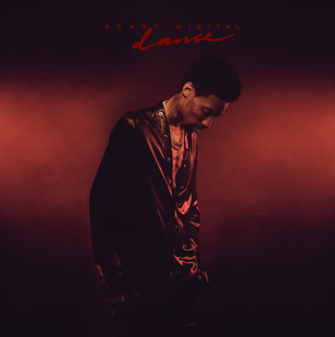

Today, Sonny Digital announced the release of an electrifying new solo single, “Dance” to celebrate his 30th birthday. The record, which was written and produced by Sonny, introduces a new and unique sound for the record-breaking songwriter and producer. He’s been working on it for the past three years, now releasing it as the world needs feel-good music again. Check out “Dance” at all DSPs and digital retailers HERE. To accompany the release, Sonny unveiled a brand new lyric video – check it out HERE.

For over a decade, Sonny has had an undeniable impact on the music industry. Most recently, his explosive takeover with “Club Digital” on Clubhouse has solidified his place as an artist in the position to lead and propel the culture forward. Within the past few months, Sonny has been building out “Club Digital,” boasting thousands of members and initiating recurring discourse on some of music’s hottest topics—most recently, notable figures in entertainment and books (“The Autobiography of Gucci Mane,” “Confessions of a Video Vixen,” “The Coldest Winter Ever” and “Hurricanes” by Rick Ross).

- - -
Sonny is one of the leading producers in the game, a visionary force boasting a stacked CV that includes GRAMMY® Award-nominated, RIAA platinum certified, and chart-topping collaborations with superstars spanning Travis Scott, Meek Mill, Wiz Khalifa, Lil Uzi Vert, Ty Dolla $ign, Yung Thug, PnB Rock, Future, ILoveMakonnen, 21 Savage, 2 Chainz & Kanye West, Beyoncé, and many more. In 2016, the Michigan-born, ATL-based artist released his first solo mixtape and quickly began drawing equal attention as a rapper in his own right. With close to 10 years in the game, American music producer and artist Sonny Digital continues to prove he is a moving force in Hip-hop music. To date, he has produced numerous records and created a catalogue of timeless, solo and collaborative art. At only 30-years-old, Sonny pushes his music to the masses while discovering and creating new sounds through his production and songwriting.

# # #

CONNECT WITH SONNY DIGITAL
OFFICIAL
TWITTER
INSTAGRAM
YOUTUBE
FACEBOOK

FOR ALL INQUIRIES, CONTACT
SYDNEY.MARGETSON@ATLANTICRECORDS.COM

