Multi-Platinum Artists Brent Smith and Zach Myers As Duo
Smith & Myers

Release Music Video for “Bad At Love”
PRESS HERE To Watch

Single Impacting Hot AC Radio Nationwide

Double Album Volume 1 & 2 Out Now

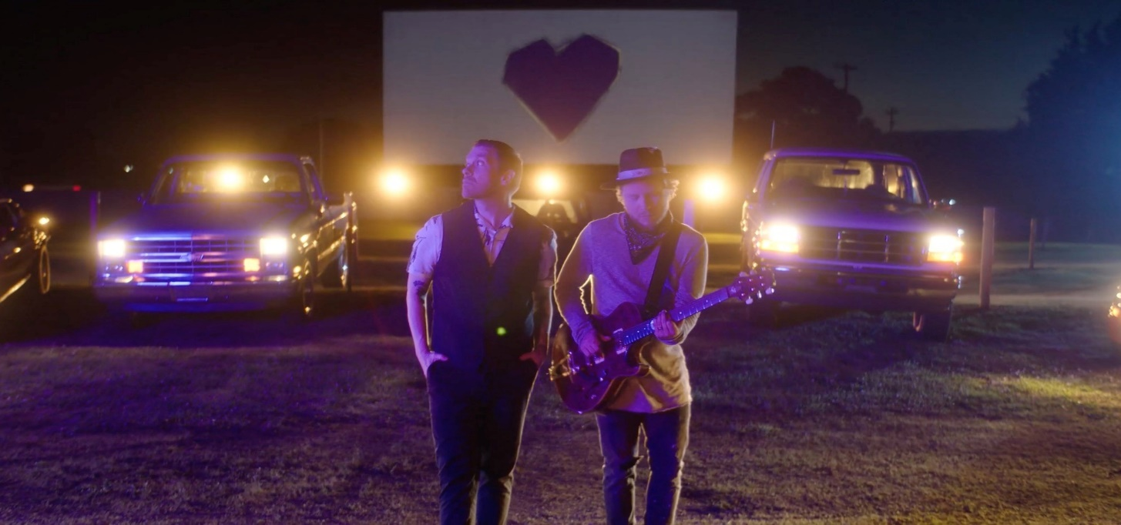
(Video Still)
New York, NY – [June 16, 2021] – Smith & Myers – the duo comprised of multi-platinum artists Brent Smith and Zach Myers – has released the official music video for their single “Bad At Love,” off their 2020 full-length album Smith & Myers Volume 2 (Atlantic Records). The vulnerable pop-rock track touches on the difficulties of staying in a romantic relationship while the visual, filmed at a 71-year-old drive-in theater in Tennessee, shows snapshots of others experiencing and overcoming those trials and tribulations. PRESS HERE to watch the “Bad At Love” music video, directed by DJay Brawner. “Bad At Love,” which has garnered nearly 6 million global streams and been featured on Spotify’s “Rockin Vibes” and Apple Music’s “Breaking Hard Rock” and “New In Rock” playlists, is now impacting Hot AC Radio nationwide. PRESS HERE to listen to “Bad At Love (2021 Mix),” a new version of the song just released last week.

“We’re excited for people to hear this new take on ‘Bad At Love’ and to watch the music video, which we really enjoyed creating,” shares Brent. “When we were making the record, this song had almost an Americana vibe, but we had an idea of changing the mix and presenting it in a different, more modern way for 2021. For the video, we wanted to showcase more than one example of love. It features three different scenarios with three different couples showcasing the diversity in each storyline. As the video unfolds, you don’t exactly know where the relationships will end up. That’s the beauty of the reveal in the finale.”

“Lyrically, Brent was writing about things in his life that maybe we wouldn’t really touch on with Shinedown and I think ‘Bad At Love’ came out to be an incredibly naked and honest song,” adds Zach. “If you’re bad at love, just realize that it’s okay. It only makes you better.”

Last October, Smith & Myers released their double album, Smith & Myers Volume 1 & Volume 2, which showcase the duo’s ability to pack power and soul into songs created with nothing more than a microphone and an instrument or two, highlighting their sonic versatility throughout a mix of poignant original songs and unexpected covers. Produced by GRAMMY nominated and longtime collaborator Dave Bassett, the duo’s debut album Volume 1 features original song “Not Mad Enough,” which touches upon the rights and wrongs of society and our connection as human beings, and original song “PANIC!” alongside renditions of Neil Young’s “Rockin’ In The Free World,” Post Malone’s “Better Now” and INXS’ “Never Tear Us Apart.” Meanwhile, Volume 2 features the alt-rock original tune “One More Time” in addition to “Bad At Love” as well as a re-imagining of Billie Eilish’s “Bad Guy” and other covers such as Peter Gabriel’s “Sledgehammer” and Billy Idol’s “Rebel Yell.” The double album marked Smith & Myers’ first original music since releasing a pair of acoustic cover EPs, Acoustic Sessions, Part 1 and Acoustic Sessions, Part 2, in 2014 when fans first fell in the love with the magic that is created between Brent and Zach in the studio and on stage, leading to Smith & Myers live shows that instantly sold out.

Smith & Myers, who recently wrapped a spring headlining tour, illuminates the depth of Brent and Zach as a duo and showcases a very different yet just as intriguing musical side of these two versatile artists. As one-half of multiplatinum band Shinedown — who were recently named #1 on Billboard’s Greatest of All Time Mainstream Rock Artists chart — Brent and Zach can often be found topping the rock charts, earning mainstream recognition, and playing to sold-out arenas around the globe with 10 million albums and 10 million singles sold worldwide, 14 platinum and gold singles, five platinum and gold albums, more than 2.7 billion streams and 16 number one rock hits (breaking the record for the most ever #1s in the 39-year history of the Billboard Mainstream Rock Songs Chart with their single “Atlas Falls”). As part of their “Atlas Falls” COVID-19 relief effort, Shinedown has raised more than $500,000 for Direct Relief, one of the largest providers of humanitarian medical resources in the world whose mission is to improve the health and lives of people affected by poverty or emergency situations by mobilizing and providing essential medical resources needed for their care.

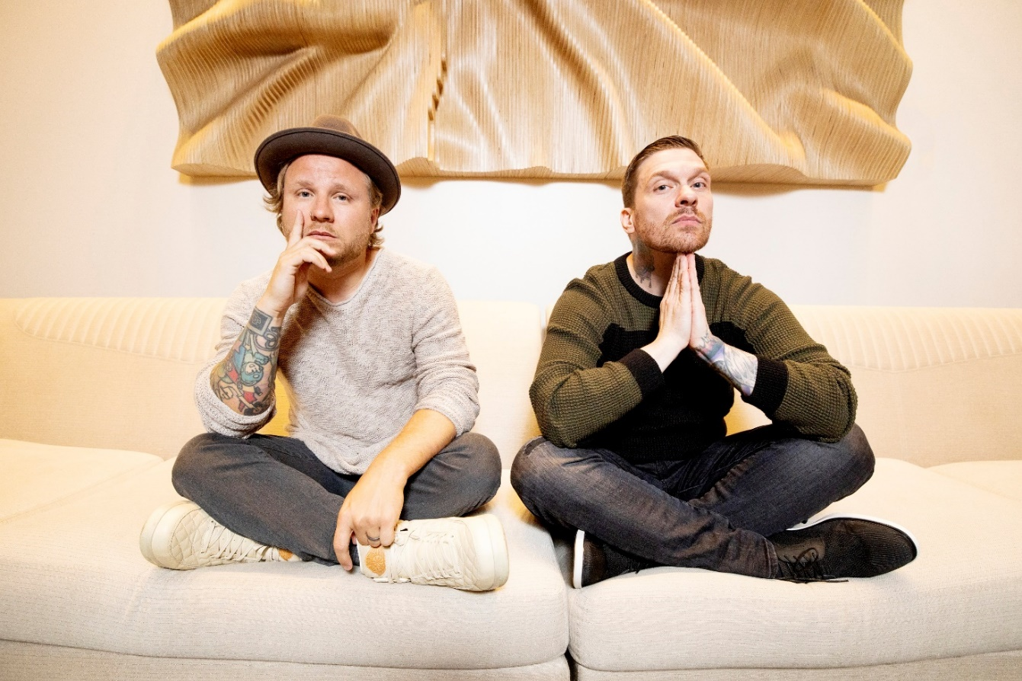
(Photo Credit: Paris Visone)

FOLLOW SMITH & MYERS
Website | Facebook | Instagram | Twitter | Spotify

For more information on Smith & Myers, please contact:

Press Here
Linda Carbone / linda@presshereproductins.com
Bari Lieberman / bari@pressherepublicity.com
Lucy Binetti / lbinetti@pressherepublicity.com

Atlantic Records
Glenn Fukushima / glenn.fukushima@atlanticrecords.com

