Multi-Platinum Artists Brent Smith and Zach Myers As Duo
Smith & Myers

Release New Album Smith & Myers Volume 1
Out Now via Atlantic Records

Featuring Single "Not Mad Enough" Addressing Racial Injustice
PRESS HERE To Watch
PRESS HERE To Watch The New Video For Song “PANIC!”
Smith & Myers Volume 2 Out October 23

String of October Drive-In Shows Kicks Off Today

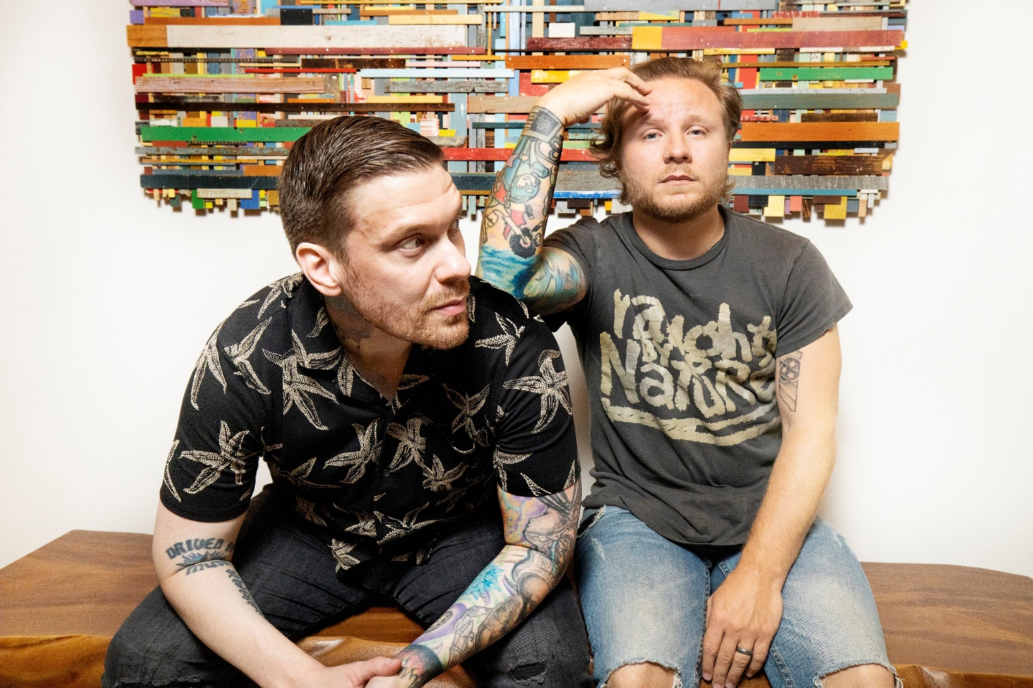
(Photo Credit: Paris Visone)

New York, NY – [October 9, 2020] – Today Smith & Myers – the duo comprised of multi-platinum artists Brent Smith and Zach Myers – have released their full-length album Smith & Myers Volume 1 via Atlantic Records – PRESS HERE to listen/stream. They have also released a brand new video for song “PANIC!” which plays on how the reactive nature of social media can perpetuate misinformation and panic over acoustic guitar and a frenetic staccato verse - PRESS HERE to watch. Volume 1 showcases Smith & Myers’ eloquent songcraft, indelible melodies, and glorious vocals created with nothing more than a microphone and an instrument or two. The album features five original songs, including single “Not Mad Enough” which was written in the immediate aftermath of George Floyd's death and addresses systemic and racial injustice (PRESS HERE to watch the video), and five re-imaginings of fan submitted songs including a poignant version of "Rockin' In The Free World" highlighting Neil Young's timeless lyrics that are just as relevant today over lone piano, as well as an upbeat acoustic rendition of Post Malone’s “Better Now,” a standout version of The Righteous Brothers’ “Unchained Melody,” and takes on " INXS' "Never Tear Us Apart" and Mark Ronson and Amy Winehouse's "Valerie" (full track listing below).

On October 23rd, Smith & Myers will release their follow up full-length album, Smith & Myers Volume 2, via Atlantic Records. The first original track off Volume 2, "Bad At Love," is a vulnerable and personal song about the difficulties of staying in a romantic relationship when you have a gypsy heart, full of clean guitar coils and finger-snaps. The duo also recently released a grungy, re-imagined version of Billie Eilish’s "Bad Guy". Volume 2 is available for pre-order now and also features five originals and five covers including Oasis’s “Don’t Look Back In Anger,” Peter Gabriel’s “Sledgehammer,” Billy Idol’s “Rebel Yell,” and R.E.M.’s “Losing My Religion.” Additionally, both the CD and LP - which collect Volumes 1 and 2 in one package - are also available now for pre-order. The Double LP is pressed on 180 gram vinyl and available in an exclusive limited edition Shiny Black vinyl in the S&M store. The vinyl will be released 11/13.
With two hearts and one truth, lifelong musicians, longstanding friends, and eternal brothers Brent Smith and Zach Myers put forth a body of work encompassing vulnerability, fearlessness, honesty, outrage, love, and understanding. Smith & Myers Volume 1, produced by GRAMMY Award-winner and longtime collaborator Dave Bassett, is the duo’s first full-length album and first original music since releasing a pair of acoustic cover EPs, Acoustic Sessions, Part 1 and Acoustic Sessions, Part 2, in 2014 when fans first fell in the love with the magic that is created between Brent and Zach in the studio and on stage, leading to Smith & Myers live shows that instantly sold out. With no boundaries on what their songwriting could discuss on the new album, Brent and Zach explore everything from certain personal topics that they have left largely unexplored until now, to commentary on children being ripped from their parents at the border, to the reactive nature of social media, to our national reckoning with racial and systemic injustice– focusing not on politics, but on right and wrong and our connection as human beings.
Smith & Myers illuminates the depth of Brent and Zach as a duo and showcases a very different yet just as intriguing musical side of these two versatile artists. As one-half of multiplatinum band Shinedown, Brent and Zach can often be found topping the rock charts, earning mainstream recognition, and playing to sold-out arenas around the globe with 10 million albums and 10 million singles sold worldwide, 14 platinum and gold singles, five platinum and gold albums, more than 2.7 billion streams and 16 number one rock hits (breaking the record for the most ever #1s in the 39-year history of the Billboard Mainstream Rock Songs Chart with their single “Atlas Falls”). Shinedown recently presented their first installment check of $230,000 from their “Atlas Falls” COVID-19 fundraiser to humanitarian aid organization Direct Relief, one of the largest providers of humanitarian medical resources in the world whose mission is to improve the health and lives of people affected by poverty or emergency situations by mobilizing and providing essential medical resources needed for their care. This follows the $20,000 that Shinedown donated to kick off the fundraiser in March, bringing the total delivered to Direct Relief so far to a quarter million dollars. More than $300,000 has been raised to date and counting.

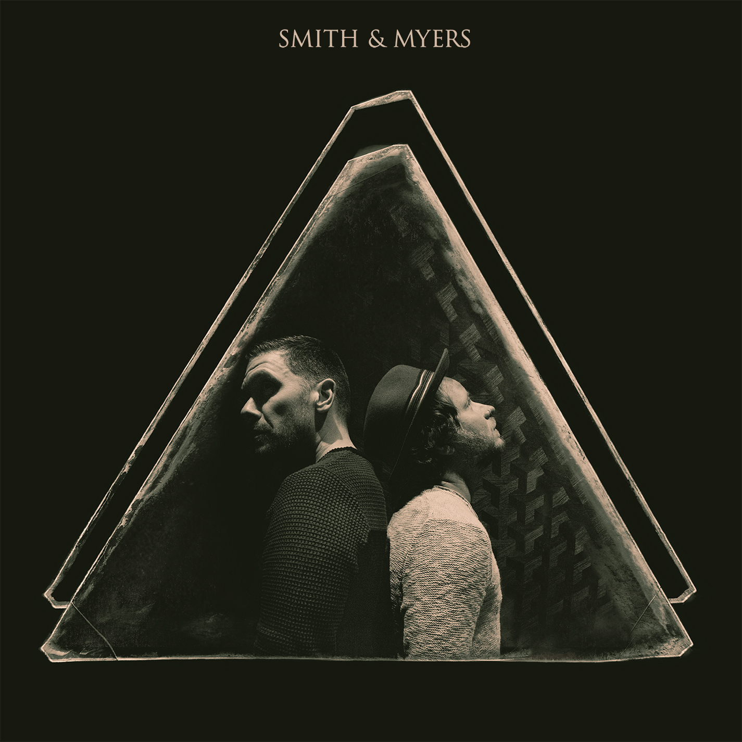
(Album Art)

Smith & Myers Volume 1 Track Listing:

1. Not Mad Enough
2. Rockin’ In The Free World
3. The Weight of It All
4. Better Now
5. Panic
6. Never Tear Us Apart
7. Coast To Coast
8. Valerie
9. Since You Were Mine
10. Unchained Melody

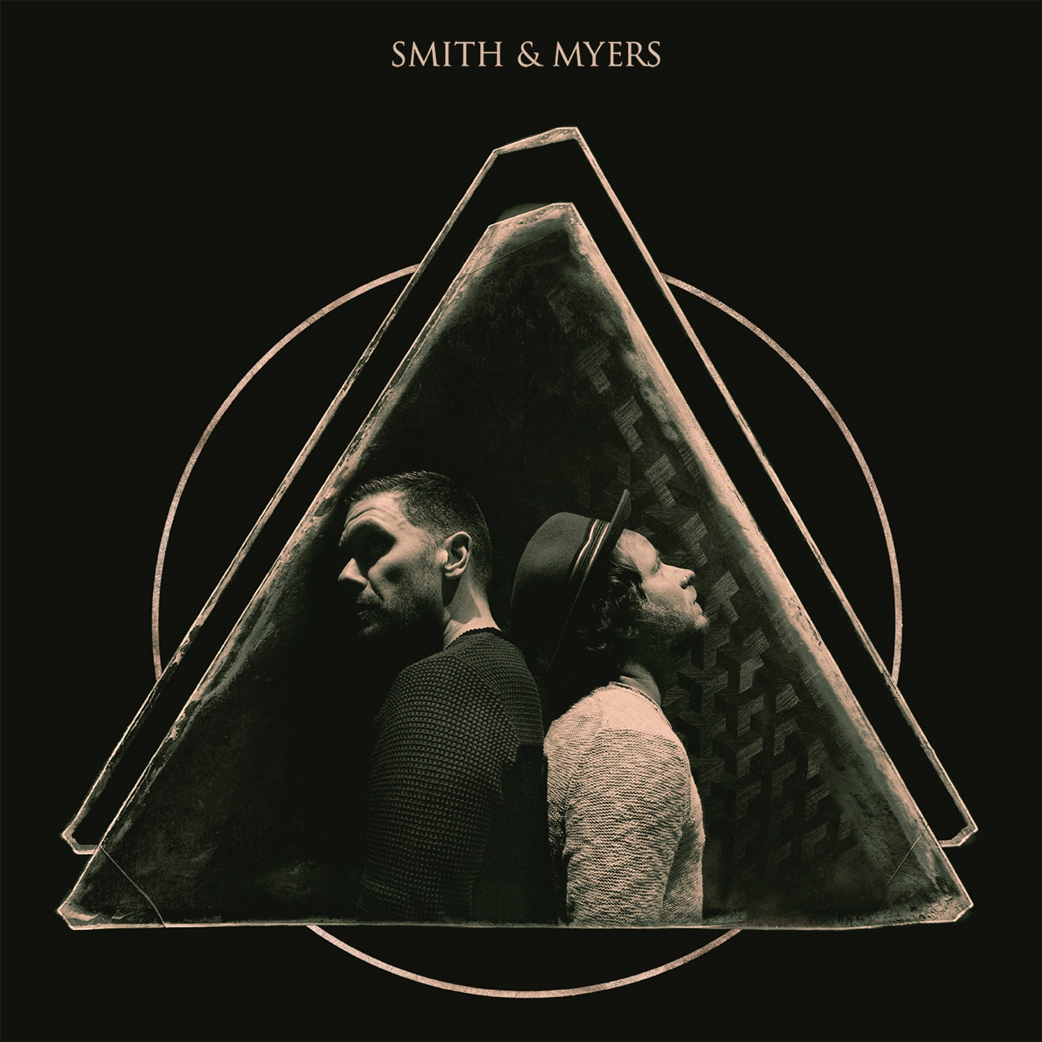
(Album Art)
Smith & Myers Volume 2 Track Listing:
1. Bad At Love
2. Bad Guy
3. New School Shiver
4. Sledgehammer
5. GBL GBD
6. Rebel Yell
7. Like You Never Left
8. Losing My Religion
9. One More Time
10. Don’t Look Back In Anger

UPCOMING SMITH & MYERS LIVE SHOWS
October 9 – Chicago, IL @ Lakeshore Drive-In
October 10 – Columbus, OH @ Westland Mall Drive-In
October 15 – East Swanzey, NH @ Cheshire Fairgrounds
October 17 – Pontiac, MI @ Crofoot Festival Grounds
October 21 – Memphis, TN @ Malco Summer Drive-In
October 22 – Alpharetta, GA @ Ameris Bank Amphitheatre

FOLLOW SMITH & MYERS
Web Site | Facebook | Instagram | Twitter | Spotify

For more information on Shinedown, please contact:

Press Here
Carla Senft / carla@pressherepublicity.com
Lucy Binetti / lbinetti@pressherepublicity.com

Atlantic Records
Glenn Fukushima / glenn.fukushima@atlanticrecords.com

