Multi-Platinum Artists Brent Smith and Zach Myers As Duo
Smith & Myers

Release Dual Songs & New Video
“Bad At Love” - PRESS HERE To Listen
&
A Re-Imagining of Billie Eilish’s “Bad Guy” - PRESS HERE To Listen

PRESS HERE To Watch The Video For “Bad At Love”
Announce Studio Album Smith & Myers Volume 2
Out October 23 via Atlantic Records

Smith & Myers Volume 1 Out October 9

String Of October Drive-In Shows Planned

Smith & Myers To Co-Headline Come Together: A Mental Health Music Festival On October 8th
Supporting Mental Health Resources & Programs In Response To The COVID-19 Pandemic

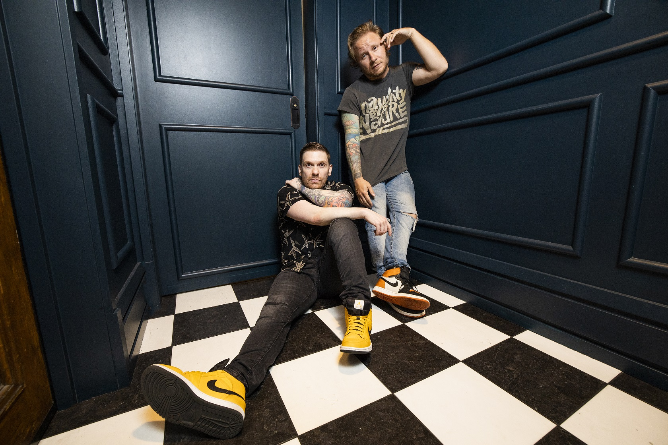
(PRESS HERE To Download Hi-Res; Credit Paris Visone)

New York, NY – [September 25, 2020] – Today, Smith & Myers – the duo comprised of multi-platinum artists Brent Smith and Zach Myers – have released dual songs from their newly-announced full-length album Smith & Myers Volume 2 out October 23 via Atlantic Records, that will follow the release of Volume 1 on October 9. Original track “Bad At Love” is a vulnerable and personal song about the difficulties of staying in a romantic relationship, full of clean guitar coils and finger-snaps, and is accompanied by a brand new video directed by Sanjay Parikh – PRESS HERE to watch and PRESS HERE to listen/stream. “Bad At Love” is paired with the release of a grungy, re-imagined version of Billie Eilish’s “Bad Guy” – PRESS HERE to listen/stream. Smith & Myers Volume 2 is available for pre-order now and features five original tunes and five re-imaginings of fan-submitted songs including Oasis’s “Don’t Look Back In Anger,” Peter Gabriel’s “Sledgehammer,” Billy Idol’s “Rebel Yell,” and R.E.M.’s “Losing My Religion” (full track listing below). Additionally, both the CD and LP - which collect Volumes 1 and 2 in one package - are also available now for pre-order. The Double LP is pressed on 180 gram vinyl and available in an exclusive limited edition Shiny Black vinyl in the S&M store. The vinyl will be released 11/13. PRESS HERE for the pre-orders.
“‘Bad At Love’ was one of the very first original songs to be written for the project. I think ultimately the song was born from my own romantic relationships. When I love someone, I love them fully, and sometimes the passion can be too much. I always know when it’s time to move on. That being said, I am extremely grateful that I am still very good friends with the ladies I have loved, and still love, to this day,” shares Brent.

“‘Bad at Love’ was one of the first original songs we wrote for this album ... lyrically Brent was writing about things in his life that maybe we wouldn’t really touch on with Shinedown and I think it came out to be an incredibly naked and honest song. And I think ‘Bad Guy’ turned out very cool – it’s a nice bluesy version of the song,” says Zach.

The new songs and the announcement of Volume 2 comes on the heels of Smith & Myers’ recent release of their original single “Not Mad Enough,” which was written in the immediate aftermath of George Floyd’s death, expressing the intense emotions that followed and laying bare a plea for racial justice through direct and urgent lyrics over acoustic guitar. PRESS HERE to listen/stream and PRESS HERE to watch the intimate, powerful video for “Not Mad Enough,” directed by Paris Visone. The song was released alongside a poignant version of “Rockin’ In The Free World” highlighting Neil Young’s timeless lyrics that are just as relevant today over lone piano – PRESS HERE to listen/stream. These two songs, featured on Volume 1, share a vision for change and equality and introduced Smith & Myers’ eloquent songcraft, indelible melodies and glorious vocals created with nothing more than a microphone and an instrument or two.

Smith & Myers Volume 1 is available for pre-order now HERE and features five original tunes and five re-imaginings of fan-submitted songs including Post Malone’s “Better Now,” INXS’ “Never Tear Us Apart,” Mark Ronson and Amy Winehouse’s “Valerie,” and The Righteous Brothers’ “Unchained Melody” (full track listing below).

With two hearts and one truth, lifelong musicians, longstanding friends, and eternal brothers Brent Smith and Zach Myers put forth a body of work encompassing vulnerability, fearlessness, honesty, outrage, love, and understanding. Smith & Myers Volume 1, produced by GRAMMY Award-winner and longtime collaborator Dave Bassett, is the duo’s first full-length album and first original music since releasing a pair of acoustic cover EPs, Acoustic Sessions, Part 1 and Acoustic Sessions, Part 2, in 2014 when fans first fell in the love with the magic that is created between Brent and Zach in the studio and on stage, leading to Smith & Myers live shows that instantly sold out. With no boundaries on what their songwriting could discuss on the new album, Brent and Zach explore everything from certain personal topics that they have left largely unexplored until now, to commentary on children being ripped from their parents at the border, to the reactive nature of social media, to our national reckoning with racial and systemic injustice– focusing not on politics, but on right and wrong and our connection as human beings.
On October 8th, Smith & Myers will co-headline Come Together, a virtual music festival organized by Sound Mind Live in celebration of World Mental Health Day (Oct. 10), with all proceeds supporting mental health resources and programs in response to the COVID-19 pandemic. The event, which will also feature performances from Jason Isbell, Kiiara, American Authors, Jade Bird and more, will be streamed live on Thursday, October 8, at 8 p.m. ET/5 p.m. PT via the Relix YouTube Channel in support of the cause. The National Alliance on Mental Illness of New York City is a founding partner of this landmark event, and AbbVie is the presenting sponsor. Experts from Mental Health America, MusiCares®, and National Alliance on Mental Illness of New York City will provide information on virtual mental health resources, support programs, and best practices for self-care as the individuals and families navigate these challenging times. Viewers will have the opportunity to access a live interactive chat and donate in real time, with proceeds benefiting affiliates of National Alliance on Mental Illness (NAMI) from around the country and their pandemic-response mental health programs.
Additionally, Smith & Myers will bring their powerful live duo show to fans with a string of drive-in shows this October, full routing below. General on-sale for Chicago IL, Columbus OH, and East Swanzey NH are available now. For all remaining shows, artist, venue, and radio pre-sale tickets are available now, general on-sale begins September 26th at 10am local time. For tickets and more information, please visit smithandmyersmusic.com.

MORE ON SMITH & MYERS
Smith & Myers illuminates the depth of Brent and Zach as a duo and showcases a very different yet just as intriguing musical side of these two versatile artists. As one-half of multiplatinum band Shinedown, Brent and Zach can often be found topping the rock charts, earning mainstream recognition, and playing to sold-out arenas around the globe with 10 million albums and 10 million singles sold worldwide, 14 platinum and gold singles, five platinum and gold albums, more than 2.7 billion streams and 16 number one rock hits (breaking the record for the most ever #1s in the 39-year history of the Billboard Mainstream Rock Songs Chart with their single “Atlas Falls” which has amassed more than 6 million streams). Shinedown’s 2018 album ATTENTION ATTENTION (Atlantic Records) landed them on Live with Kelly & Ryan, garnered four iHeart Radio Music Award nominations, and earned them an invitation to 92Y’s prestigious talk series 92Y Talks in NYC. Most recently, in response to the COVID-19 pandemic, Shinedown raised more than $300,000 by making available a T-shirt and song bundle featuring a single from their vault “Atlas Falls,” with all proceeds going to humanitarian aid organization Direct Relief - one of the largest providers of humanitarian medical resources in the world that is working to provide personal protective equipment to frontline health workers and essential medications and supplies for patients.

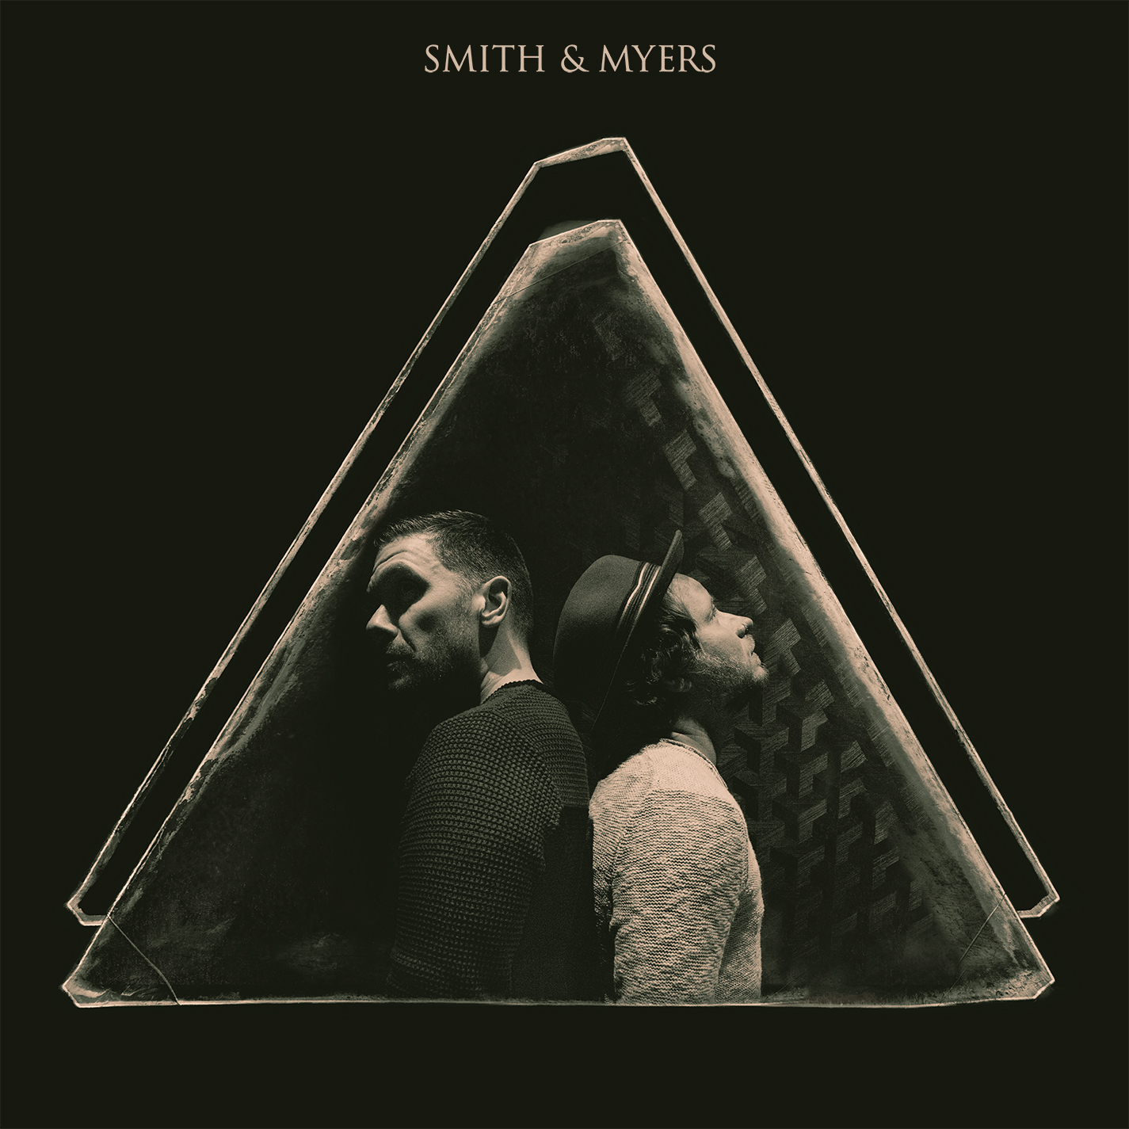
(Album Art)

Smith & Myers Volume 1 Track Listing:

1. Not Mad Enough
2. Rockin’ In The Free World
3. The Weight of It All
4. Better Now
5. Panic
6. Never Tear Us Apart
7. Coast To Coast
8. Valerie
9. Since You Were Mine
10. Unchained Melody

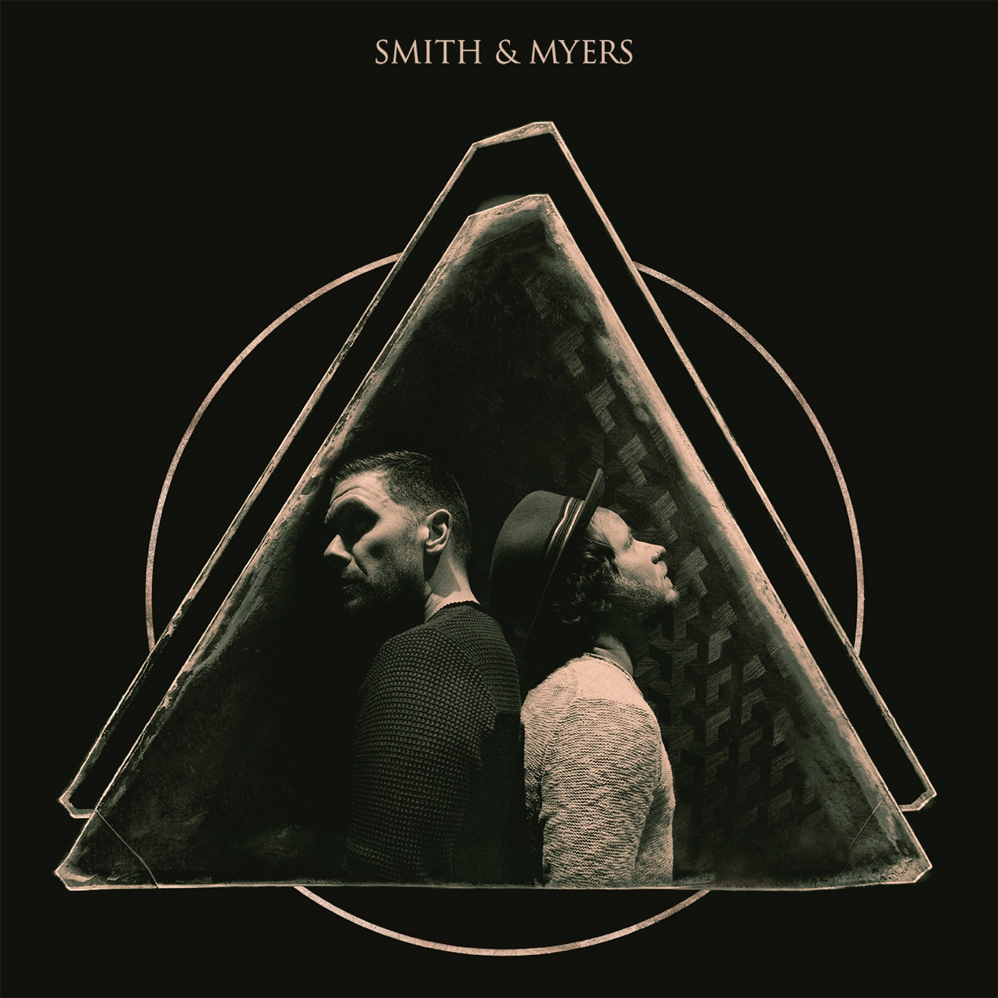
(Album Art)
Smith & Myers Volume 2 Track Listing:
1. Bad At Love
2. Bad Guy
3. New School Shiver
4. Sledgehammer
5. GBL GBD
6. Rebel Yell
7. Like You Never Left
8. Losing My Religion
9. One More Time
10. Don’t Look Back In Anger

UPCOMING SMITH & MYERS LIVE SHOWS
October 9 – Chicago, IL @ Lakeshore Drive-In
October 10 – Columbus, OH @ Westland Mall Drive-In
October 15 – East Swanzey, NH @ Cheshire Fairgrounds
October 17 – Pontiac, MI @ Crofoot Festival Grounds
October 21 – Memphis, TN @ Malco Summer Drive-In

FOLLOW SMITH & MYERS
Web Site | Facebook | Instagram | Twitter | Spotify

For more information on Shinedown, please contact:

Press Here
Carla Senft / carla@pressherepublicity.com
Lucy Binetti / lbinetti@pressherepublicity.com

Atlantic Records
Glenn Fukushima / glenn.fukushima@atlanticrecords.com

