Multi-Platinum Artists Brent Smith and Zach Myers As Duo
Smith & Myers

Release New Album Smith & Myers Volume 2
Out Now via Atlantic Records
PRESS HERE To Watch The New Video For Song “One More Time”

Double Album Volume 1 & 2 Available on CD Now
Shiny Black 180-gram Vinyl Available For Pre-Order – Out Nov 13
Tune In To HelloooTV’s YouTube Tonight At 9PM ET/6PM PT
As Brent and Zach Perform The New Smith & Myers Songs Including Radio Single “Not Mad Enough” and Their Shinedown Hits

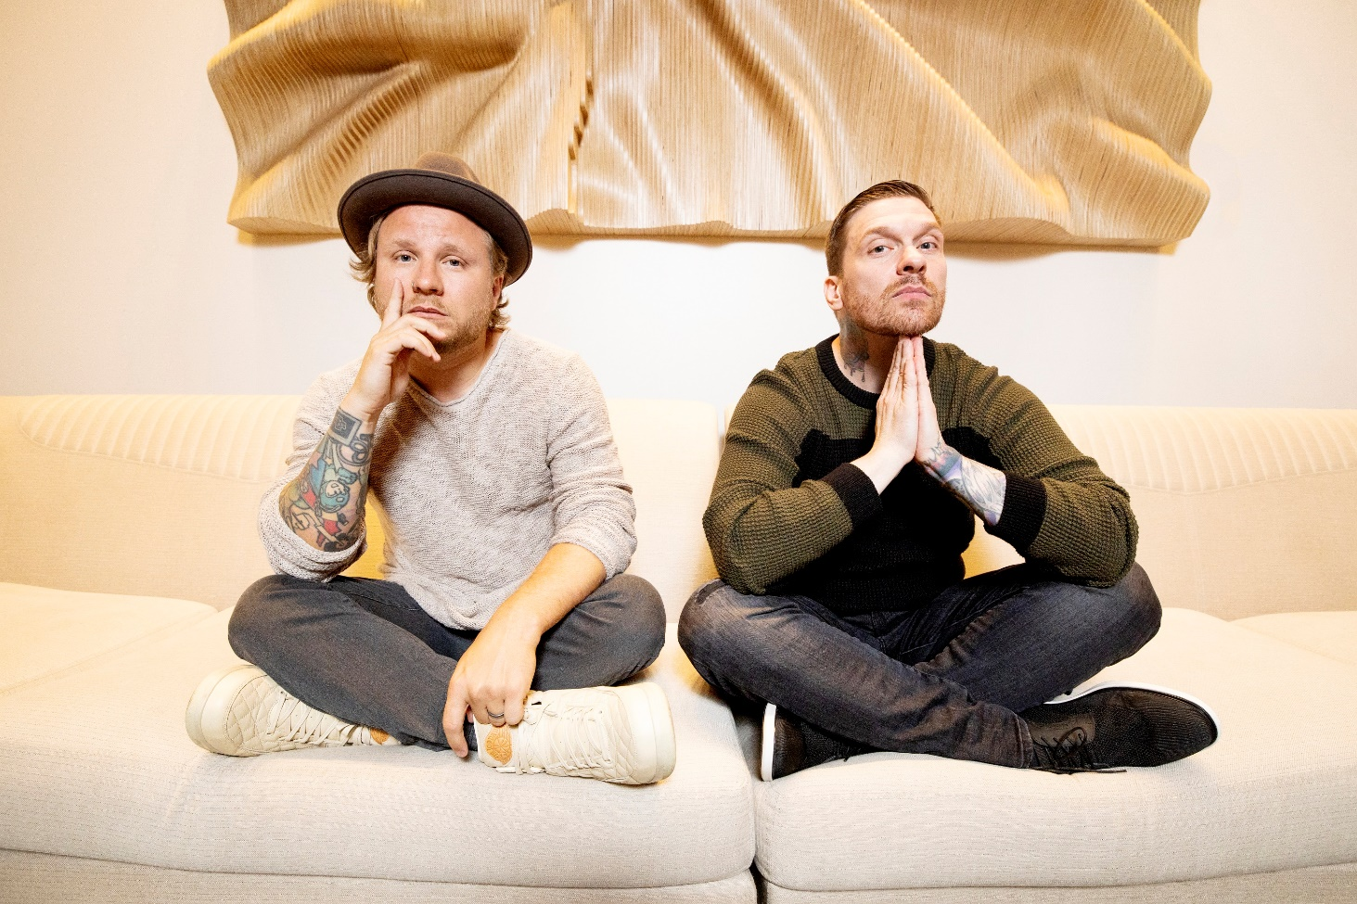
(Photo Credit: Paris Visone)

New York, NY – [October 23, 2020] – Today Smith & Myers – the duo comprised of multi-platinum artists Brent Smith and Zach Myers – have released their full-length album Smith & Myers Volume 2 via Atlantic Records, completing their double album – PRESS HERE to listen/stream Volume 2, which follows the release of Volume 1 earlier this month. They have also released a brand new video for original song “One More Time,” a gritty and colorful visual for the catchy alt-rock tune accented with solo electric guitar riffs – PRESS HERE to watch the video directed by Paris Visone. Both volumes showcase Smith & Myers’ ability to pack power and soul into songs created with nothing more than a microphone and an instrument or two, highlighting their sonic versatility throughout a mix of poignant original songs and unexpected covers. Volume 2 features five original songs, including “Bad At Love” a vulnerable and personal song about the difficulties of staying in a romantic relationship when you have a gypsy heart, full of clean guitar coils and finger-snaps and five re-imaginings of fan submitted songs including a grungy version of Billie Eilish’s “Bad Guy” as well as an electrifying rendition of Peter Gabriel’s “Sledgehammer,” a euphoric version of Oasis’ “Don’t Look Back In Anger,” and unique takes on Billy Idol’s “Rebel Yell” and R.E.M.’s “Losing My Religion” (full track listing below).

Volume 1 and Volume 2 are available as a double album on CD now. The Double LP, an exclusive limited edition 180-gram Shiny Black vinyl, is available for pre-order now and will be released November 13th. PRESS HERE to purchase/pre-order on the Smith & Myers store.
Additionally, Smith & Myers will celebrate the release of Smith & Myers Volume 2 with a special live performance which will be streamed tonight, October 23, at 9PM ET/6PM PT via the HelloooTV YouTube Channel.

Earlier this month, Volume 1 kicked off with a pair of songs that speak to the times we are living through – single “Not Mad Enough” was written the night of George Floyd’s death and addresses systemic and racial injustice alongside a powerful version of “Rockin’ In The Free World” highlighting Neil Young's timeless lyrics that are just as relevant today over lone piano, as well as an upbeat acoustic rendition of Post Malone’s “Better Now,” a standout version of The Righteous Brothers’ “Unchained Melody,” and takes on " INXS' "Never Tear Us Apart" and Mark Ronson and Amy Winehouse's "Valerie" (full track listing below).
With two hearts and one truth, lifelong musicians, longstanding friends, and eternal brothers Brent Smith and Zach Myers put forth a body of work encompassing vulnerability, fearlessness, honesty, outrage, love, and understanding. Smith & Myers Volume 1, produced by GRAMMY Award-winner and longtime collaborator Dave Bassett, is the duo’s first full-length album and first original music since releasing a pair of acoustic cover EPs, Acoustic Sessions, Part 1 and Acoustic Sessions, Part 2, in 2014 when fans first fell in the love with the magic that is created between Brent and Zach in the studio and on stage, leading to Smith & Myers live shows that instantly sold out. With no boundaries on what their songwriting could discuss on the new album, Brent and Zach explore everything from certain personal topics that they have left largely unexplored until now, to commentary on children being ripped from their parents at the border, to the reactive nature of social media, to our national reckoning with racial and systemic injustice– focusing not on politics, but on right and wrong and our connection as human beings.
Smith & Myers illuminates the depth of Brent and Zach as a duo and showcases a very different yet just as intriguing musical side of these two versatile artists. As one-half of multiplatinum band Shinedown, Brent and Zach can often be found topping the rock charts, earning mainstream recognition, and playing to sold-out arenas around the globe with 10 million albums and 10 million singles sold worldwide, 14 platinum and gold singles, five platinum and gold albums, more than 2.7 billion streams and 16 number one rock hits (breaking the record for the most ever #1s in the 39-year history of the Billboard Mainstream Rock Songs Chart with their single “Atlas Falls”). Shinedown recently presented their first installment check of $230,000 from their “Atlas Falls” COVID-19 fundraiser to humanitarian aid organization Direct Relief, one of the largest providers of humanitarian medical resources in the world whose mission is to improve the health and lives of people affected by poverty or emergency situations by mobilizing and providing essential medical resources needed for their care. This follows the $20,000 that Shinedown donated to kick off the fundraiser in March, bringing the total delivered to Direct Relief so far to a quarter million dollars. More than $300,000 has been raised to date and counting.

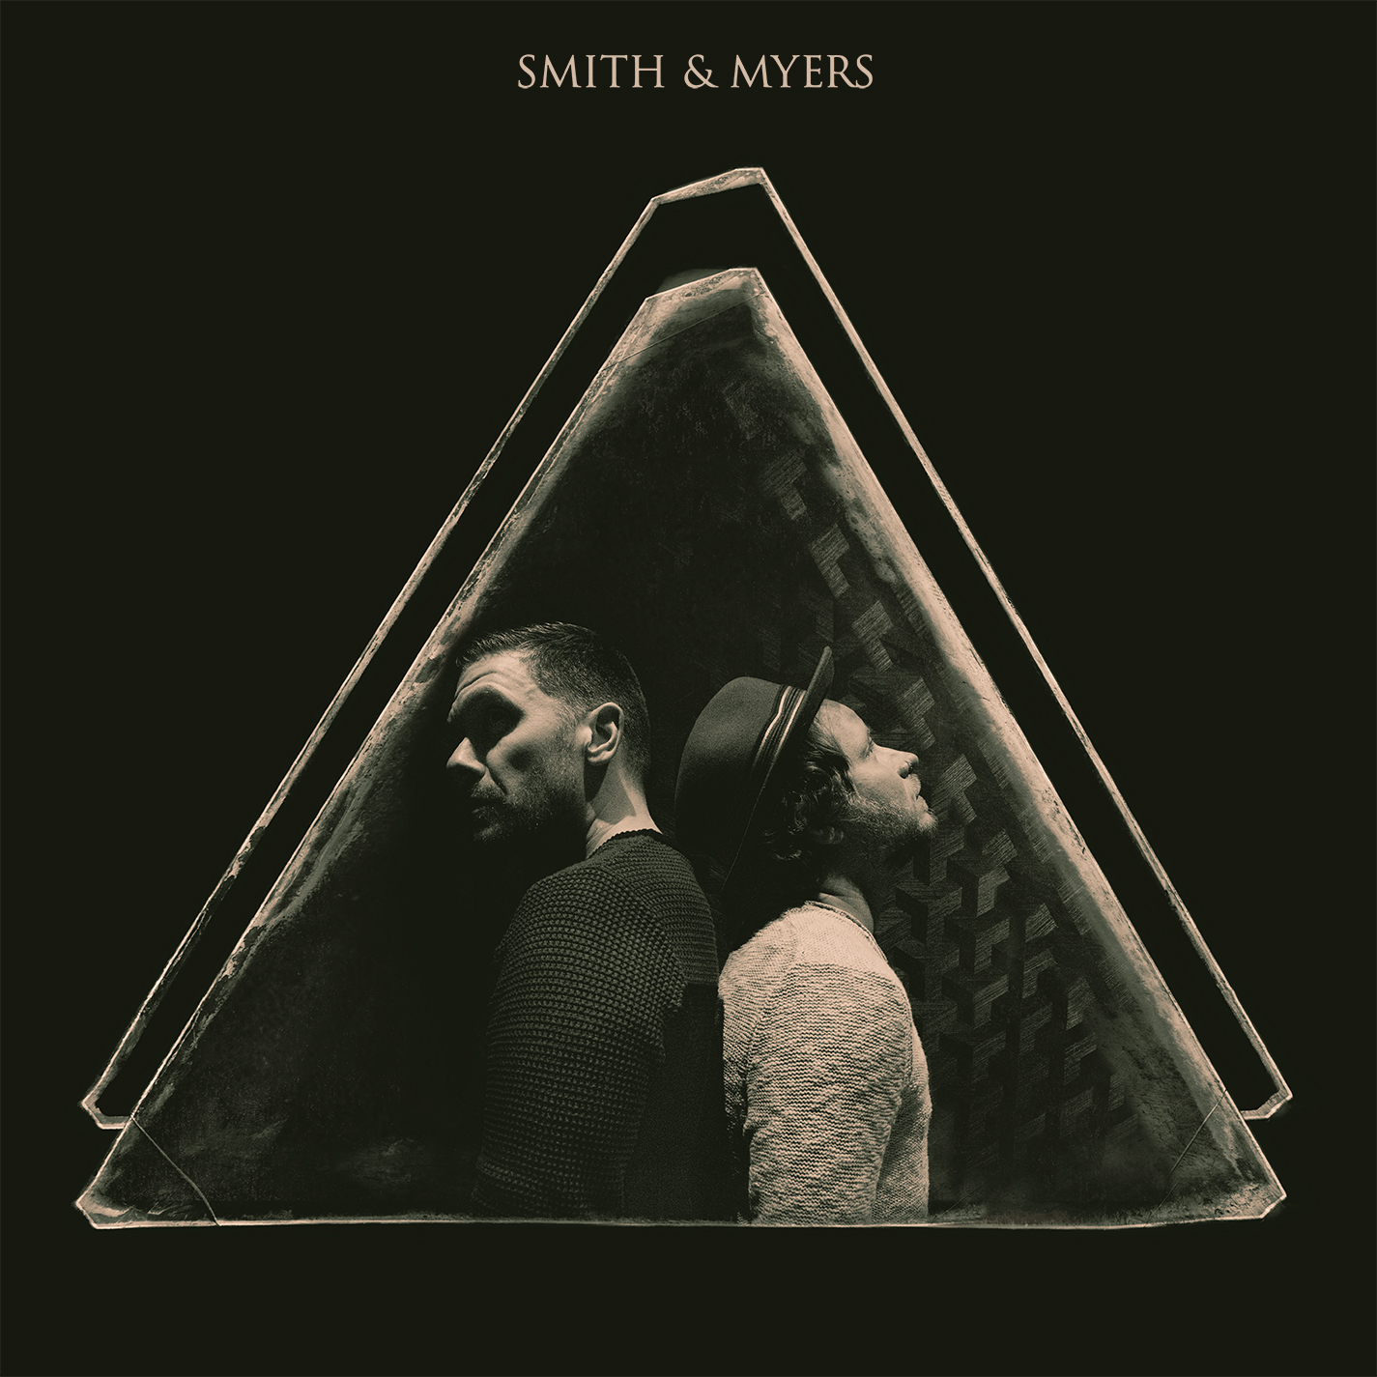
(Album Art)

Smith & Myers Volume 1 Track Listing:

1. Not Mad Enough
2. Rockin’ In The Free World
3. The Weight of It All
4. Better Now
5. Panic
6. Never Tear Us Apart
7. Coast To Coast
8. Valerie
9. Since You Were Mine
10. Unchained Melody

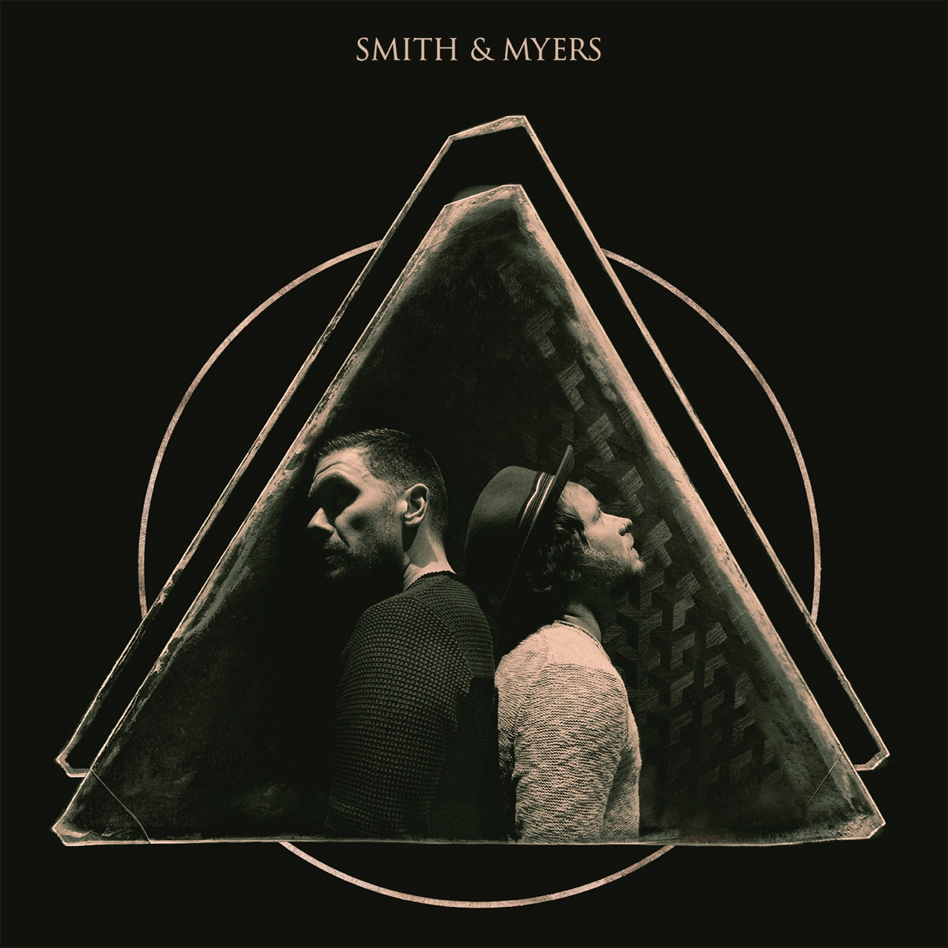
(Album Art)
Smith & Myers Volume 2 Track Listing:
1. Bad At Love
2. Bad Guy
3. New School Shiver
4. Sledgehammer
5. GBL GBD
6. Rebel Yell
7. Like You Never Left
8. Losing My Religion
9. One More Time
10. Don’t Look Back In Anger

FOLLOW SMITH & MYERS
Web Site | Facebook | Instagram | Twitter | Spotify

For more information on Shinedown, please contact:

Press Here
Carla Senft / carla@pressherepublicity.com
Lucy Binetti / lbinetti@pressherepublicity.com

Atlantic Records
Glenn Fukushima / glenn.fukushima@atlanticrecords.com

