ELECTRO-POP GROUP STUDIO KILLERS RELEASE ANIMATED LYRIC VIDEO
FOR VIRAL HIT “JENNY” (I WANNA RUIN OUR FRIENDSHIP)

WATCH HERE

SINGLE REACHES 152 MILLION GLOBAL STREAMS

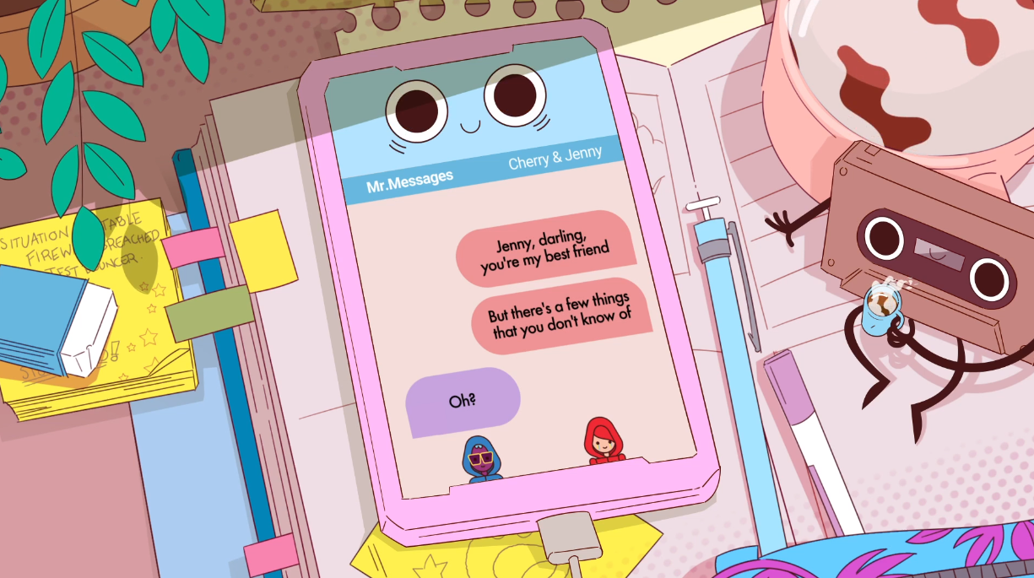

Animated virtual electro-pop group Studio Killers signed their TikTok viral hit “Jenny” to Atlantic Records last month, and today the group (known for their brilliantly surreal animated videos) releases the single’s accompanying lyric video. Watch the song unfold through text messages between band member Cherry and her best friend/lover Jenny HERE.

Studio Killers’ breakout single “Jenny” found a second life thanks to the extraordinarily unpredictable world of TikTok and now has a new label home of Atlantic Records, who signed the single to their label in December. Listen and watch the official music video HERE.

Composed of frontwoman and vocalist Cherry, keytarist Goldie Foxx, Dyna Mink, Studio Killers’ “Jenny” is an infectiously catchy song that opens with a tweaked accordion beat set against steel drums. The song takes a surprising twist early on, with Studio Killers’ frontwoman Cherry singing to her best friend Jenny, confessing her desire to ruin their friendship and be lovers instead. The song recently took off within the LGBTQIA+ community on TikTok back in September and has turned in to one of 2020’s biggest hits and still continues to be as we roll into 2021.

Once it began trending on TikTok circles this Fall, the song echoed around the platform (and beyond) for more than 10 weeks. In December, the “Jenny” trend exploded into the mainstream, garnering over 1 million creations on TikTok alone across various original users. Unsurprisingly, the subsequent viral nature of TikTok’s impressions have translated to stream counts of the single skyrocketing across the board, netting 7.5 million streams in seven days. The YouTube video has taken off as well, now over 77.5 million views!

“Jenny” shot up viral charts worldwide too, charting on more than 53 country and global viral charts, 90% of which were the Top 10 (including peaking at #6 on Spotify’s Global Viral Chart and #3 on Spotify’s US Viral chart). To put it in context, “Jenny” was nabbing a still incredibly-respectable 55k streams a day back in July (not bad for a song that’s five years old), but since the TikTok discovery, the song has shot up to the hundreds of thousands a day, with its highest peak to date at 947.7k on November 30!

2021 brings a long-awaited return from Studio Killers, and fans around the globe will soon hear the music they’ve been highly anticipating from the group. Stay tuned!

CONNECT WITH STUDIO KILLERS:
Facebook | Instagram | YouTube | Spotify | Official Website

FOR MORE INFORMATION:
Paige Rosoff – Big Beat Records
Paige.Rosoff@atlanticrecords.com

