STUDIO KILLERS AND KIM PETRAS
TEAM UP ON NEW VERSION OF VIRAL ANTHEM
“JENNY” (I WANNA RUIN OUR FRIENDSHIP)

WATCH HERE: https://studiokillers.lnk.to/JennyKimPetras

THE ORIGINAL VERSION APPROACHES 200 MILLION GLOBAL STREAMS

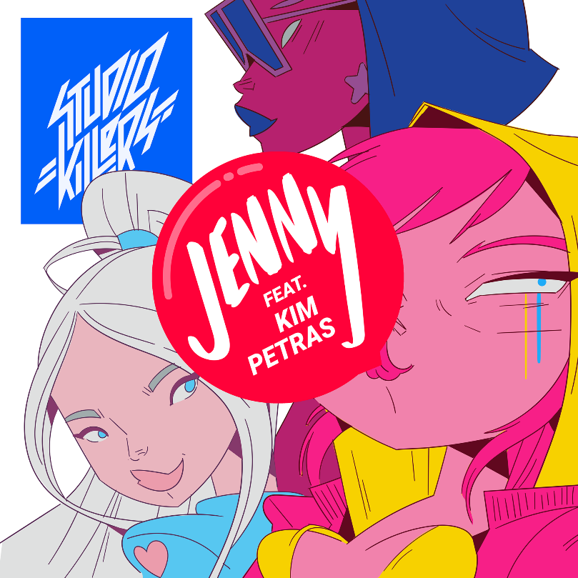

From being the best kept secret in the LGBTQ+ community, to viral trends on Tik Tok that sparked conversations around the world, to being an internationally known crown jewel signed to Atlantic Records: Studio Killers track “Jenny (I Wanna Ruin Our Friendship)” is a gift that keeps on giving – and today it gets even better. The beloved Kim Petras has hopped the track, bringing the bouncy anthem to the next level – and in true Kim Petras fashion, it’s pure pop perfection. Listen HERE.

The song takes a surprising twist early on, with Studio Killers’ frontwoman Cherry singing to her best friend Jenny, confessing her desire to ruin their friendship and be lovers instead. From the outpouring of support around the world, it’s undeniable the impact “Jenny” has had in the LGBTQ+ community, igniting conversations about culture and inspiring fans to share their memories associated with the song. Kim Petras being a member of the community and a confident voice for so many within it (in addition to being a fan of the song!) made for a natural fit and led her to lend her powerful vocals to this new version.

“I’m super excited for this release! I loved the song when I heard it on TikTok for the first time,” said Kim. “With the LGBTQ theme in the lyrics it just made sense and I had to jump on it right away.”

“We never thought we’d be told that Jenny would go viral and have over 3 billion views on TikTok or close to 200m streams worldwide. This blows our mind” said Studio Killers. “Jenny and Cherry can’t believe they are still living their best lives with this release! We’ve been a fan of Kim’s for a while now so it only seemed fitting to add her to our SK world. We are so excited she is on this new mix and can’t wait for you all to hear it!”

Homegrown all the way, Studio Killers is an unlikely seed of pop magic comprised of architects of music and vibrant animation. The band members are iconic fictional characters who have been capturing hearts with their infectious electronic music and visual delights since 2011: femme boss and front woman Cherry, keytarist Goldie Foxx and DJ Dyna Mink. Their first single ‘Ode to the Bouncer’ knocked down the door and rode high in the European charts, before grabbing the no.1 airplay position in the Netherlands. Their first album was self-released globally on Studio Killers Records & rose to no.1 on the US and Canadian iTunes dance charts. Without major label backing, the album reached an impressive no.16 on the US combined album chart.

Fast-rising international pop sensation Kim Petras has become one of music’s most buzzed-about artists. Her newest single “Malibu” (PRESS HERE) - a glittering, sun-kissed bop inspired by the silver screen, Baywatch fantasy of Malibu – is quickly adding to her more than 550 million global streams. Kim also recently released a star-studded “Malibu (At Home Edition)” fan video. PRESS HERE to watch the video, which features Kim’s most spirited fans alongside some special celebrity friends including Demi Lovato, Paris Hilton, Jonathan Van Ness, Charli XCX, Jessie J, and many more. Kim’s acclaimed 2019 debut full-length project Clarity dominated Spotify’s “New Music Friday” and Apple Music’s “Best of The Week” playlists for 10 consecutive weeks with its acclaimed singles, including glacial hit “Icy” (PRESS HERE) which landed her on Good Morning America for her national TV debut. Selling her first ticket in 2019, Kim sold out her first-ever headline tour last summer in minutes during presale, and her international The Clarity Tour sold out The Shrine in LA and two back to back nights at Avant Gardner in NYC. Kim’s undeniable voice and imaginative artistry have skyrocketed her to international recognition and earned her major mainstream media acclaim from the likes of NY Times, NPR, Vanity Fair, People, Rolling Stone, MTV, Glamour, Elle, Variety, Harper’s Bazaar, Allure, Billboard, Cosmopolitan, Seventeen, Paper, V Magazine, Noisey, OUT, Pitchfork, i-D, Refinery29, and more. First breaking out with her #1 Spotify Global Viral 50 bop “I Don’t Want It At All,” Kim launched into Top 40 radio with her pop hit “Heart to Break,” opened for Troye Sivan, revived and redefined Halloween music with her spooky project TURN OFF THE LIGHT, collaborated with Charli XCX, Kygo, Cheat Codes, MAX, SOPHIE, Lil Aaron, Riot Games’ K-pop supergroup K/DA and more, appeared on “How It’s Done” from the Ariana-Grande-produced Charlie’s Angels soundtrack, and has been featured on multiple billboards in New York, London, and Los Angeles as a Spotify RISE artist.

Stay tuned, as 2021 brings a long-awaited return from Studio Killers, and fans around the globe will soon hear the music they’ve been highly anticipating from the group.

CONNECT WITH STUDIO KILLERS:
Facebook | Instagram | YouTube | Spotify | Official Website

CONNECT WITH KIM PETRAS:
Facebook | Instagram | YouTube | Spotify | Official Website

FOR MORE INFORMATION:

STUDIO KILLERS
Paige Rosoff
Paige.Rosoff@atlanticrecords.com
Atlantic Records | Big Beat Records

KIM PETRAS
Linda Carbone
Linda@presshereproductions.com

