**SYMBA UNVEILS NEW SINGLE “BIRDS IN THE BANDO”**

[**LISTEN TO “BIRDS IN THE BANDO” HERE**](https://therealsymba.lnk.to/BirdsInTheBando)

**RAPPER ON THE RISE’S FOLLOW UP TO ATLANTIC RECORDS DEBUT, “SERVE”**

**WATCH SYMBA’S FIERY NEW FREESTYLES** [**“BROKE IN A MINUTE”**](https://nam04.safelinks.protection.outlook.com/?url=https%3A%2F%2Ftherealsymba.lnk.to%2FBrokeInAMinuteFreestyle&data=02%7C01%7CBrian.Sommer%40atlanticrecords.com%7C4ecab3c6f2d5440d386008d7dbe32fa4%7C8367939002ec4ba1ad3d69da3fdd637e%7C0%7C0%7C637219641122546453&sdata=1sDalorsa0xTrhPknxO6OhPjhXgO%2F%2BinK4DEdctVDiA%3D&reserved=0) **&** [**“NOTHIN TO LOSE”**](https://nam04.safelinks.protection.outlook.com/?url=https%3A%2F%2Fwww.youtube.com%2Fwatch%3Fv%3DWdHi158jmWU&data=02%7C01%7CBrian.Sommer%40atlanticrecords.com%7C4ecab3c6f2d5440d386008d7dbe32fa4%7C8367939002ec4ba1ad3d69da3fdd637e%7C0%7C0%7C637219641122546453&sdata=nku9fFgCOEeZy%2BvvzDpgGKwQdtm1lUUlV2RmJa798HU%3D&reserved=0)

**+ HIS TIMELY FREESTYLE OVER FABOLOUS’** [**“COLD SUMMER”**](https://www.instagram.com/tv/B-nLgtLlOUI/?utm_source=ig_web_copy_link)

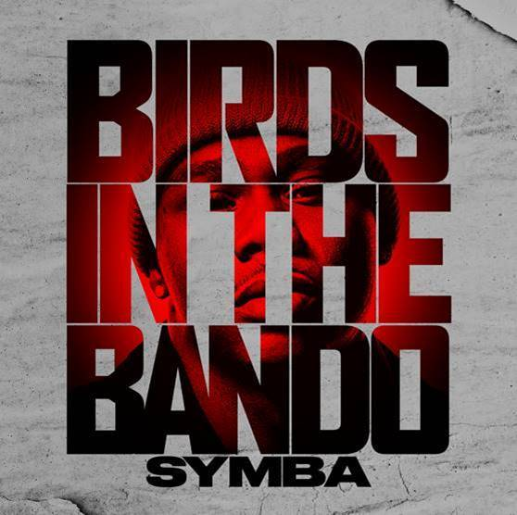

[DOWNLOAD ARTWORK HERE](https://nam04.safelinks.protection.outlook.com/?url=http%3A%2F%2Fpress.atlanticrecords.com%2Fsymba%2F&data=02%7C01%7CBrian.Sommer%40atlanticrecords.com%7C4ecab3c6f2d5440d386008d7dbe32fa4%7C8367939002ec4ba1ad3d69da3fdd637e%7C0%7C0%7C637219641122556448&sdata=fsN%2BV0GPzPP3%2FXHu2jY%2Bi0QylaaDCn6GDhuEl%2FT%2BL2c%3D&reserved=0)

**New York, NY – April 10, 2020 –** Bay Area-born and Los Angeles-based rapper **Symba** is back again with **“Birds In The Bando,”** another instant classic now available on all DSPs and digital retailers – [LISTEN HERE](https://therealsymba.lnk.to/BirdsInTheBando).

The fiery new tracksucceeds **Symba**’s previous single, [**“Serve,”**](https://nam04.safelinks.protection.outlook.com/?url=https%3A%2F%2Fwww.youtube.com%2Fwatch%3Fv%3D6YbQ9kngGis&data=02%7C01%7CBrian.Sommer%40atlanticrecords.com%7C4ecab3c6f2d5440d386008d7dbe32fa4%7C8367939002ec4ba1ad3d69da3fdd637e%7C0%7C0%7C637219641122556448&sdata=2yKN1bH8zHlVGaiQN01sobZ1maj4xjPYtMTKiTxhnp0%3D&reserved=0) the up-and-coming rap star’s Atlantic Records debut which premiered on [***Billboard***](https://nam04.safelinks.protection.outlook.com/?url=https%3A%2F%2Fwww.billboard.com%2Farticles%2Fcolumns%2Fhip-hop%2F9332309%2Fsymba-signs-atlantic-records-serve-video&data=02%7C01%7CBrian.Sommer%40atlanticrecords.com%7C4ecab3c6f2d5440d386008d7dbe32fa4%7C8367939002ec4ba1ad3d69da3fdd637e%7C0%7C0%7C637219641122566445&sdata=FoTHkbM7y4FG1HZ0uk9mghsvwPdPHktX82UP3OSrGTA%3D&reserved=0). **“Serve”** arrived accompanied by a **McCracken**-directed visual counterpart that found **Symba** serving time in jail while delivering crisp rap verses with an irresistible earworm hook.

**“Birds In The Bando”** also arrives after **Symba** unleashed a duo of fiery freestyles titled [**“Broke In A Minute”**](https://nam04.safelinks.protection.outlook.com/?url=https%3A%2F%2Fwww.youtube.com%2Fwatch%3Fv%3DmQhjlleAcio&data=02%7C01%7CBrian.Sommer%40atlanticrecords.com%7C4ecab3c6f2d5440d386008d7dbe32fa4%7C8367939002ec4ba1ad3d69da3fdd637e%7C0%7C0%7C637219641122566445&sdata=Ie3DWoTq6Y%2FcqG3pFgsu1hZs5dIsQXhQeC7nnG192ck%3D&reserved=0) and [**“Nothin To Lose”**](https://nam04.safelinks.protection.outlook.com/?url=https%3A%2F%2Fwww.youtube.com%2Fwatch%3Fv%3DWdHi158jmWU&data=02%7C01%7CBrian.Sommer%40atlanticrecords.com%7C4ecab3c6f2d5440d386008d7dbe32fa4%7C8367939002ec4ba1ad3d69da3fdd637e%7C0%7C0%7C637219641122576439&sdata=Cy1u9K%2FOyMDGtNJAs1kXV5IwI5e%2F8os07ndYR9fIxGE%3D&reserved=0) that highlight display the rising emcee’s lyricism and versatility.

**Symba** also recently took to social media for **Fabolous**’ [**#ColdSummerChallenge**](https://www.instagram.com/tv/B-nLgtLlOUI/?utm_source=ig_web_copy_link) to freestyle about the hardships everyday people are facing during the COVID-19 pandemic.

***ABOUT SYMBA:***

Inspired by everyone from JAY-Z to Steve Stoute and Steve Jobs, Bay Area-born and Los-Angeles based rapper Symba dove headfirst into the rap game following a rough upbringing. After a series of collaborations with Young Curt took off in the Bay, he headlined early Los Angeles shows on bills with the likes of YG, Tyga, and DJ Mustard as early as 2010. Symba struggled financially while recording, but eventually connected with friend and producer Nic Nac [Chris Brown, Kevin Gates] who encouraged him to move down to L.A. Upon arriving in the City of Angels, he turned heads with the *2 More Words* mixtape in 2015, boasting collaborations with the likes of Marc E. Bassy and IamSu!. In addition to praise from *XXL*, *Hypebeast* dubbed it, *“a fiery collection of songs balancing club-ready hooks with deft, incisive narratives*.*”* His grind paid off, and he inked a short-lived deal in 2017. A meeting with producer Cas inspired the next move.

Early demos caught the attention of Atlantic Records who signed him during 2019. Now, his single “Serve” chronicles a key moment. Over a throwback bass line and guitar buzz, he recalls his first experiences trapping taught by his uncle and outlined in vivid verses with this “Hustling Song.”

[**DOWNLOAD APPROVED PRESS IMAGE HERE**](https://app.box.com/s/rzabf812cy4gjy28vqga6ayf73mz1n3u)

***[Photo Credit: Jimmy Fontaine]***

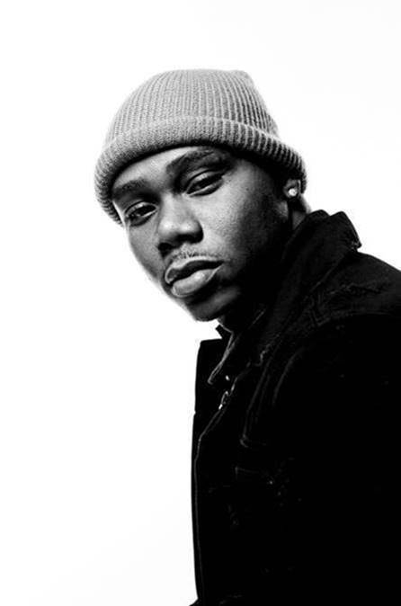

**CONNECT WITH SYMBA:**  
[INSTAGRAM](https://nam04.safelinks.protection.outlook.com/?url=https%3A%2F%2Fwww.instagram.com%2Ftherealsymba%2F%3Fhl%3Den&data=02%7C01%7CBrian.Sommer%40atlanticrecords.com%7C4ecab3c6f2d5440d386008d7dbe32fa4%7C8367939002ec4ba1ad3d69da3fdd637e%7C0%7C0%7C637219641122576439&sdata=HOclOVOyy%2F%2FwIhLKs5fcsR0SbQAAVgf8UZSb6egfN5E%3D&reserved=0) | [TWITTER](https://nam04.safelinks.protection.outlook.com/?url=https%3A%2F%2Ftwitter.com%2Ftherealsymba%3Flang%3Den&data=02%7C01%7CBrian.Sommer%40atlanticrecords.com%7C4ecab3c6f2d5440d386008d7dbe32fa4%7C8367939002ec4ba1ad3d69da3fdd637e%7C0%7C0%7C637219641122586436&sdata=s0iC2lPNsM7bzB9nSUa9QMYABjuA4siIQDfna9T7teY%3D&reserved=0) | [FACEBOOK](https://nam04.safelinks.protection.outlook.com/?url=https%3A%2F%2Fwww.facebook.com%2FTheRealSymba%2F&data=02%7C01%7CBrian.Sommer%40atlanticrecords.com%7C4ecab3c6f2d5440d386008d7dbe32fa4%7C8367939002ec4ba1ad3d69da3fdd637e%7C0%7C0%7C637219641122586436&sdata=0rWnl5Rk91LNEn0pMhkoBbpyOWDIIt4vAT2MT%2BjrzXc%3D&reserved=0) | [YOUTUBE](https://nam04.safelinks.protection.outlook.com/?url=https%3A%2F%2Fwww.youtube.com%2Fuser%2FSymbaOnline&data=02%7C01%7CBrian.Sommer%40atlanticrecords.com%7C4ecab3c6f2d5440d386008d7dbe32fa4%7C8367939002ec4ba1ad3d69da3fdd637e%7C0%7C0%7C637219641122596422&sdata=fSC4v7fBSZKk37Z%2FZo%2BB%2FSrwXjfayZEwNmy8JW54DdE%3D&reserved=0) | [WEBSITE](https://nam04.safelinks.protection.outlook.com/?url=http%3A%2F%2Fofficialsymba.com%2F&data=02%7C01%7CBrian.Sommer%40atlanticrecords.com%7C4ecab3c6f2d5440d386008d7dbe32fa4%7C8367939002ec4ba1ad3d69da3fdd637e%7C0%7C0%7C637219641122596422&sdata=4s23BTQZxhZ8m5otO074qDNAVUBX3lUHfRu5Ab4JUAU%3D&reserved=0)

**PRESS CONTACT:**

JASON DAVIS | [JASON.DAVIS@ATLANTICRECORDS.COM](mailto:JASON.DAVIS@ATLANTICRECORDS.COM)

# # #