SYMBA OFFICIALLY SIGNS WITH ATLANTIC RECORDS

BAY AREA-BORN, LOS ANGELES-BASED RAPPER CELEBRATES
RECORD DEAL WITH NEW SINGLE “SERVE” ALONGSIDE COMPANION VISUAL

ATLANTIC RECORDS DEBUT MIXTAPE DON’T RUN FROM R.A.P. DUE MAY 1ST

WATCH HERE | LISTEN HERE

DOWNLOAD APPROVED PRESS IMAGE HERE
[Photo Credit: Jimmy Fontaine]

New York, NY – March 11th, 2020 – Bay Area-born and Los Angeles-based rapper Symba has released his Atlantic Records debut single “Serve” alongside an eccentric companion visual to match – WATCH HERE.
True to its title, the McCracken-directed video finds Symba serving time in jail while delivering crisp rap verses with an earworm hook over a lo-fi beat.

“Serve is a story about the highlights of my life. When I first heard the beat, it gave me a flash back to the music my uncle used to listen to. So, I decided to tell the story about all the things my uncle had got me into to be able to make some money. He’s actually my mom’s best friend but I called him my uncle since he was like a brother to her. He was a smooth hustling ass player.”
- SYMBA

“Serve” marks Symba’s first official release as an Atlantic Records artist after he announced earlier today that he’d officially signed a deal with the label via Billboard.

Fans of the eclectic, up-and-coming rapper can expect more music arriving soon, with his Atlantic Records debut mixtape Don’t Run From R.A.P. due for release on May 1st.

ABOUT SYMBA:
Inspired by everyone from JAY-Z to Steve Stoute and Steve Jobs, Bay Area-born and Los-Angeles based rapper Symba dove headfirst into the rap game following a rough upbringing. After a series of collaborations with Young Curt took off in the Bay, he headlined early Los Angeles shows on bills with the likes of YG, Tyga, and DJ Mustard as early as 2010. Symba struggled financially while recording, but eventually connected with friend and producer Nic Nac [Chris Brown, Kevin Gates] who encouraged him to move down to L.A. Upon arriving in the City of Angels, he turned heads with the 2 More Words mixtape in 2015, boasting collaborations with the likes of Marc E. Bassy and IamSu!. In addition to praise from XXL, Hypebeast dubbed it, “a fiery collection of songs balancing club-ready hooks with deft, incisive narratives.” His grind paid off, and he inked a short-lived deal in 2017. A meeting with producer Cas inspired the next move.

Early demos caught the attention of Atlantic Records who signed him during 2019. Now, his single “Serve” chronicles a key moment. Over a throwback bass line and guitar buzz, he recalls his first experiences trapping taught by his uncle and outlined in vivid verses with this “Hustling Song.” It sets the stage for a lot more to come in 2020, including his debut Don’t Run From R.A.P.

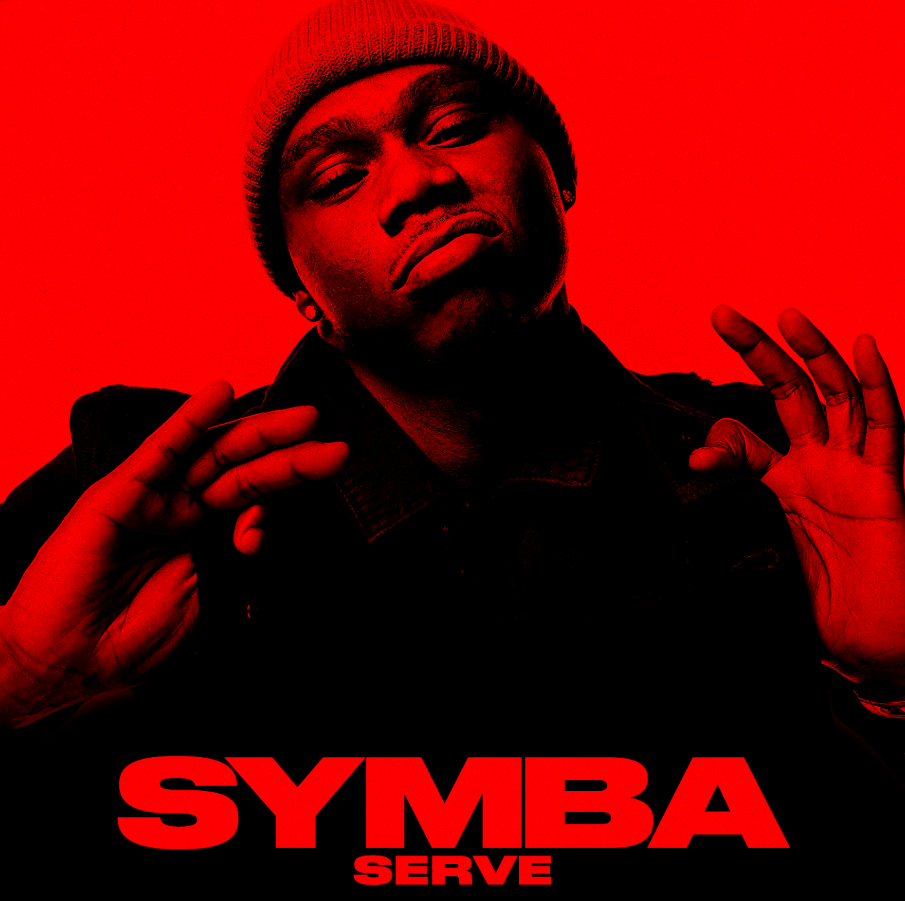
DOWNLOAD ARTWORK HERE

CONNECT WITH SYMBA:
INSTAGRAM | TWITTER | FACEBOOK | YOUTUBE | WEBSITE

PRESS CONTACT:
JASON DAVIS | JASON.DAVIS@ATLANTICRECORDS.COM

# # #

