FOR IMMEDIATE RELEASE
APRIL 30, 2021

THE MARÍAS UNVEIL “HUSH” –
FIRST SINGLE OFF UPCOMING DEBUT ALBUM CINEMA

EAGERLY AWAITED DEBUT ALBUM, CINEMA, DUE OUT JUNE 25TH

LISTEN TO “HUSH” HERE
CINEMA – PRE-ORDER | WATCH TRAILER FOR ALBUM

“The Marías have dreamed up a flurry of magnetizing tracks with redolent lyrics balanced out by melodies that meld jazz, funk, and electro-lounge…(María) beguiles with her velvety bilingual vocals, sultry grooves, and striking features.” – VOGUE

“It’s hard to describe The Marías without using the adjective “smooth” in every sentence. That’s the farthest thing from a put-down: Led by singer María, the band employs maximal slinkiness in the service of jazzy, gauzy, utterly charming, slyly funky pop.” – NPR

“The Marías play smooth, melodic pop with sensual lyrics in both English and Spanish, not to mention complicated grooves that hint at soul music and Latin jazz…María sings about love in a hushed murmur that invites the listener to lean in to catch every word.” – LOS ANGELES TIMES

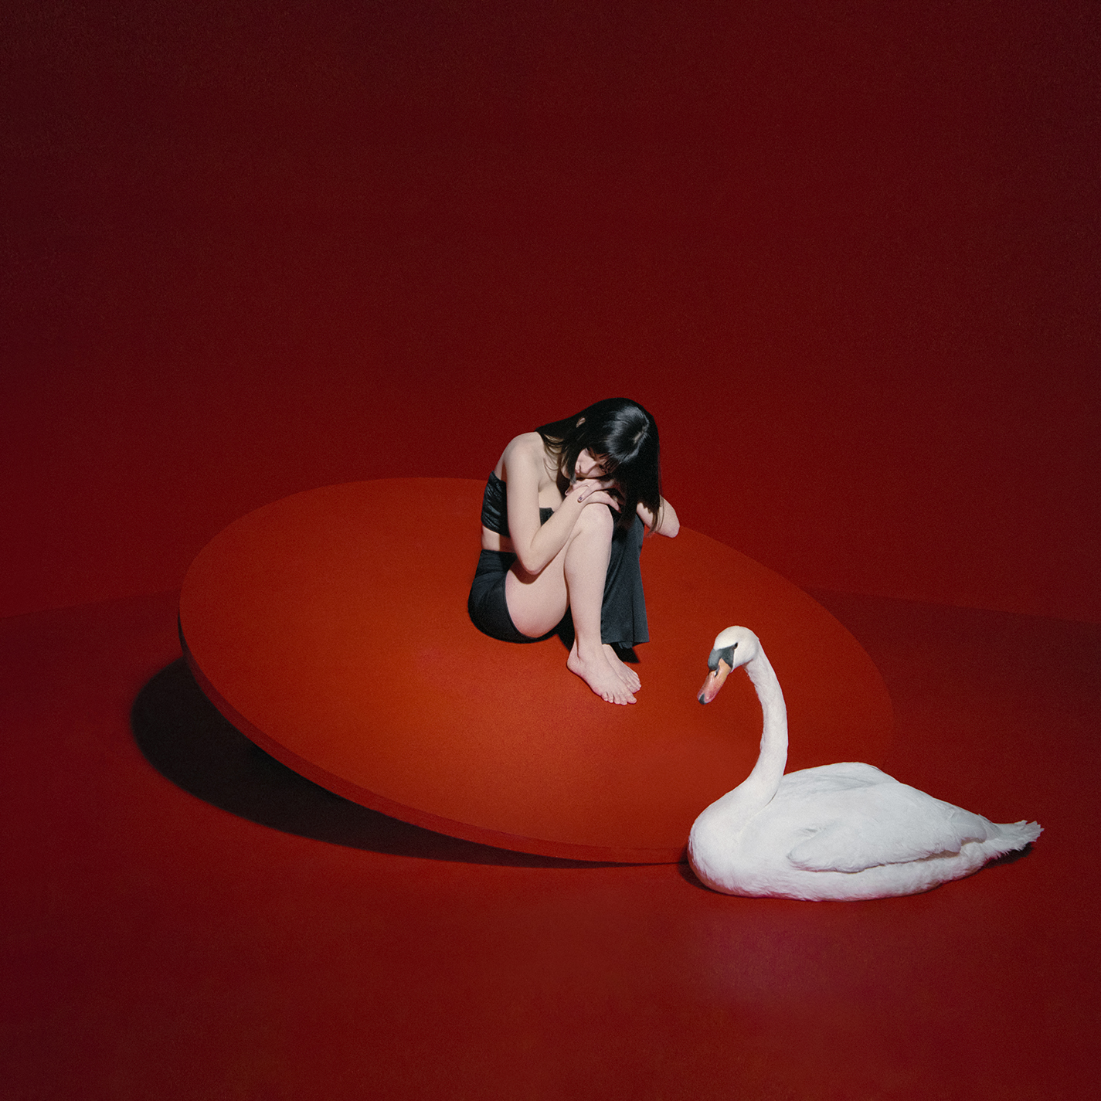
download hi res artwork here
download hi res press photos here

Acclaimed alternative-pop band The Marías have announced the release of their new single “Hush” – out today via Nice Life Recording Company and Atlantic Records (listen HERE).

“Hush” heralds The Marías’ eagerly awaited debut album, Cinema – due out June 25th – and also marks the band’s official debut for Nice Life and Atlantic – album pre-order is live now HERE. The group recently released a stunning trailer for the album – directed by lead singer María Zardoya and co-edited with producer/drummer Josh Conway (watch HERE).

Cinema – which features tracks in English and Spanish – draws inspiration from the classic films and directors that María and Josh grew up watching, including Pedro Almodóvar and Wes Anderson. The title also pays homage to how the band first began creating music in the first place.

“The Marías were born from cinema,” says María. “The reason Josh and I started writing music together was because of cinema. Through a friend, we were connected to a music supervisor who would send us requests for music for films. We’d receive a synopsis of a scene, and then we’d have to write music to it within a couple of days. Not only did that teach us how to write songs together fairly quickly, it taught us how to think like filmmakers. We’d imagine worlds in our minds based on the synopses – the colors in the scene, the lighting, the actors, the set design, and of course, the music.”

The Marías have fast proven among the most visionary and entrancing new bands in recent memory. Born in Puerto Rico and raised in Atlanta, María Zardoya moved to Los Angeles in 2016 where she met drummer Josh Conway after a performance at the famed Kibitz Room Bar at Canter’s Deli. The two began writing together, crafting a remarkable collection of mesmerizing original songs fusing kaleidoscopic soul, gentle jazz, and imagistic, bilingual lyricism. The couple is joined by their closest friends Jesse Perlman (guitar), Edward James (keys), and Gabe Steiner (trumpet) to complete the band.

The Marías quickly grew a passionate local following, prompting the Los Angeles Times to declare them “the perfect indie band for L.A. kids.” With sold out shows and rapidly increasing national attention, the band made an auspicious debut with their twin EPs: SUPERCLEAN, VOL. I (released in 2017) and 2018’s SUPERCLEAN, VOL II, the latter highlighted by the single, “Ruthless,” joined by an official video directed and produced by Ian Lipton and The Marías.

Last year saw The Marías unleash a series of new songs affirming their continued creative evolution. “Hold It Together” and “Jupiter” were released in the top half of 2020, accompanied by official music videos. The former received praise from The FADER, which wrote, “The pop-leaning and low-key love song features guitar and key lines that interlock hand in hand. Right in the pocket is the cotton candy-textured voice of vocalist María that coolly asks you to slow down with her.” Meanwhile, “Jupiter” was hailed as “a soothing dream from retro outer-space,” by Melted.

In October of last year, the group released two new songs written and recorded during lockdown – “Care For You” and “bop it up!” – both joined by official videos co-directed by María with longtime visual collaborator Bethany Vargas. “Care For You” received acclaim from V Magazine, which praised it as “a slow, jazzy jam, both sensual and soothing,” while Órale enthused, “‘bop it up!’ is unlike any project The Marías have put out before… Although their signature tenderness is still recognizable, listeners will discover a newfound sense of invigoration.” International art and fashion magazine Teeth added: “Both tracks are quarantine jams to dance and cry to, the kind of music we need during this endlessly trying time… The Marías have this incredible ability to transport you.”

Stay tuned for more news from The Marías in the coming months!

# # #

CONNECT WITH THE MARÍAS
OFFICIAL | INSTAGRAM | TWITTER | YOUTUBE | TIKTOK

FOR PRESS INQUIRIES, PLEASE CONTACT:
Ashley Kalmanowitz | Ashley.Kalmanowitz@AtlanticRecords.com
Libby Kober | Libby.Kober@AtlanticRecords.com
Trish Mollo | Trish.Mollo@AtlanticRecords.com

