FOR IMMEDIATE RELEASE
JUNE 4, 2021

THE MARÍAS UNVEIL “UN MILLÓN”

MESMERIZING NEW SINGLE HERALDS EAGERLY AWAITED DEBUT ALBUM, CINEMA

CINEMA ARRIVES FRIDAY, JUNE 25TH

LISTEN TO “UN MILLÓN” HERE

PRE-ORDER CINEMA | WATCH ALBUM TRAILER

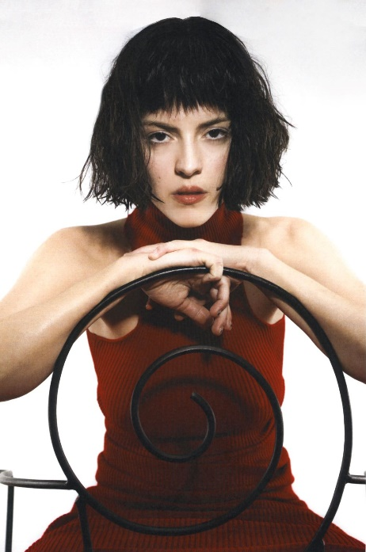

DOWNLOAD HI RES PRESS PHOTOS
DOWNLOAD HI RES ALBUM ARTWORK

“The Marías have dreamed up a flurry of magnetizing tracks with redolent lyrics balanced out by melodies that meld jazz, funk, and electro-lounge…(María) beguiles with her velvety bilingual vocals, sultry grooves, and striking features.” – VOGUE

“It’s hard to describe The Marías without using the adjective “smooth” in every sentence. That’s the farthest thing from a put-down: Led by singer María, the band employs maximal slinkiness in the service of jazzy, gauzy, utterly charming, slyly funky pop.” – NPR

“The Marías play smooth, melodic pop with sensual lyrics in both English and Spanish, not to mention complicated grooves that hint at soul music and Latin jazz…María sings about love in a hushed murmur that invites the listener to lean in to catch every word.” – LOS ANGELES TIMES

Acclaimed alternative-pop band The Marías have announced today’s premiere of their captivating new single – “Un Millón” (listen HERE). A thrilling new leap for the band, the track finds The Marías expanding their sonic palette and drawing influence from the potent rhythms of reggaetón. One of several songs in Spanish on CINEMA, “Un Millón” unfolds in swaying beats, spellbinding melodies, and lyrics expressing a tender affection for lead singer María Zardoya’s beloved birthplace of Puerto Rico. Today’s release arrives alongside an official visualizer – watch HERE.

“I wanted to pay homage to the island and its music and people,” she says, “so in the song I’m calling out some of the places I used to go visit with my family when I was little.”

“Un Millón” heralds the upcoming release of The Marías’ eagerly awaited full-length album, CINEMA, arriving via Nice Life Recording Company/Atlantic Records on Friday, June 25th; pre-orders are available now HERE.

The Marías recently celebrated CINEMA with a stunning new album trailer, directed by Zardoya and co-edited with producer/drummer Josh Conway – watch HERE. In dreaming up their first full-length, Zardoya and Conway mined inspiration from such hyper-imaginative filmmakers as Pedro Almodóvar and Wes Anderson, achieving an untamed emotionality that acutely amplifies the most intimate of feelings. By sharing CINEMA with the world, the band hopes to ignite a similarly powerful creative impulse in their listeners.

“We want people to feel inspired to create anything, whether it’s music or art or whatever else they’re drawn to,” says María. “Hopefully the songs will help them to break away from real life for a while and create some kind of dream world in their heads – something like the scenes to their own little movie.”

CINEMA also includes the bold, bass-heavy single, “Hush,” available now on all digital platforms HERE; a mystical official music video is streaming now HERE. “Hush” was instantly met with ecstatic praise from a wide variety of national media outlets:

PRAISE FOR THE MARÍAS AND “HUSH”

“The hypnotic lead single entrances with a minimal electronic beat and almost blasé, sometimes whispered kiss-offs, while the visual is reminiscent of giallo-era Italian horror. Decadent blood-red tones suggest something delightfully sinister is at work.”
– MTV

“The L.A.-based indie band embrace pop's ongoing (and always welcome) disco trend on this sultry lead single from their long-awaited debut album, CINEMA. This one's seriously sexy.”
– E!

“The Marías have finally put out the first single ahead of their highly-anticipated debut album… ‘Hush’ continues to develop their talent for breathy, hypnotic jams.”
– PASTE (“BEST NEW SONGS OF THE WEEK”)

“First single ‘Hush’ is definitely on the cinematic tip; modern noir synth.”
– BROOKLYN VEGAN

“After sharing a handful of effervescent singles, The Marías have officially unveiled their debut full-length album ‘Cinema’ with the dark pop anthem track ‘Hush.’ Over a reverberating beat, vocalist María Zardoya’s gossamer vocals delicately ushers in an era of sensual-yet-energizing music.”
– UPROXX

“A woozy, bass-heavy, and impeccably intoxicating track… as always it’s the chemistry between the couple that ignites something within their music.”
– GRIMY GOODS

“The Los Angeles-based group is the picture of unbothered excellence on the first lead-up to their new album…It doesn’t matter how cool you are – you’re probably not as cool as The Marías.”
– CULTURE COLLIDE

The Marías have fast proven among the most visionary and entrancing new bands in recent memory. Born in Puerto Rico and raised in Atlanta, María Zardoya moved to Los Angeles in 2016 where she met drummer Josh Conway after a performance at the famed Kibitz Room Bar at Canter’s Deli. The two began writing together, crafting a remarkable collection of mesmerizing original songs fusing kaleidoscopic soul, gentle jazz, and imagistic, bilingual lyricism. The couple is joined by their closest friends Jesse Perlman (guitar), Edward James (keys), and Gabe Steiner (trumpet) to complete the band.

The Marías quickly grew a passionate local following, prompting the Los Angeles Times to declare them “the perfect indie band for L.A. kids.” With sold out shows and rapidly increasing national attention, the band made an auspicious debut with their twin EPs: SUPERCLEAN, VOL. I (released in 2017) and 2018’s SUPERCLEAN, VOL II, the latter highlighted by the single, “Ruthless,” joined by an official video directed and produced by Ian Lipton and The Marías.

Last year saw The Marías unleash a series of new songs affirming their continued creative evolution. “Hold It Together” and “Jupiter” were released in the top half of 2020, accompanied by official music videos. Melted hailed “Jupiter” as “a soothing dream from retro outer-space” while “Hold It Together” received applause from such publications as The FADER, which wrote, “The pop-leaning and low-key love song features guitar and key lines that interlock hand in hand. Right in the pocket is the cotton candy-textured voice of vocalist María that coolly asks you to slow down with her.”

In October, The Marías released two new songs written and recorded during lockdown – “Care For You” and “bop it up!” – both joined by official videos co-directed by María with longtime visual collaborator Bethany Vargas. “Care For You” received acclaim from V Magazine, which praised it as “a slow, jazzy jam, both sensual and soothing,” while Órale enthused, “‘bop it up!’ is unlike any project The Marías have put out before… Although their signature tenderness is still recognizable, listeners will discover a newfound sense of invigoration.” “Both tracks are quarantine jams to dance and cry to, the kind of music we need during this endlessly trying time, added international art and fashion magazine Teeth. “The Marías have this incredible ability to transport you.”

# # #

CONNECT WITH THE MARÍAS
OFFICIAL | INSTAGRAM | TWITTER | YOUTUBE | TIKTOK

FOR PRESS INQUIRIES, PLEASE CONTACT:
Ashley Kalmanowitz | Ashley.Kalmanowitz@AtlanticRecords.com
Libby Kober | Libby.Kober@AtlanticRecords.com
Trish Mollo | Trish.Mollo@AtlanticRecords.com

