FOR IMMEDIATE RELEASE
FEBRUARY 18, 2022

TION WAYNE X M24 BRAND NEW SINGLE/VIDEO
KNOCK KNOCK

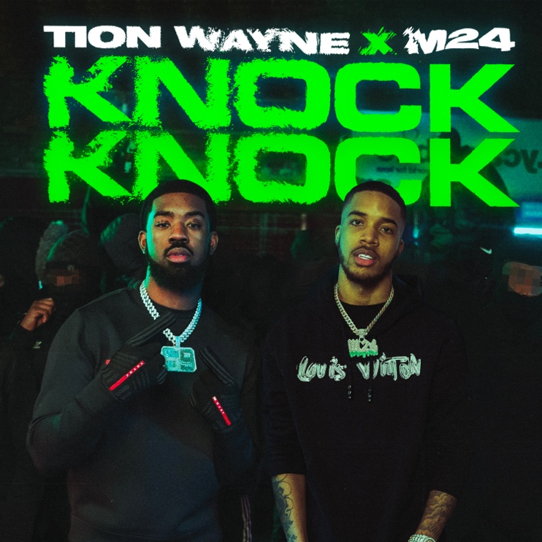

1.8 BILLION streams last year alone. The first drill track to go No.1 in the UK, Ireland, Australia, and New Zealand (with his Russ Millions collab Body). The most viewed video on YT & GRM Daily and most used sound on TikTok. Outside of Adele, is there another British artist that had a bigger 2021 than MOBO winning, Brit-nominated rap star Tion Wayne? Now the Titan of UK Rap has reunited with M24 for the first time since their Top 40 2019 collab London for new single KNOCK KNOCK. Purchase/stream the track via Atlantic Records here and watch the -directed video below.

WATCH THE VIDEO FOR KNOCK KNOCK

Previewing the single with over 1.5m views on TikTok in less than three days, the anticipation for Tion’s latest release is at an time high and once again, Tion does not disappoint. Produced by Andy Broski & Frank Ampomah, KNOCK KNOCK is another gothic-tinged drill banger guaranteed to be one of 2022’s biggest tracks.

With multiple UK Top 10 singles, a Top 5 album with his highly anticipated debut Green With Envy last September, a collaboration with Central Cee and Ed Sheeran on the Bad Habits remix and record-breaking sold-out shows across the UK, Tion Wayne has emerged as one of Britain’s biggest cultural exports. With heavy support across BBC Radio 1 and 1Xtra and consistent premium placement on the popular Spotify playlists Hot Hits UK, Rap UK and Who We Be, Tion Wayne has collaborated with some of the biggest and most exciting names working today including Stormzy, Potter Payper, D-Block Europe, Fivio Foreign, Davido, 6lack, Central Cee, Rema, NSG, Rudimental & Jack Harlow amongst others.

CONNECT WITH TION WAYNE
FACEBOOK | TWITTER | YOUTUBE | INSTAGRAM

FOR PRESS INQUIRIES CONTACT:
SELAM.BELAY@ATLANTICRECORDS.COM

