FOR IMMEDIATE RELEASE
DECEMBER 13, 2021

ATLANTIC RECORDS, XBOX AND COINBASE LAUNCH THE GREEN ROOM GAMING SERIES
WITH FIRST CELEBRITY PRO-AM HALO INFINITE EVENT

THE GREEN ROOM WILL FEATURE STREAMERS BUGHA, FAZE NATE HILL AND SNIP3DOWN, TEAMING UP WITH ATLANTIC RECORDS ARTISTS SUECO, BANKROL HAYDEN, JUCEE FROOT, ALT J’S THOM SONNY GREEN, AND NFL STARS BAKER MAYFIELD, JUJU SMITH-SCHUSTER AND UFC FIGHTER SEAN O'MALLEY - WITH MORE ADDITIONS TO BE ANNOUNCED SOON

TEAMS WILL COMPETE FOR $10K IN CRYPTOCURRENCY ON COINBASE + $10K IN CASH AND A CHAMPIONSHIP RING CUSTOM DESIGNED BY KAY JEWELERS
SERIES TO DEBUT “THE GREEN ROOM X AIM LAB COLLAB” FEATURING ARTIST CONTENT AND THE LAUNCH OF AIM LAB’S SPOTIFY PLAYLIST. IN-GAME SOUNDTRACK AIM LAB PRESENTS: THE GREEN ROOM, VOL. 1 TO BE UNVEILED SOON
IN PARTNERSHIP WITH GAMING LEADERS VAYNERSPORTS, EFUSE AND AIM LAB, THE FIRST INSTALLMENT OF THE GREEN ROOM TAKES PLACE WEDNESDAY, DECEMBER 15TH AT 6 PM EST ON ATLANTIC RECORDS’ YOUTUBE CHANNEL - HERE

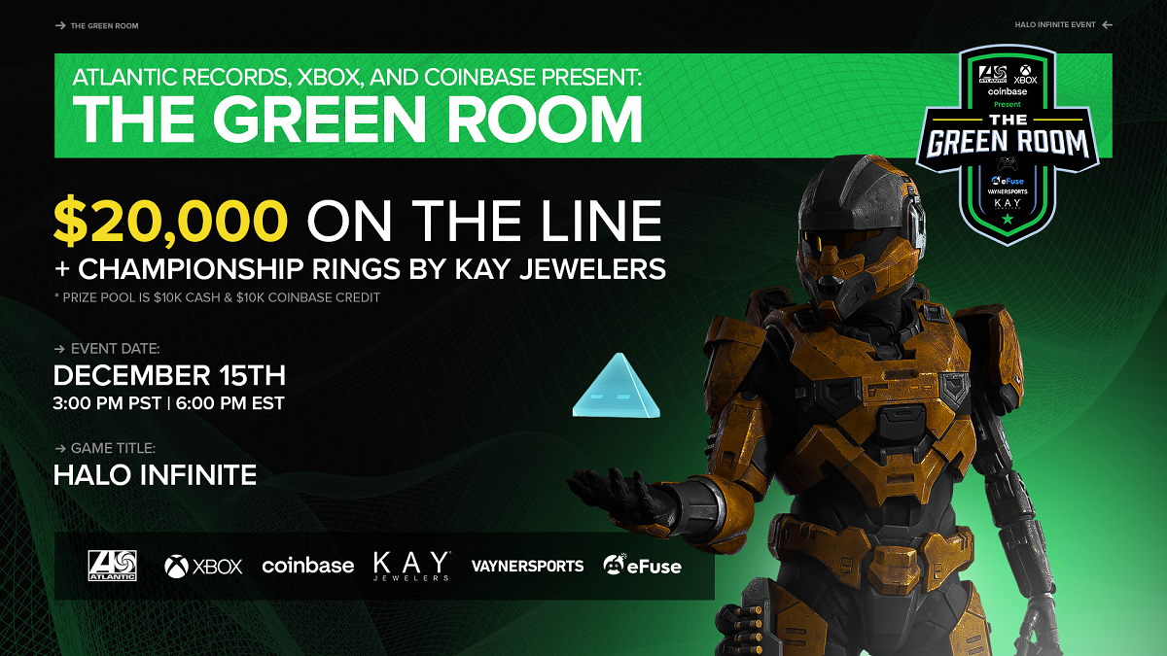
DOWNLOAD ASSETS HERE

Atlantic Records, Xbox and Coinbase have announced the official launch of The Green Room, an innovative music, gaming and sports crossover event series presented in partnership with gaming giants VaynerSports, eFuse and Aim Lab. Series kicks off with the first ever Halo Infinite™ celebrity Pro-Am Tournament this Wednesday, December 15th at 6 PM EST, exclusively via the official Atlantic Records YouTube channel – tune in HERE.

Among the artists taking part in the debut event are: Bankrol Hayden, Sueco, Childish Major, Alt J’s Thom Sonny Green, Jucee Froot, Bizzy Banks, Lil Eazzyy and MILES, as well as superstar streamers OpTic Hitch, LEGIQN, Bugha, FaZe Nate Hill and Snip3down along with UFC fighter Sean O’Malley and NFL stars Baker Mayfield, Marquez Valdes-Scantling and JuJu Smith-Schuster - with his gaming organization, Team Diverge - and many more. Tied to Xbox’s overall mission to bring the joy of gaming to as many as possible, this all-star competition convenes notable stars among the gaming community, fosters new connections, and encourages fans around the world to jump in on the fun.

Hosted by Mitch "OG Pickle" Long and Joey Franchize, The Green Room will feature 8 gaming squads competing for a total prize pool of $10K in cash and $10K in cryptocurrency on Coinbase as well as a custom designed Championship Ring created by KAY Jewelers. Each team will be composed of an Atlantic or Elektra recording artist, a renowned athlete, and two high-profile streamers.

In between rounds, The Green Room will showcase a wide variety of exclusive music and gaming content including interviews, and special Aim Lab and Halo Infinite™ content. The Green Room viewers will be able to get in on the action via an array of exciting contests and giveaways with prizes including tickets to upcoming tours, Xbox Game Pass subscriptions, a HyperX Ultimate Streamer Package and more.

“I’m stoked to be a part of The Green Room! Aside from music, gaming is how I spend most of my time so being a part of this is really dope,” Sueco shared. “I’m a big fan of Halo, Xbox and everyone involved. It’s an honor to get to play a legendary game alongside some of my favorite artists, streamers and athletes.”

Future installments of The Green Room event series will feature an array of fan-favorite games, which will be announced soon.

ABOUT ATLANTIC RECORDS
Atlantic Records celebrated its 70th anniversary in 2018. Founded in New York City, the label literally grew from a one-room operation into one of the world’s preeminent music companies. Atlantic has released a string of recordings that have had a profound impact on the course of modern music, its rich history including such musical icons as Ray Charles, Aretha Franklin, John Coltrane, and Led Zeppelin. The Atlantic Records Group roster today includes many of the world’s most popular recording artists, among them Kelly Clarkson, Bruno Mars, Ed Sheeran, Cardi B, Sia, Coldplay, Charlie Puth, Janelle Monáe, Wiz Khalifa, Death Cab for Cutie, Matchbox Twenty, Lil Uzi Vert, Jason Mraz, Kevin Gates, Melanie Martinez, Rob Thomas, Skrillex, Trey Songz, and many more.

ABOUT VAYNERSPORTS
VaynerSports is a full-service agency representing elite talent in football, baseball, combat, gaming, and most recently NCAA. The agency was founded by Gary and AJ Vaynerchuk (Co-CEO) and led by agency veteran Greg Genske (Co-CEO).

VaynerSports continues its disruption of the traditional sports representation landscape with VaynerGaming, a division focused on esports athletes and gaming personalities.

VaynerMedia - founded in 2009 by brothers Gary and AJ Vaynerchuk - is a global creative and media agency that builds brands for the now and has been recognized for its work by the Cannes Lions International Festival of Creativity, the Clio Awards, and the Webby Awards.

For more information, please visit https://vaynersports.com or follow on social media at @vaynersports.

ABOUT eFUSE
As the ‘Linked for Gamers,’ eFuse is solving esports’ talent development problem by helping gamers get discovered. Since securing $6 million in extended seed funding from Ohio Innovation Fund, Odell Beckham, Jr. (Cleveland Browns), Ezekiel Elliott (Dallas Cowboys) and other notable investors in early 2021, eFuse has provided the spotlight rising stars need to compete at the next level. Be it connecting top talent with elite collegiate programs or finding a path to pro, 500,000 users actively count on eFuse to showcase recent performances, compete in big-dollar, high-production tournaments, and engage with career-making scouts. After an explosive 2020 where gaming experienced record-setting activity due to an extended ‘safer-at-home’ season, eFuse has launched dozens of events, revealed the industry’s first definitive ranking of the top college-eligible players via its new ‘Pipeline’ program, and has persistently paired gamers from underrepresented communities with local programs where they can flourish. eFuse hosts 25 employees from its Columbus, Ohio, headquarters, has $7.4 million in total funding, and was founded in 2018 by Forbes’ 30 under 30 alums Matthew Benson and Austin May.

ABOUT COINBASE
Coinbase is building the crypto economy – a more fair, accessible, efficient, and transparent financial system enabled by crypto. Coinbase started in 2012 with the radical idea that anyone, anywhere, should be able to easily and securely send and receive Bitcoin. Today, Coinbase offers a trusted and easy-to-use platform for accessing the broader crypto economy.

ABOUT AIM LAB
Aim Lab is the training platform of choice for over 20 million gamers around the globe. Designed using performance data to help all players get better at the games they love. Aim Lab’s training tools are paired with shareable social features, leaderboards, and score cards to allow gaming communities to improve and get better together. Download Aim Lab for free on Steam or at aimlab.gg. Follow Aim Lab on Discord, Instagram, and Twitter.

ABOUT MICROSOFT
Microsoft (Nasdaq “MSFT” @microsoft) enables digital transformation for the era of an intelligent cloud and an intelligent edge. Its mission is to empower every person and every organization on the planet to achieve more.

ABOUT KAY JEWELERS
For over 100 years, KAY Jewelers has helped millions of people express love and celebrate life’s most meaningful moments. Operated by Signet Jewelers Ltd., KAY Jewelers is America’s #1 jewelry retailer and the world’s largest retailer of diamond jewelry. For additional information on KAY Jewelers visit www.Kay.com.

ABOUT MITCH “OG PICKLE” LONG
From YouTube and Twitch, to the NFL and NBA, Mitch has helped build some of the biggest influencer merchandise brands on the internet. Currently working at eFuse on the revenue team, Mitch is also a Twitch Partner with a large following for his PlayerUnknown's Battleground (PUBG), which streams nightly during the week.

ABOUT JOEY FRANCHIZE
Joey Franchize started out as a hip-hop DJ and producer out of Hartford, Connecticut. He developed a cult following as a regularly featured DJ in premier nightclubs in Connecticut, New York, and Massachusetts. He’s also the official DJ for the UConn Huskies football and basketball teams. He has worked with and DJ’d for artists such as Wiz Khalifa, Mac Miller, Wale, Kendrick Lamar, MGK, J. Cole, A$AP Rocky, and Big Sean. Joey joins the WiLD 94.1 team after an 8-year stint on-air in Hartford. Joey Franchize is a great draft choice for WiLD 94.1, with his energy, talent and love of pop culture. A full-time DJ, part-time gamer, and moviegoer, Joey has the character WiLD has always embodied.

For press inquiries, please contact:
Jessica Nall // Jessica.Nall@atlanticrecords.com

