TION WAYNE & RUSS MILLIONS TAP FIVIO FOREIGN, BUGZY MALONE, DARKOO AND MORE FOR “BODY (REMIX)”

ARRIVES WITH AN OFFICIAL COMPANION VISUAL AVAILABLE NOW

RECORD BREAKING SINGLE CELEBRATES OVER 25M STREAMS

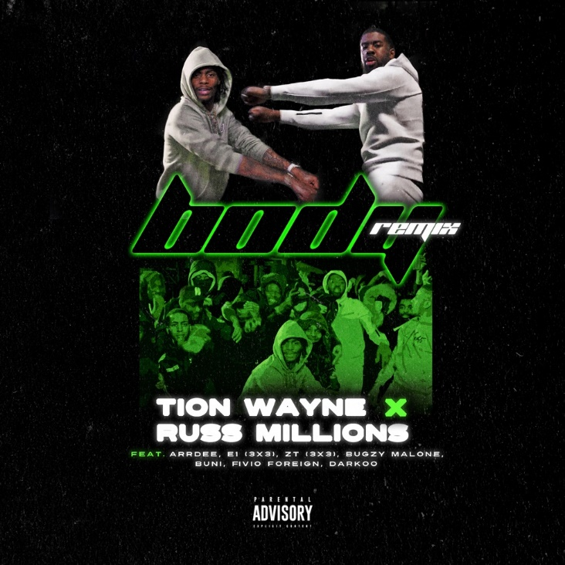

Already a frontrunner for one of this 2021’s biggest British rap songs, “Body”, the latest collaboration from Tion Wayne x Russ Millions is now receiving an all-star remix featuring Bugzy Malone, Buni, Fivio Foreign, Darkoo, ArrDee, and E1 and ZT from 3x3. Produced by Gotcha, the track is also accompanied by a new video directed by Kaylum Dennis (Stormzy, Dave).

WATCH/SHARE THE OFFICIAL VISUAL

Following in the footsteps of their previous massive collaboration “Keisha & Becky”, “Body” has quickly gained steam to become a true behemoth of an early season banger. With over 25M streams in just a few short weeks, the track is currently streaming 800K times per day on Spotify globally, charted at #11 on the OCC last week and has already clocked in hundreds of millions of views on TikTok alone. Additionally, the video was the fastest video to hit over 10M views on GRM Daily since the platform’s creation and is currently B-List on Radio1. Now the track is getting a premium rework from a transatlantic roster of some of the most exciting voices in music today.

TION WAYNE
A true titan of British rap, few artists within the scene can begin to touch Tion Wayne’s culture relevance and numbers. In a short amount of time, Tion has racked up multiple UK Top 10 singles, 2 silver records, 1 gold and 1 platinum, and over 500 million streams. With heavy support across BBC Radio 1 and 1Xtra and consistent premium placement on the popular Spotify playlists Hot Hits UK, Rap UK and Who We Be, he’s become a go to collaborator for some of the biggest and most exciting names working today including Stormzy, 6lack, Rema, NSG, Rudimental, Ms Banks amongst others.

At just 27 years old and the middle child to Nigerian immigrant parents, his drive to succeed has seen him overcome an insurmountable odds to build a fervent fan base that has stuck with him over the years and led him to sell out venues like Brixton Academy within record time. Most impressively, Tion has managed to do this despite not yet releasing his debut album.

Keep posted for more Tion Wayne news soon.

CONNECT WITH TION WAYNE
INSTAGRAM | TWITTER | YOUTUBE

PRESS CONTACT
SELAM BELAY | SELAM.BELAY@ATLANTICRECORDS.COM

