RISING EMCEE TOKEN TRANFORMS INTO “30 PEOPLE” IN ONE OF THE MOST CREATIVE VIDEOS OF THE YEAR;
NEW SINGLE OUT TODAY

ANNOUNCES THE CREATION OF LABEL NEVER TOO DIFFERENT
AND PARTNERSHIP WITH ATLANTIC RECORDS

WATCH THE OFFICIAL VIDEO FOR “30 PEOPLE” HERE
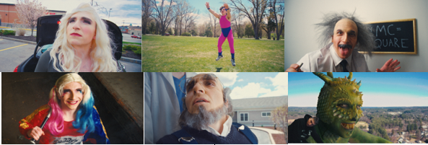

“More than a freestyle savant, Token showcases some supreme storytelling abilities…” -XXL
“…some of the speediest rhymes this side of a young Busta. He’s already tackled a lifetime of adversity and lived to tell the tale. Not only that, but he’s lived to rap about it in pretty insane fashion. -COMPLEX
Fast-spitting freestyle maven, Token, who went viral with his freestyle on Sirius XM’s Sway in the Morning, has released his long-awaited official single, “30 People” via his newly announced label, Never Too Different, in partnership with Atlantic Records. The track is joined by an official music video which sees Token take on many different personalities (30 to be exact) - from a grandma to Albert Einstein to Michaelangelo’s David. Watch the incredibly creative video HERE.
The video was shot in quarantine which provided a creative challenge. Token rose to the occasion, playing all of the characters and using a green screen inside a studio.
Hailed by The Boston Globe as “hip-hop’s next big star,” Token has quickly grown from viral rap sensation to acclaimed new artist. The MA-based rapper was introduced to hip-hop early on and by the age of six, began expressing himself through poetry. At 10 years old, Token began putting melody to his lyrics and recorded the poems as raps. What had started out as an outlet of expression soon became his passion.
Token crafted his art posting idiosyncratic rhymes on YouTube, scoring national attention in 2015 when his entry to a rap video contest went viral. “No Sucka MCs” proved a breakthrough, currently boasting over 5 million views on YouTube.
2016 saw Token achieve even further viral fame with a six-minute-long flawless freestyle on Sirius XM’s influential Sway in the Morning, which XXL dubbed “one of the year's best freestyles, if not one of the best performances ever on Sway's legendary show.” Following that, Token’s first project, ERASER SHAVINGS, was released in September and a tour of France and an appearance at the Chorus Festival (with stars like Robert Glasper and the Pharcyde) came shortly after.
A series of increasingly popular singles and collaborations have followed, among them such favorites as “Code Red,” “YouTube Rapper” feat Tech N9ne and “Household Name.” The latter was featured on his 2018 album BETWEEN SOMEWHERE, which reached #4 on the iTunes US Hip-Hop chart. Upon release, Token embarked on the 39-date “Between Somewhere” tour across major US cities including New York, Cleveland, Chicago, Los Angeles, Dallas, Atlanta, and then to Europe with stops in France, Germany, Switzerland, Poland and the UK.
Token was featured in 2019’s Fast & Furious Hobbs & Shaw motion picture soundtrack with “All Roads Lead Home (Hobbs & Shaw Remix)" by Ohana Bam feat. Token, The Madden 20 Soundtrack with “No Game” and Scoob! The Album from the animated film Scoob! with “Homies.” Token also released single “Curfew” earlier this year.
On what his work means to him Token says, “Music is what helped me get confidence. Music is my time to be invincible. Even though I’m young, my childhood already feels like a different life, because I’m looking back and writing on it.”
# # #
CONNECT WITH TOKEN
OFFICIAL | FACEBOOK | TWITTER | INSTAGRAM | YOUTUBE
Press photos: https://www.dropbox.com/sh/vx5houoj6h6okgi/AAAnUFukkptLsxwPMR5Cjrsua?dl=0

Press contact: Corey.brewer@atlanticrecords.com

