**TOKEN RETURNS WITH ANOTHER SUPERSTAR COLLABORATION, ‘[IOD](https://tokenllc.lnk.to/IOD)’ FT LIL SKIES**

**WATCH THE ‘IOD’ MUSIC VIDEO** [**HERE**](https://youtu.be/VYqp0bYPxCI)

**FOLLOWS TOKEN’S “**[**HIGH HEELS**](https://youtu.be/JGF0ozcn9gU)**” WITH INIMITABLE PUNK RAPPER RICO NASTY**

**NEW ALBUM *PINK IS BETTER* OUT JANUARY 14TH**

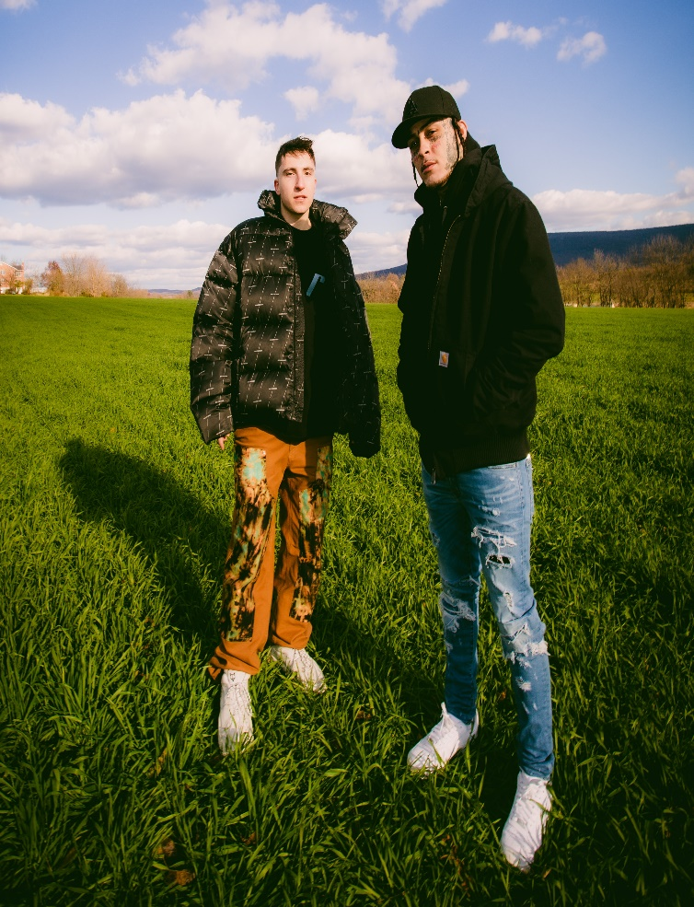

[DL press photos here](https://press.atlanticrecords.com/token/)

Ever-evolving rapper **Token** releases the introspective ‘[IOD’ ft](https://tokenllc.lnk.to/IOD)**[. Lil Skies](https://tokenllc.lnk.to/IOD)** today, where he touches on his struggles with addiction. Watch the music video [HERE](https://youtu.be/VYqp0bYPxCI)! The single follows Token’s October release “[High Heels](https://youtu.be/JGF0ozcn9gU),” featuring fiery rapper Rico Nasty. Both tracks can be found on Token’s upcoming album, *Pink is Better*, which will be released January 14th, 2022 on Token’s label [Never Too Different](https://www.nevertoodifferent.com/), in partnership with Atlantic Records. Pre-Order/Pre-Save *Pink Is Better* [HERE.](https://presavetoken.atlanticrecords.com/)

‘IOD’ ft Lil Skies is deeply personal to Token, opening up about his own addiction struggles in the song. “*This is the first time I've acknowledged it. Seeing my sister battling addiction scared me because I knew that could’ve been me. The album addresses my unhealthy habits & the things that led me there. With Lil Skies, you can always hear the pain behind the admittance. He was the perfect fit for ‘IOD.’”*

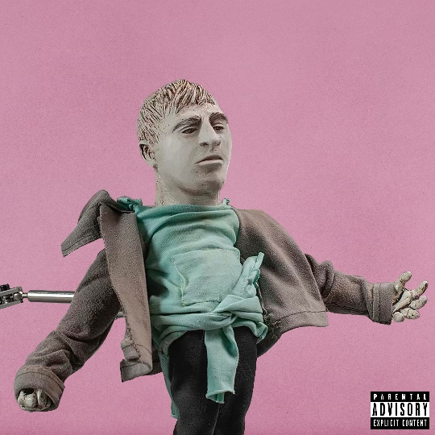

[DL album art here](https://press.atlanticrecords.com/token/)

Token was recently co-signed by NBA superstar Damian Lillard, who was impressed with Token’s freestyle paying tribute to J. Cole. ‘[Hi J. Cole…](https://youtu.be/6ySZSAgxoTo)’ is one of Token’s highest viewed on YouTube, reaching 310k views in its first 24 hours and 1.2M views within the first 7 days of release. Additionally, Token’s 2021 single “[Chit Chat](https://www.youtube.com/watch?v=dwBhYBHKPi8&src=Linkfire&lId=8414c15b-2e8b-415a-9228-290ab5e994a8&cId=d3d58fd7-4c47-11e6-9fd0-066c3e7a8751&ab_channel=tokenhiphop),” produced by Ronny J (Juice WRLD, Eminem, Kanye West, Denzel Curry), has over 4M streams since its May release. Spanning his fast-growing music career, Token has garnered 233M global streams, 193M video views, and 2.4M followers across all social platforms.

Confidence can’t be given. Instead, it’s earned. Through a prolific, albeit quiet grind, Token has morphed into an outlier in hip-hop. After amassing hundreds of millions of streams and views independently and receiving acclaim from *The Boston Globe*, *XXL*, *Complex*, and more, he leaps forward again on his 2021 project *Pink Is Better*—the first to be released under his own label Never Too Different and Atlantic Records.

Growing up outside of Boston, music anesthetized depression, anxiety, stress, and loneliness throughout his childhood. So, Token put his head down and honed his craft at just 10-years-old, putting in countless hours, recording tracks of his own, burning CDs, and distributing them around Massachusetts. During 2015, his “No Sucka MCs Contest Entry” went viral, eventually exceeding 5.7 million YouTube views. After Token wound up on Mark Wahlberg’s radar, he appeared on the hit television show Wahlburgers and landed a role in the blockbuster *Patriots Day*. Simultaneously, he lit up *Sway in the Morning* with a headline-making six-minute freestyle. *XXL* christened it *“one of the year’s best freestyles, if not one of the best performances ever on Sway’s legendary show*.*”*

On its heels, he dropped his first mixtape *Eraser Shavings* in 2016 followed by 2018’s *Between Somewhere*, which vaulted into the Top 5 on the iTunes Hip-Hop/Rap Albums Chart. Generating 100 million-plus streams, it also spawned anthems, including “YouTube Rapper” [feat. Tech N9ne], “Household Name,” and “Flamingo.” Not to mention, he sold out shows on multiple continents and contributed music to the *Fast & Furious Hobbs & Shaw* soundtrack and *Scoob! The Album*.

Throughout 2019 and 2020, he carefully assembled what would become *Pink Is Better*, achieving a sense of personal and creative balance.

“The project is about the highest of highs and the lowest of lows,” he observes. “It’s me realizing, no matter what, it’s all going to be okay.”

# # #

CONNECT WITH TOKEN

[OFFICIAL](https://nam04.safelinks.protection.outlook.com/?url=https%3A%2F%2Furldefense.proofpoint.com%2Fv2%2Furl%3Fu%3Dhttps-3A__nam04.safelinks.protection.outlook.com_-3Furl-3Dhttps-253A-252F-252Fwww.tokenhiphop.com-252F-26data-3D02-257C01-257CCorey.Brewer-2540atlanticrecords.com-257Cf6dbca39bcd84c6d7ed108d837c027de-257C8367939002ec4ba1ad3d69da3fdd637e-257C0-257C0-257C637320645884163493-26sdata-3D460MQh5-252BV8mFg7VeUdsfk0Wwwy6b-252BQJOV1FJ9v-252FqRBg-253D-26reserved-3D0%26d%3DDwMGaQ%26c%3DeuGZstcaTDllvimEN8b7jXrwqOf-v5A_CdpgnVfiiMM%26r%3DFSTML3jvsT1nrXb7i-MgtoMF-nQTL90szF2A1QEeZW4%26m%3D6Pl3ZINBZvjRd0sOFnk1OANEo54se9XTkD4PnPO_bSE%26s%3D14Gvax5rRUZL8q8iuIYiVfZsCUcVklVDIyHKFLETUCA%26e%3D&data=02%7C01%7CGabrielle.Reese%40atlanticrecords.com%7Cfc83bae6964c48800d2a08d8389379f7%7C8367939002ec4ba1ad3d69da3fdd637e%7C0%7C0%7C637321553348257580&sdata=3g1iFPco47x%2BG2u%2F8Ol41ieGnYbKiHVG%2Bn0LDAHqADE%3D&reserved=0) | [FACEBOOK](https://nam04.safelinks.protection.outlook.com/?url=https%3A%2F%2Furldefense.proofpoint.com%2Fv2%2Furl%3Fu%3Dhttps-3A__nam04.safelinks.protection.outlook.com_-3Furl-3Dhttps-253A-252F-252Fwww.facebook.com-252Ftokenhiphop-26data-3D02-257C01-257CCorey.Brewer-2540atlanticrecords.com-257Cf6dbca39bcd84c6d7ed108d837c027de-257C8367939002ec4ba1ad3d69da3fdd637e-257C0-257C0-257C637320645884163493-26sdata-3DxlNUIRvibwCbF4ftnKeY2KVXtuL0-252BhFJmjW6qBgVS6I-253D-26reserved-3D0%26d%3DDwMGaQ%26c%3DeuGZstcaTDllvimEN8b7jXrwqOf-v5A_CdpgnVfiiMM%26r%3DFSTML3jvsT1nrXb7i-MgtoMF-nQTL90szF2A1QEeZW4%26m%3D6Pl3ZINBZvjRd0sOFnk1OANEo54se9XTkD4PnPO_bSE%26s%3D9xA297qt20Sl4b1iFKqGv6B-wjDJsjTW6CvwWp2wPZk%26e%3D&data=02%7C01%7CGabrielle.Reese%40atlanticrecords.com%7Cfc83bae6964c48800d2a08d8389379f7%7C8367939002ec4ba1ad3d69da3fdd637e%7C0%7C0%7C637321553348257580&sdata=xwHA5QzKCdc%2BfltU93ccHK154O7Li8dG41yeqR9PpEc%3D&reserved=0) | [TWITTER](https://nam04.safelinks.protection.outlook.com/?url=https%3A%2F%2Furldefense.proofpoint.com%2Fv2%2Furl%3Fu%3Dhttps-3A__nam04.safelinks.protection.outlook.com_-3Furl-3Dhttps-253A-252F-252Ftwitter.com-252Ftokenhiphop-26data-3D02-257C01-257CCorey.Brewer-2540atlanticrecords.com-257Cf6dbca39bcd84c6d7ed108d837c027de-257C8367939002ec4ba1ad3d69da3fdd637e-257C0-257C0-257C637320645884173453-26sdata-3DhN0RSZ-252FzcriClH4j8ke9rMwqVG1sVzeUc-252Ft07pSP5v8-253D-26reserved-3D0%26d%3DDwMGaQ%26c%3DeuGZstcaTDllvimEN8b7jXrwqOf-v5A_CdpgnVfiiMM%26r%3DFSTML3jvsT1nrXb7i-MgtoMF-nQTL90szF2A1QEeZW4%26m%3D6Pl3ZINBZvjRd0sOFnk1OANEo54se9XTkD4PnPO_bSE%26s%3DY4oH3ymktOt_Ov-zAvGVIyCeVNfKUrQg9tA_7fRnMmo%26e%3D&data=02%7C01%7CGabrielle.Reese%40atlanticrecords.com%7Cfc83bae6964c48800d2a08d8389379f7%7C8367939002ec4ba1ad3d69da3fdd637e%7C0%7C0%7C637321553348267572&sdata=WU9KqNfvxgNPyjfy3lwbfU3NHaYpOgVxPLBS1EwTwHc%3D&reserved=0) | [INSTAGRAM](https://nam04.safelinks.protection.outlook.com/?url=https%3A%2F%2Furldefense.proofpoint.com%2Fv2%2Furl%3Fu%3Dhttps-3A__nam04.safelinks.protection.outlook.com_-3Furl-3Dhttps-253A-252F-252Fwww.instagram.com-252Ftokenhiphop-252F-26data-3D02-257C01-257CCorey.Brewer-2540atlanticrecords.com-257Cf6dbca39bcd84c6d7ed108d837c027de-257C8367939002ec4ba1ad3d69da3fdd637e-257C0-257C0-257C637320645884173453-26sdata-3D9MzmnUdTDk7IqRc3CQ7I2UK-252BYNTu6ip594RNEE5jUZE-253D-26reserved-3D0%26d%3DDwMGaQ%26c%3DeuGZstcaTDllvimEN8b7jXrwqOf-v5A_CdpgnVfiiMM%26r%3DFSTML3jvsT1nrXb7i-MgtoMF-nQTL90szF2A1QEeZW4%26m%3D6Pl3ZINBZvjRd0sOFnk1OANEo54se9XTkD4PnPO_bSE%26s%3DIEPNWh8yqf3UP4PCb9LrL-X4jr1udlASspgWAyCmP2Q%26e%3D&data=02%7C01%7CGabrielle.Reese%40atlanticrecords.com%7Cfc83bae6964c48800d2a08d8389379f7%7C8367939002ec4ba1ad3d69da3fdd637e%7C0%7C0%7C637321553348277569&sdata=%2BGR05PcwUuD6lEtb3255vorwGLbSwNbu1qJNvQCs7hQ%3D&reserved=0) | [YOUTUBE](https://nam04.safelinks.protection.outlook.com/?url=https%3A%2F%2Furldefense.proofpoint.com%2Fv2%2Furl%3Fu%3Dhttps-3A__nam04.safelinks.protection.outlook.com_-3Furl-3Dhttps-253A-252F-252Fwww.youtube.com-252Fuser-252Ftokenhiphop-26data-3D02-257C01-257CCorey.Brewer-2540atlanticrecords.com-257Cf6dbca39bcd84c6d7ed108d837c027de-257C8367939002ec4ba1ad3d69da3fdd637e-257C0-257C0-257C637320645884183402-26sdata-3DK5DrmCo2WTP4Mg-252BasEi33D2MSsLoZbAmlQj6h8VjYj8-253D-26reserved-3D0%26d%3DDwMGaQ%26c%3DeuGZstcaTDllvimEN8b7jXrwqOf-v5A_CdpgnVfiiMM%26r%3DFSTML3jvsT1nrXb7i-MgtoMF-nQTL90szF2A1QEeZW4%26m%3D6Pl3ZINBZvjRd0sOFnk1OANEo54se9XTkD4PnPO_bSE%26s%3DK5cauwof1Su58q-3Itj_KCW9R1k-fe_hLal4TEXY3_k%26e%3D&data=02%7C01%7CGabrielle.Reese%40atlanticrecords.com%7Cfc83bae6964c48800d2a08d8389379f7%7C8367939002ec4ba1ad3d69da3fdd637e%7C0%7C0%7C637321553348277569&sdata=b%2BmYMpjc00siijfacX8gm7TJOpf6do4wqd32gTub5Cw%3D&reserved=0) | [PRESS SITE](https://press.atlanticrecords.com/token/)

Press contact: [Corey.brewer@atlanticrecords.com](mailto:Corey.brewer@atlanticrecords.com)