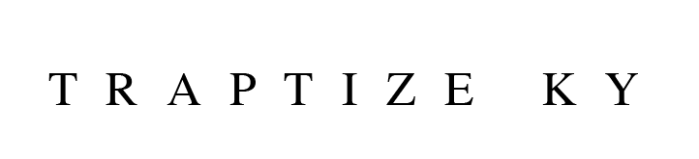
Traptize Ky infuses a wide spectrum of emotions into his music, letting you know exactly what’s on his mind. Aggressive flows mirror anger and pain, while fluttering and woozy melodies float on pure feels. The Richmond, VA rapper introduces himself with a distinct, diverse, and dynamic style. After receiving acclaim from Elevator Magazine and putting numbers on the board with 1 million-plus views independently, he formally introduces himself on his 2021 mixtape A Different Me 2 and more music on the horizon.

“I found out rap was the best way for me to put my emotions out there,” he explains. “When I’m going through shit, there’s no better outlet for me. It’s my favorite thing. If I’m mad, happy, or if things don’t go my way, you’ll hear it. I don’t know how to do anything else for real.”
Born and raised in Richmond, VA, he developed a passion for hip-hop by watching underground battle rap videos on YouTube with his uncle who actually rapped under the name of Tubb. With dad in and out of jail through most of his childhood, Traptize Ky primarily lived with his mother and two sisters. Mom worked long hours in the hospital, so he split his time between music and the streets. He listened to everyone from Boosie Badazz and Webbie to Jeezy and Meek Mill and began to rap. Eventually, he co-founded fan favorite local group Ward Boyz and cut his teeth in the studio. During 2018, he went solo with “Living Proof.” On its heels, “Duh” and the debut mixtape A Different Me increased his momentum, while 2019’s “All Whites” took over his hometown. The record ignited a demand for all white Air Force Ones, causing sneaker stores throughout Richmond to completely sell out of the shoe in the market.

However, he wound up in jail around the same time…

“It was just a little lesson learned,” he sighs. “I ended up doing seven months, and I had labels reaching out while I was in there. I wanted to focus as soon as I got out.”

Upon returning home, he dropped the Back I Go mixtape. Elevator Magazine predicted, “Traptize Ky has arrived to make his mark on the rap game” and raved, “The 14-track project from this prodigal 18-year-old star is at turns shockingly sophisticated, others bluntly raw, yet always full of heart.” Paving the way for A Different Me 2, he ignited 2021 with the single “Seen Her.” On the track, he dips into the 808-laden beat with hypnotic harmonies and carries the instantly unshakable warbling hook punctuated by fiery falsetto. “I was really inspired by Kodak Black, because I like his music,” he explains. “Lyrically, it’s all about falling in love with a girl from the projects.”
On “Operation,” he devours trap keys and thick bass with an authoritative flow about “how things go in the street when people are telling shit.” Then, there’s “Redlight.” Glassy piano gives way to skittering claps as he captures a sense of anxiety anytime the car stops—“You don’t want to stop at the red light late at night and die, so you’ve got to be ready,” he warns.

Everything about Traptize Ky stands out. He never sticks to the script. Instead, he rewrites it entirely.

“When you listen to me, I want you to notice a different mindset, different flows, different styles, different energy, and a different part of me,” he leaves off. “Everybody talks about the streets. I give it to you the Richmond way. It’s a new me. It’s better. It’s elevated. It’s authentic. It’s real.”

