USERx RELEASES SELF-TITLED DEBUT EP

USERx IS CHART-TOPPING ALT SINGER/SONGWRITER MATT MAESON & MUSIC PRODUCER/DESIGNER ROZWELL

EP FEATURES INCLUDE PUSHA-T, MASEGO, MANCHESTER ORCHESTRA & WEST BANKS

LISTEN HERE: https://userx.lnk.to/USERxPR

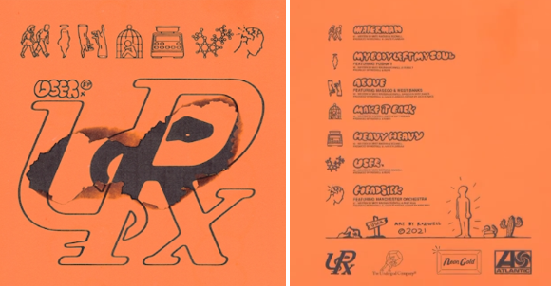
DL art here

USERx (comprised of RIAA Gold-Certified singer/songwriter Matt Maeson and producer/designer Rozwell) release their introspective, self-titled debut EP ‘USERx’ today on Neon Gold/Atlantic Records. Listen HERE and watch the ‘My Body Left My Soul’ (featuring Pusha-T) lyric video HERE.

The EP release follows USERx’s debut single “Waterman” and collaborations “Above” with Masego and West Banks and “Headsick” with Manchester Orchestra.

USERx track list:
- Waterman
- My Body Left My Soul (featuring Pusha-T)
- Above (featuring Masego & West Banks)
- Make It Back
- Heavy Heavy
- USERx
- Headsick (featuring Manchester Orchestra)

USERx (pronounced 'USER') is the beautifully warped brainchild of RIAA Gold-Certified singer/songwriter Matt Maeson and producer/designer Rozwell, two hometown friends from wildly different musical backgrounds. They share lead vocal duties, with Maeson on guitar and Rozwell programming and producing. Matt and Rozwell recently spoke about the project with Travis Mills on Apple Music 1- you can listen to the interview HERE.

Rozwell has served as Matt's creative director since day one, designing all of his artwork, album and single covers and merch to date, while also crafting his own futuristic R&B/hip hop records, garnering praise from everyone from Pigeons & Planes to Zane Lowe.

In August 2020, acclaimed singer-songwriter Matt Maeson achieved yet another Alternative Radio #1 hit with “Hallucinogenics” (taken from his 2019 debut album Bank On The Funeral) making him the 1st male solo artist to achieve 2 Billboard #1 Alternative hits on a full-length debut album. The iconic Lana Del Rey lent her vocals to the track as well, after inviting him to play it on stage with her on her 2019 tour. “Hallucinogenics” follows Matt’s single “Cringe,” which hit #1 the same week in 2019 and spent four consecutive weeks at #1 on Billboard’s Alt Songs chart after a steady 25-week climb.

Throughout USERx, Maeson and Rozwell match their unfiltered expression with the kaleidoscopic musicality they’ve honed their whole lives. Raised by parents who played in heavy metal bands in his early childhood and who later started a prison ministry, Maeson took up guitar at age 15 and soon moved on to writing his own songs, at one point traveling the country with just his guitar and a notebook. Meanwhile, Rozwell played cello and drums in the school orchestra at the urging of his mother (a singer who’d performed in a barbershop quartet), and at age 12 taught himself to make beats, quickly becoming enchanted with the art of sampling. After crossing paths through the local Virginia Beach music scene in the early 2010s, the two started teaming up on myriad projects, with Rozwell producing an early version of Maeson’s “Grave Digger”—the breakthrough hit that led to his signing a joint deal with Neon Gold/Atlantic Records in 2016. With Maeson now based in Austin and Rozwell in L.A., each musician has since come to rely on USERx as an ever-evolving outlet for their most outlandish creative impulses.

“There’s a lot of kids out there who need a home in a cultural sense—the kids who aren’t necessarily accepted by the rap world or the alternative world, and feel out of place everywhere they go,” says Rozwell. “We want to create some kind of tribe for all the people who check that box that says ‘other.’”

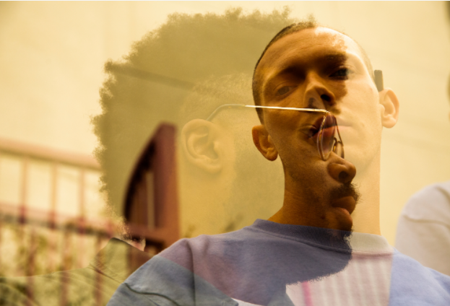
(DL press photos here- credit Jesse Deflorio)

CONNECT WITH USERx
TWITTER | INSTAGRAM | NEON GOLD | PRESS SITE
Press contact: Corey.brewer@atlanticrecords.com

