MANCHESTER ORCHESTRA TEAMS UP WITH USERx ON “HEADSICK”

PASSION PROJECT USERx INCLUDES CHART-TOPPING SINGER/SONGWRITER MATT MAESON
& MUSIC PRODUCER/DESIGNER ROZWELL

SELF-TITLED EP USERx OUT 3/12

LISTEN HERE: https://userx.lnk.to/HeadsickPR

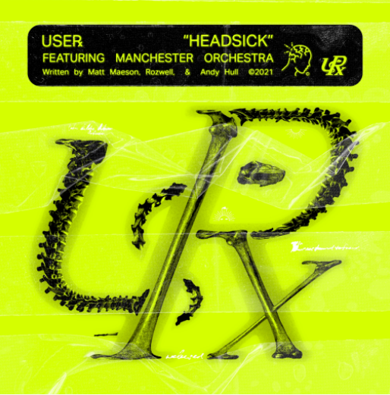
DL art here

Following their debut single “Waterman” and collaboration “Above” with Masego and West Banks, USERx enters 2021 with the emotion-filled “Headsick”, featuring Manchester Orchestra, out now on Neon Gold/Atlantic Records. Listen HERE. The duo has also announced their self-titled debut EP, to be released Friday, March 12th.

On the collaboration Andy Hull of Manchester Orchestra said: “I became friends with Matt a few years ago and have loved watching him continue to create and evolve into an amazing artist. It was a no brainer when he asked to collaborate and when I heard the initial bones of this song, it became all the more exciting. Matt and Roz are a really complimentary team and the final product gave me the chills.”

And Matt Maeson said, “Manchester Orchestra has always been my favorite band. Rozwell and I have probably spun “Leaky Breaks” a thousand times over. Andy’s songwriting, specifically, continues to have a huge impact on my own writing. The way he writes and the subjects he chooses to write about are very human and admirable. That, combined with the way the band changes dynamics in such creative ways depending on where the emotion or lyrics lead the song, has inspired time and time again.
All I can say is collaborating on “Headsick” with them is an incredibly validating feeling and I’m honored that they would lend their greatness to us for a song that we’re all very proud of.”

USERx (pronounced 'USER') is the beautifully warped brainchild of RIAA Gold-Certified singer/songwriter Matt Maeson and producer/designer Rozwell, two hometown friends from wildly different musical backgrounds. They share lead vocal duties, with Maeson on guitar and Rozwell programming and producing. Matt and Rozwell recently spoke about the project with Travis Mills on Apple Music 1- you can listen to the interview HERE.

Rozwell has served as Matt's creative director since day one, designing all of his artwork, album and single covers and merch to date, while also crafting his own futuristic R&B/hip hop records, garnering praise from everyone from Pigeons & Planes to Zane Lowe.

In August 2020, acclaimed singer-songwriter Matt Maeson achieved yet another Alternative Radio #1 hit with “Hallucinogenics” (taken from his 2019 debut album Bank On The Funeral) making him the 1st male solo artist to achieve 2 Billboard #1 Alternative hits on a full-length debut album. The iconic Lana Del Rey lent her vocals to the track as well, after inviting him to play it on stage with her on her 2019 tour. “Hallucinogenics” follows Matt’s single “Cringe,” which hit #1 the same week in 2019 and spent four consecutive weeks at #1 on Billboard’s Alt Songs chart after a steady 25-week climb.

Throughout USERx, Maeson and Rozwell match their unfiltered expression with the kaleidoscopic musicality they’ve honed their whole lives. Raised by parents who played in heavy metal bands in his early childhood and who later started a prison ministry, Maeson took up guitar at age 15 and soon moved on to writing his own songs, at one point traveling the country with just his guitar and a notebook. Meanwhile, Rozwell played cello and drums in the school orchestra at the urging of his mother (a singer who’d performed in a barbershop quartet), and at age 12 taught himself to make beats, quickly becoming enchanted with the art of sampling. After crossing paths through the local Virginia Beach music scene in the early 2010s, the two started teaming up on myriad projects, with Rozwell producing an early version of Maeson’s “Grave Digger”—the breakthrough hit that led to his signing a joint deal with Neon Gold/Atlantic Records in 2016. With Maeson now based in Austin and Rozwell in L.A., each musician has since come to rely on USERx as an ever-evolving outlet for their most outlandish creative impulses.

“There’s a lot of kids out there who need a home in a cultural sense—the kids who aren’t necessarily accepted by the rap world or the alternative world, and feel out of place everywhere they go,” says Rozwell. “We want to create some kind of tribe for all the people who check that box that says ‘other.’”

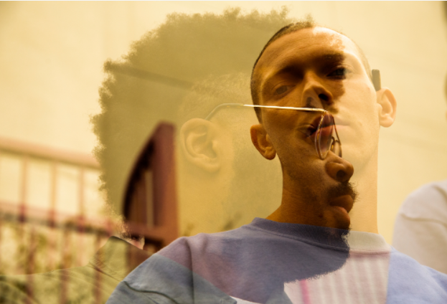
(DL press photos here- credit Jesse Deflorio)

CONNECT WITH USERx
TWITTER | INSTAGRAM | NEON GOLD | PRESS SITE
Press contact: Corey.brewer@atlanticrecords.com

