**RIAA GOLD-CERTIFIED SINGER/SONGWRITER MATT MAESON AND MUSIC PRODUCER/DESIGNER ROZWELL DEBUT NEW COLLABORATION USERx**

**RELEASE FIRST SINGLE, “WATERMAN,” WITH MUSIC VIDEO**

**EP TO COME EARLY NEXT YEAR**

**WATCH HERE:** [**https://youtu.be/GuvPTeWQ268**](https://youtu.be/GuvPTeWQ268)

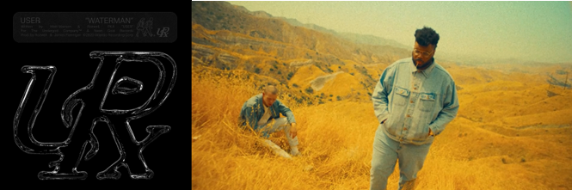

**USERx** (pronounced 'USER') is the beautifully warped brainchild of RIAA Gold-Certified singer/songwriter **Matt Maeson** and producer/designer **Rozwell**, two hometown friends from wildly different musical backgrounds. Sharing lead vocal duties, Maeson on guitar and Rozwell programming and producing, the duo releases their debut single “Waterman” today on Neon Gold/Atlantic Records, accompanied by the official music video. Watch the video [HERE](https://atlantic.lnk.to/Waterman) and look out for USERx’s EP coming out at the top of next year.

On “Waterman,” USERx present a potent introduction to their sound and sensibilities. “*The chorus to that song came from being drunk on tour and having an epiphany that I needed to just go get some water*,” Maeson recalls. “*It’s such a simple idea but there was something very sincere about it*.” Threaded with stark and soulful guitar work, “Waterman” spins a strangely tender narrative of desperation and fragile hope, drawing much of its hypnotic power from Rozwell’s use of stipped back drumbeats. “*I tried all different drums but ended up going with something simple that gave it this very human element*,” he says. “*This whole project is experimental by nature, so I’m mostly just following my intuition—it’s about whatever hits me right in the moment.”*

Rozwell has served as Matt's creative director since day one, designing all of his artwork, album and single covers and merch to date, while also crafting his own futuristic R&B/hip hop records, garnering praise from everyone from Pigeons & Planes to Zane Lowe.

Acclaimed singer-songwriter Matt Maeson recently achieved another Alternative Radio #1 hit with “[Hallucinogenics](https://nam04.safelinks.protection.outlook.com/?url=https%3A%2F%2Fwww.youtube.com%2Fwatch%3Fv%3DdoRUhDIB29s&data=02%7C01%7CGabrielle.Reese%40atlanticrecords.com%7C3a250eaf3361468d611608d849e9759a%7C8367939002ec4ba1ad3d69da3fdd637e%7C0%7C0%7C637340614331163735&sdata=IQHJU93SYEnO9HY6CoqijVRWoGrHj2sXWAPADH5ZdRQ%3D&reserved=0" \t "_blank)” (taken from his 2019 debut album *Bank On The Funeral*) making him the 1st male solo artist to achieve 2 Billboard #1 Alternative hits on a full-length debut album. “Hallucinogenics” follows his single “[Cringe](https://nam04.safelinks.protection.outlook.com/?url=https%3A%2F%2Fwww.youtube.com%2Fwatch%3Fv%3DeoJtlPQzqkQ&data=02%7C01%7CGabrielle.Reese%40atlanticrecords.com%7C3a250eaf3361468d611608d849e9759a%7C8367939002ec4ba1ad3d69da3fdd637e%7C0%7C0%7C637340614331163735&sdata=AojWTpr3Oksp1O6pFPoqlw0VV2aTsnOtZvHhjrAkysU%3D&reserved=0),” which hit #1 the same week last year and spent four consecutive weeks at #1 on Billboard’s Alt Songs chart after a steady 25-week climb. Maeson also recently passed 500 million worldwide streams on his catalog to date.

Throughout USERx, Maeson and Rozwell match their unfiltered expression with the kaleidoscopic musicality they’ve honed their whole lives. Raised by parents who played in heavy metal bands in his early childhood and who later started a prison ministry, Maeson took up guitar at age 15 and soon moved on to writing his own songs, at one point traveling the country with just his guitar and a notebook. Meanwhile, Rozwell played cello and drums in the school orchestra at the urging of his mother (a singer who’d performed in a barbershop quartet), and at age 12 taught himself to make beats, quickly becoming enchanted with the art of sampling. After crossing paths through the local music scene in the early 2010s, the two started teaming up on myriad projects, with Rozwell producing an early version of Maeson’s “Grave Digger”—the breakthrough hit that led to his signing a joint deal with Neon Gold/Atlantic Records in 2016. With Maeson now based in Austin and Rozwell in L.A., each musician has since come to rely on USERx as an ever-evolving outlet for their most outlandish creative impulses.

In reflecting on the making of their project, USERx point to a certain purpose behind their wayward sound. “*There’s a lot of kids out there who need a home in a cultural sense—the kids who aren’t necessarily accepted by the rap world or the alternative world, and feel out of place everywhere they go*,” says Rozwell. “*We want to create some kind of tribe for all the people who check that box that says ‘other*.’” And in their lyrics, USERx aim to deepen that solidarity by being unapologetically open about the decisions they’ve made and damage they’ve endured. “*Growing up in church, it always seemed strange to me that it was unacceptable to talk about these kinds of things in music*,” says Maeson. “*By being honest and unashamed about my experiences, I want to help other people realize that they can do what I did: they can learn from their past and move on, and make something out of what they’ve gone through. I think there’s a lot of hopefulness in that.”*

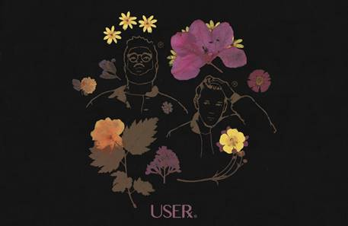

CONNECT WITH USERx

[TWITTER](https://twitter.com/USERxWORLD) | [INSTAGRAM](https://www.instagram.com/mybodyleftmysoul/?hl=en) | [NEON GOLD](https://nam04.safelinks.protection.outlook.com/?url=http%3A%2F%2Fneon.gold%2Freleases%2Fwhokilledmattmaeson%2F&data=02%7C01%7CGabrielle.Reese%40atlanticrecords.com%7C3a250eaf3361468d611608d849e9759a%7C8367939002ec4ba1ad3d69da3fdd637e%7C0%7C0%7C637340614331213703&sdata=QTwec9U027ZHQaOJNl0FmuOUVB%2BI40D8%2FdgXP8pLSrA%3D&reserved=0) | [PRESS SITE](https://press.atlanticrecords.com/userx/)

Press contact: [Corey.brewer@atlanticrecords.com](mailto:Corey.brewer@atlanticrecords.com)