FOR IMMEDIATE RELEASE
OCTOBER 29, 2021

DAINE REWRITES HER FIRST CHAPTER WITH “CEMETERY DREAMS”

ANNOUNCES DEBUT MIXTAPE EARLY 2022

STREAM/DOWNLOAD “CEMETERY DREAMS”: https:///daine.lnk.to/cemetery

“A future emo icon” - NME
“Teen angst’s freshest voice” - V Magazine
“It feels healing and painful; like looking directly at a solar flare.” - The Guardian
“A nihilistically detached voice” - The FADER
“daine’s creative spin on such a distinctive sound evokes an irresistible nostalgia” - Pigeons & Planes

For the past 18 months, Melbourne based artist daine has become one of the musical spokespeople for a disillusioned generation forced to live their lives behind a screen. Wearing her influences on her sleeve, she blends the melancholic atmospheres of the midwest emo and skramz she used as her solace growing up, with the progressive sounds of modern pop - finding community within the perennially online devotees of each of those sounds. Her confessional emo-pop plays like an open-ended diary entry, finding fans in the likes of Charli XCX, and collaborators in Bring Me The Horizon’s Oli Sykes (‘SALT’), 100 Gecs’ Dylan Brady (‘boys wanna txt’) and Danny L Harle (‘Angel Numbers’). Today, daine revisits the opening chapter of that sonic diary with ‘Cemetery Dreams’, the first song she ever wrote.

A devastatingly immersive soundscape that belies the 16 years that daine had lived when she wrote the track, ‘Cemetery Dreams’ is a spiritually infused cut of emo-pop that balances finely crafted emotional peaks and melodrama expertly. Formed around a lo-fi loop of daine’s own guitar playing, the track swells gradually with subtle textures and grandiose strings alongside contemporary rap production flourishes from regular collaborator Circle Pitt. Lyrically daine perfectly encapsulates the feeling of emptiness after lost love, leading the song’s emotionally wrought subject matter to be delivered with an apathy that makes the track even more soul-rendering.

‘Cemetery Dreams’ is the first track to be taken from daine’s highly anticipated debut project, which is due for release in early 2022. A self-professed “tombstone to her adolescence,” the project marks the story of a young woman growing in real time while feeling alienated from the world, only to gradually build her own across the project’s collection of tracks.

That world of daine’s own design is now on full display and has marked her out as one of 2021’s most exciting breakout stars. Pushing the boundaries of alternative music, pop, electronic sounds and more, daine’s genre-eschewing compositions are a perfect encapsulation of the boundless creativity at her fingertips. With her demand to subvert expectations only growing with each release, the possibilities on where she may go next are endless.

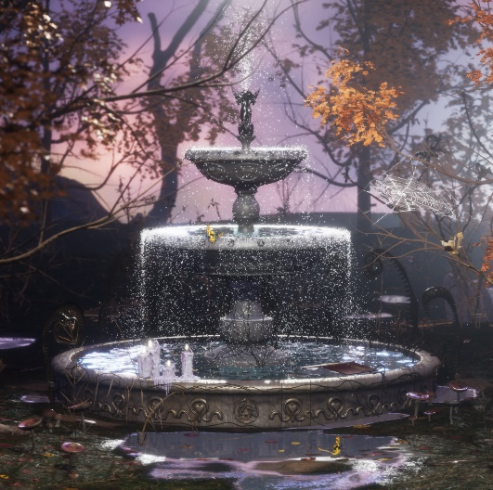

daine: Website | Twitter | Instagram

For more information on daine, contact mitch@revenant.earth

