FOR IMMEDIATE RELEASE
MAY 20, 2022

22Gz UNVEILS OFFICIAL VISUAL FOR HIS LATEST SINGLE “SPIN” VIA METAVERSE EXPERIENCE IN DECENTRALAND IN PARTNERSHIP WITH TERRAZERO

DRILL PIONEER PREMIERES VIDEO IN AN IMMERSIVE BROOKLYN-INSPIRED EXPERIENCE IN DECENTRALAND THAT LAUNCHED TODAY

THE BLIXKY TAPE 2 (DELUXE) AVAILABLE NOW VIA SNIPER GANG/ATLANTIC

LISTEN TO “THE BLIXKY TAPE 2 (DELUXE)”

WATCH “SPIN” OFFICIAL MUSIC VIDEO

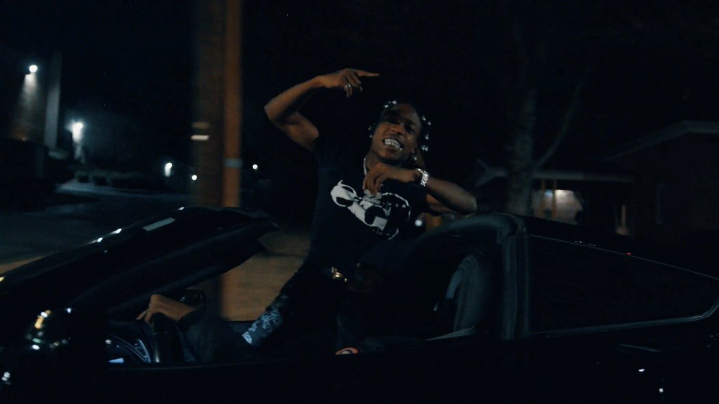

RIAA gold certified Brooklyn Drill pioneer 22Gz is continuing his current single run. Today he releases his official music video for “SPIN” streaming on all DSPs HERE. The video premiered in the immersive Brooklyn-inspired experience on Decentraland and will be available for viewing for 48 hours. For the Metaverse experience, TerraZero recreated the historic Brooklyn Bridge and launched the first-ever music activation on it in Decentraland where fans can join 22Gz in the park to watch the video. The single is a re-release from THE BLIXKY TAPE 2 (DELUXE) and the video is now available on his official YouTube HERE. The video also made its broadcast premier today via Revolt.

Just last week we saw the release of his current single “Keep A Blixky” streaming via YouTube HERE. Last month we saw the release of “Omerta (Feat. COACHDAGHOST)” streaming via YouTube HERE. Previously, the “Year of the Blixky” rolled on with the March 22nd release of the official music video for “Loyalty (Feat. Internet Money),” directed by Todd Uno (Gucci Mane, Pooh Shiesty) and streaming now via YouTube HERE. “Omerta” – which pairs 22Gz with his longtime friend, fellow Brooklyn Drill star CoachDaGhost – and “Loyalty” are among the many highlights found on THE BLIXKY TAPE 2 (DELUXE), available now via Sniper Gang/Atlantic at all DSPs and streaming services. The expanded edition of 22Gz’s blockbuster 2021 mixtape also includes such explosive new tracks as “Possessed” and “Said It’s Lit,” both accompanied by official music videos streaming now at YouTube.

First released March 2021 to wide ranging national applause, THE BLIXKY TAPE 2 is highlighted by the hugely popular single, “Twirlanta,”. The track has earned millions of worldwide streams to date and is joined by an equally potent official video, now surpassing 10M views via YouTube HERE.

In addition, THE BLIXKY TAPE 2 – which features beats created by a cadre of top domestic and international producers including Reazy Renegade, Ghosty, Young Dza, Zacky Beatz, and more – also includes such hits as “Blixky Gang Freestyle Pt. 2,” “Movie (Feat. CoachDaGhost),” “Casa,” “Never Be The Same (Feat. Jackboy),” and “Fallen Blixkys.” Furthermore, 22Gz kept the fire going with a pair of additional 2021 smashes, “Retaliation” and “Steppers,” both of which are joined by official visuals at YouTube.

With hundreds of millions of worldwide streams and more than 116M YouTube views thus far, 22Gz stands tall at the forefront of New York Drill, consistently rewriting the rulebook with every release, leading the pack while bringing “Blixky” to the worldwide lexicon. Beyond the metallic ironclad beats, viral dances, hundreds of millions of streams, and acclaim from such high-profile outlets as Vulture, The Source, Pitchfork, and Noisey, 22Gz has cast a long shadow over the genre with a one-of-a-kind combination of menacing melodies and razor-sharp rhymes. Toughened up by the trauma of his father’s murder, the tribulations of being raised by his older sisters, and his own trouble with the law, 22Gz first lit the match for the Brooklyn Drill movement in 2017 with “Suburban,” christened by Pitchfork as “the first Brooklyn Drill song worth a damn.” A deal with Sniper Gang in partnership with Atlantic Records kicked off with 2019’s original THE BLIXKY TAPE, followed a year later by GROWTH & DEVELOPMENT, highlighted by the RIAA gold certified breakthrough, “Suburban Pt. 2,” now boasting over 32.5M YouTube views. In its aftermath, Complex cited 22Gz as “a trailblazer of Brooklyn drill music,” while HYPEBEAST simply stated, “22Gz is one of the main reasons Brooklyn’s drill scene made its way to the masses.”

About TerraZero Technologies Inc.
TerraZero (www.terrazero.com) is a Metaverse development group and leading Web 3.0 technology company specializing in brand activations for the Metaverse space. The Company's vision is to develop user experiences that will shape the future of Web 3.0. TerraZero’s clients include major Fortune 100 companies across all sectors, and legacy entertainment IP. For more information, please visit www.terrazero.com or contact media@terrazero.com.

# # #

CONNECT WITH 22Gz
22GZOFFICIAL.COM | INSTAGRAM | YOUTUBE | TWITTER | FACEBOOK
FOR PRESS INQUIRIES PLEASE CONTACT
For 22Gz/Atlantic Records: ARIANA.WHITE@ATLANTICRECORDS.COM
For TerraZero: DENVER@SWITCHBOARDPR.COM

